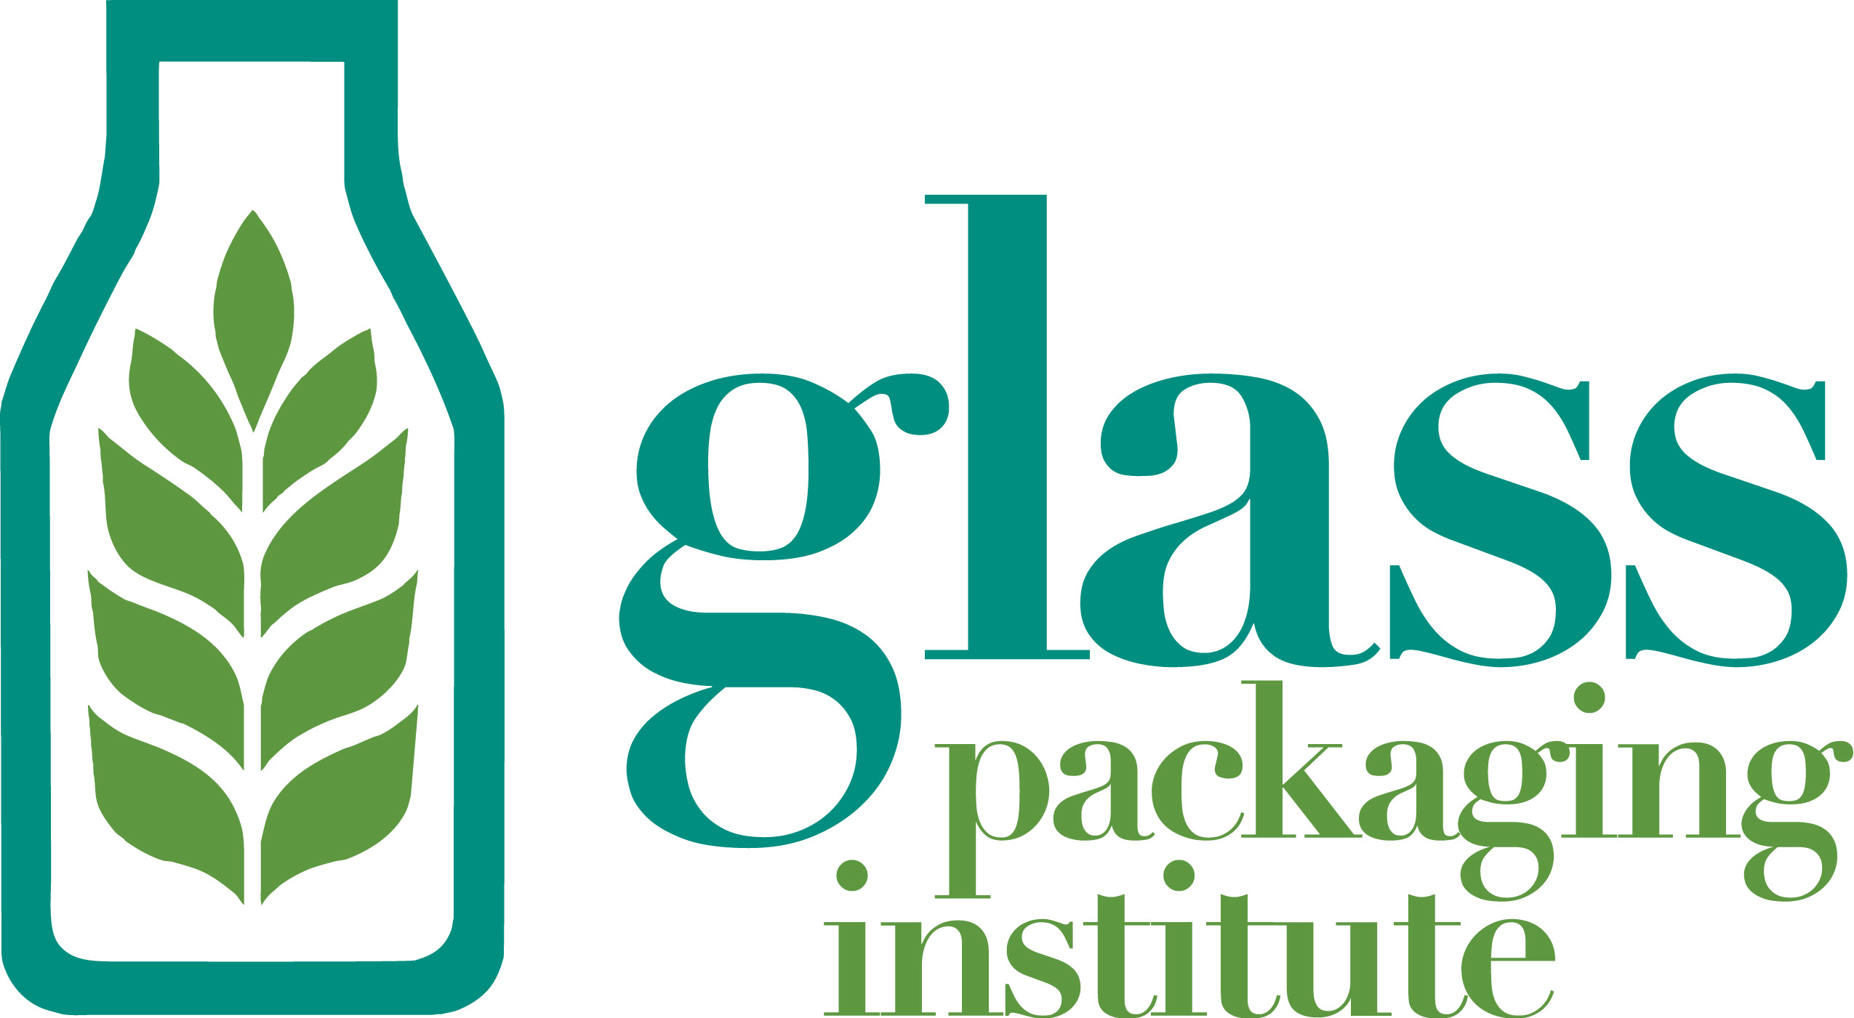

November 4, 2016

California Air Resources Board
1001 I Street
Sacramento, CA 95814

The Glass Packaging Institute (GPI) provides the following comments to the October 14, 2016 ARB issued Cap-and-Trade Regulation Industry Assistance Factor Calculation Informal Staff Proposal.

The Glass Packaging Institute (GPI) previously submitted comments to the Initial Statement of Reasons on September 19th, 2016. In our comments, we emphasized the importance of maintaining a 100% industry assistance factor to prevent leakage in the container glass sector. Unfortunately, staff’s informal proposal for post-2020 allocation of allowances would provide only a 76% assistance factor for container glass manufacturers.

This recommendation, if finalized, will have a significant and potentially devastating impact on the California glass container manufacturing industry, our industry’s four plants, and over 2,000 workforce employees with high paying, benefit provided manufacturing careers.

As we noted in our September 19 letter, California’s container glass industry competes directly with out of state and international glass plants. Any lost productivity in California’s container glass industry as a result of the Cap-and-Trade program will result directly in increase in production of glass containers at these facilities, which are often less regulated than California facilities. This conclusion is born out in studies commissioned by the Board to assess the leakage impact of the program.

Specifically, as highlighted in the May 16, 2016 Final Report to CARB on Employment and Output Leakage under California’s Cap-and-Trade Program, “an increase in California energy prices relative to prices in nearby regions will raise production costs in energy-intensive industries located in California and likely result in short-term (one year) losses in output, employment, and value added for those industries.”

The Report (p. 16) clearly states that no EITE industry participant is impacted more by leakage than glass container manufacturers, who are anticipated to lose significantly in terms of output (17.10%) and jobs (13.31%). These losses will only be exacerbated by future increases in the cost of energy.

According to data culled from the U.S. Census Bureau, Datamyne ® and internal company estimates:

- California glass container demand is 1.7 million tons annually, representing 20% of the total US glass demand.

- Imports account for a significant share of the California glass container supply (28% in California, versus 13% nationally)

- The value of glass containers imported into California in 2009 was $210 million USD. For 2015, this value more than doubled to $510 million USD.

According to data collected by the US International Trade Commission (ITC) 2.1 billion additional containers were imported into the US in 2015, then in 2008. Nationally, imports of glass containers have increased 3-5% annually since 2008.

Our industry’s trade exposure requires a 100% industry assistance factor to avoid leakage.

Even with a 100% industry assistance factor, California’s glass container manufacturers must reduce emissions to meet its compliance obligations since allowance allocations will continue to decline over time regardless of the assistance factor. In short, providing a 100% assistance factor to the container glass industry does not in any way jeopardize the state’s GHG reduction goals or give industry a free pass on compliance. Instead, it helps minimize the risk of jobs leakage.

In consideration of the unique, increasing, ongoing and competitive pressures surrounding the California glass container industry, we are requesting 100% industry assistance for the duration of the Cap and Trade program.

Thank you for your thoughtful consideration of our comments.

Sincerely,
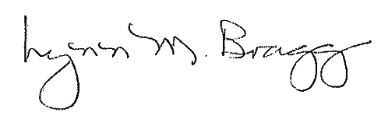
Lynn M. Bragg
President

