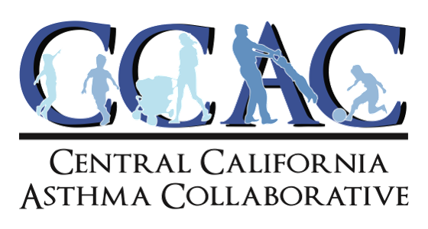

The CARB Board should direct staff to incorporate the policy changes identified in the first resolution adopted by the permanent Environmental Justice Advisory Committee. The EJAC carefully considered the issues and invested its time, expertise, and energy to provide thoughtful recommendations to address the environmental injustice inflicted by the LCFS.

Staff appear more concerned with protecting profits for producers of and investors in factory farm gas than achieving actual and substantial environmental benefits through the LCFS. Our flagship climate and transportation programs should be solely focused on improving air quality, greenhouse gas reductions, and environmental justice. Ensuring a return on investments and protecting lavish subsidies is not and should not be part of CARB’s mission. Unfortunately, it seems to be in this program.

Prioritizing environmental justice as CARB has proclaimed it does actually mean far, far more than giving EJ leaders a seat at the EJAC table while ignoring their well-founded recommendations. As it stands, EJ communities are at the table at EJAC and here today, but we are still on the menu.

The CARB Board must provide leadership and direct staff to incorporate the EJAC’s resolution into the proposed regulations. Otherwise, the LCFS will sacrifice environmental justice communities for factory farm gas and hydrogen production.

Kimberly McCoy
Climate & Environmental Justice Associate
Central California Asthma Collaborative

