
California Environmental Protection Agency

Air Resources Board

Staff Report: Initial Statement of Reasons for proposed rulemaking

Proposed Regulatory Amendments Extending the California Standards for Motor Vehicle Diesel Fuel to Diesel Fuel Used in Harborcraft and Intrastate Locomotives

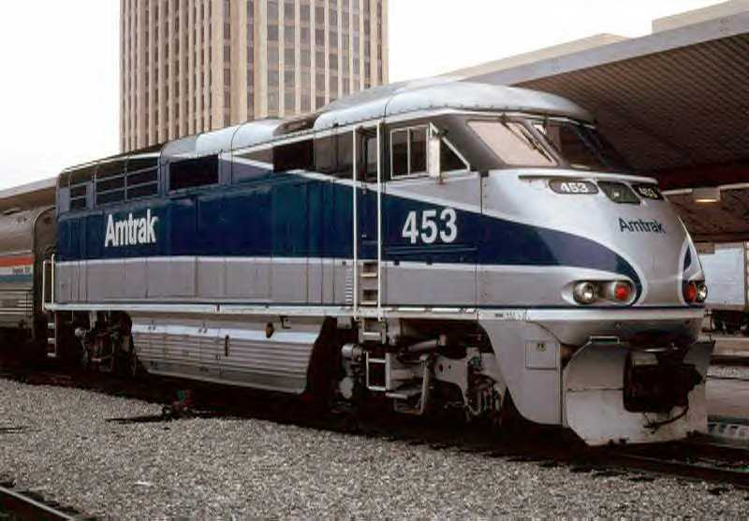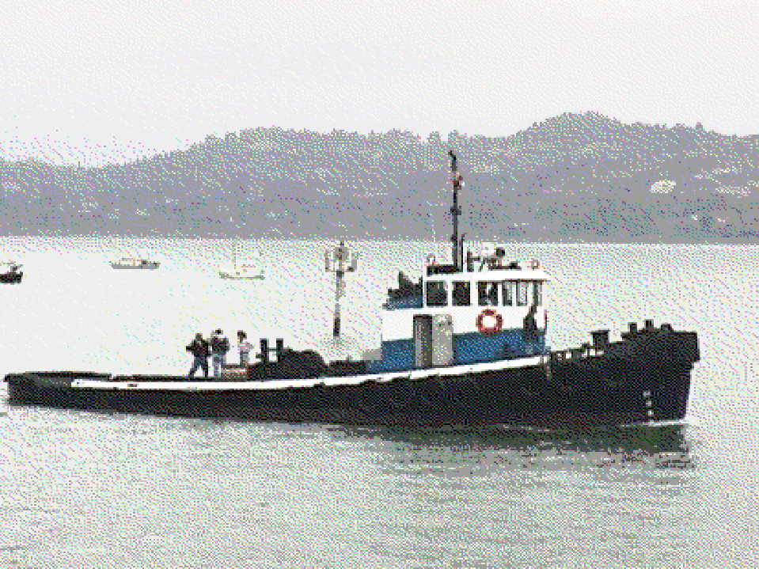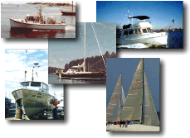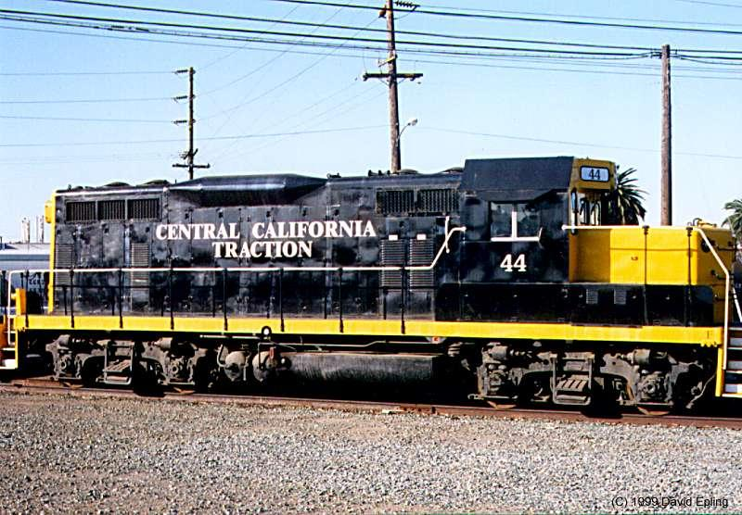

Release Date: October 1, 2004

State of California

California Environmental Protection Agency
AIR RESOURCES BOARD
Stationary Source Division

STAFF REPORT: INITIAL STATEMENT OF REASONS

Public Hearing to Consider Proposed Regulatory Amendments Extending the California Standards for Motor Vehicle Diesel Fuel to Diesel Fuel Used in Harborcraft and Intrastate Locomotives

Date of Release: October 1, 2004
Scheduled for Consideration: November 18-19, 2004

Location:

California Air Resources Board
Central Valley Auditorium, Second Floor
1001 I Street
Sacramento, California 95814

This report has been reviewed by the staff of the Air Resources Board and approved for publication. Approval does not signify that the contents necessarily reflect the views and policies of the Air Resources Board, nor does mention of trade names or commercial products constitute endorsement or recommendation for use. This report is available for viewing or downloading from the Air Resources Board’s Internet site: http://www.arb.ca.gov/regact/carblohc/carblohc.htm

Acknowledgments

This report was prepared with the assistance and support from the other divisions and offices of the Air Resources Board. In addition, we would like to acknowledge the assistance and cooperation that we have received from many individuals and organizations.

Principal Authors

Harold Holmes, Engineering Evaluation Section
Paul Milkey, Technical Analysis Section
Gloria Lindner, Fuels Section

Contributing Authors:
Tim Dunn, Engineering Evaluation Section
Chan Pham, Fuels Section
Kirk Rosenkranz, Technical Analysis Section
Reza Mahdavi, Economic Studies Section
Pingkuan Di, Technical Analysis Section
Walter Wong, Off-Road Modelling and Assessment Section
David Salardino, Off-Road Controls Section
Joann Lu, Health and Ecosystems Assessment Section
Andrew Panson, SIP Development Section
Win Setiwan, Fuels Section
James Guthrie, Fuels Section
Cherie Rainforth, Industrial Section
Todd Sterling, Technical Analysis Section
Tom Jennings, Office of Legal Affairs

Reviewed by:

Michael Scheible, Deputy Executive Officer
Peter D. Venturini, Chief, Stationary Source Division
Robert Barham, Assistant Division Chief, Stationary Source Division
Dean C. Simeroth, Chief, Criteria Pollutants Branch
Daniel Donohoue, Chief, Emission Assessment Branch
Peggy Taricco, Manager, Technical Analysis Section
Erik C. White, Manager, Engineering Evaluation Section

Table of Contents
I. Introduction and Summary 1
A. Introduction 1
1. What are Intrastate Diesel-Electric Locomotives? 1
2. What are Commercial and Recreational Harborcraft? 2
B. What are the Specifications for Diesel Fuel in California? 4
1. Sulfur and Aromatic Hydrocarbon Standards 4
2. Lubricity Standard 4
C. What are the Specifications for Diesel Fuel in the Rest of the Nation? 5
1. On-Road Diesel Fuel 5
2. Nonroad Diesel Fuel 6
D. What are the Emission Benefits of California Diesel Fuel? 6
E. Are there Any Current Diesel Fuel Requirements for Intrastate Diesel-Electric Locomotives and Harborcraft? 6
F. What are the Current Properties of In-Use Diesel Fuel? 6
G. What Type of Diesel Fuel are Intrastate Diesel-Electric Locomotives and Harborcraft Currently Using? 7
1. Fuel Consumption by Fuel Type for Intrastate Locomotives 7
2. Fuel Consumption by Fuel Type for Harborcraft 8
3. Total Fuel Consumption and Fuel Type for Both Intrastate Locomotives and Harborcraft 10
H. What are the Proposed Amendments? 11
I. Why are These Regulations Being Proposed? 11
1. Need for Emission Reductions 11
2. ARB Board Direction 12
3. Diesel Risk Reduction Plan 12
4. State Implementation Plan - 2003 State and Federal Strategy and 2003 South Coast State Implementation Plan 13
5. Governor's Action Plan for California's Environment 14
J. What Alternatives Were Considered? 14
K. Do the Proposed Amendments Satisfy Commitments in the State Implementation Plan? 15
L. What Are the Emission Impacts of the Proposed Amendments? 15
M. What are the Environmental Impacts of the Proposed Amendments? 16
1. Air Quality 16
2. Greenhouse Gas Emissions 16
3. Refinery Modifications 17
N. What are the Anticipated Impacts of the Proposed Amendments on California Diesel Fuel Supply? 17
O. What are the Overall Costs of the Proposed Amendments? 17
P. Are the Proposed Regulations Cost-Effective? 18
Q. What are the Economic Impacts of the Proposed Regulations? 18
II. Recommendations 19
III. Existing Diesel Fuel Regulations and Diesel Fuel Quality 21
A. California Diesel Fuel Regulations 21
1. Sulfur Standard 21
2. Aromatic Hydrocarbon Standard 21
3. Lubricity Standard 22
B. Federal Diesel Fuel Regulations 22
1. Federal On-Road Diesel Fuel 22
2. Federal Nonroad Diesel Fuel 23
C. SCAQMD Rule 431.2 23
D. Texas Diesel Fuel Regulations 24
E. Properties of In-Use Diesel Fuel 24
IV. Need for Emissions Reductions 27
A. Criteria Pollutants 27
1. One-Hour Ozone Standard 27
2. Eight-Hour Ozone Standard 27
3. PM 28
B. Governor's Action Plan for California's Environment 29
C. State Implementation Plan Commitments 30
1. State Implementation Plan - 2003 State and Federal Strategy and 2003 South Coast SIP 30
D. Toxic Air Contaminants 31
1. Components of Diesel Exhaust 31
2. Potential Cancer Risk 32
V. Health Benefits of Diesel Emissions Reductions 35
A. Diesel Exhaust 35
1. Diesel PM 35
B. Health Impacts of Exposure to Diesel Exhaust 36
C. Health Impacts of Exposure to Diesel PM 37
D. Health Impacts of Exposure to Ozone 37
E. Health Benefits of Reductions of Diesel Exhaust Emissions 38
1. Reduced Ambient PM Levels 38
2. Reduced Ambient Ozone Levels 38
VI. Intrastate Locomotives: Operations, Fuel Consumption, and Emission Studies 39
A. Diesel-Electric Locomotives 39
1. Definition of a Diesel-Electric Locomotive 39
2. Use of Engine Power on a Diesel-Electric Locomotive 39
3. Differences Between Motor Vehicles and Diesel-Electric Locomotive Engines 39
4. Use of Hotel Power on Passenger Trains 40
B. Types of Railroads that Operate in California 40
1. Class I Freight Railroads 42
2. Passenger Railroads 42
3. Class II Railroads 42
4. Class III Railroads 42
5. Industrial and Military Locomotives 43
C. CARB Intrastate Locomotive Survey on Operations and Fuel Consumption 43
D. California's Intrastate Locomotive Population 44
1. Class I Railroads 44
2. Passenger (Commuter) Trains 45
3. Class III Railroads 46
4. Industrial and Military Locomotives 46
E. Fuel Consumption for California's Intrastate Locomotives 47
F. Interstate Locomotive Activities in California 48
1. Interstate Locomotive Fuel Consumption 48
2. Interstate Locomotive Emission Inventory 49
G. Summary of the Benefits of Clean Fuels in Diesel-Electric Locomotives 50
1. NOx 50
2. SOx 51
3. PM 51
VII. Harborcraft - California Operations and Emissions 53
A. Types of Harborcraft Operating in California 53
B. Harborcraft Operational Range 54
C. Harborcraft Distinction from Oceangoing Ships 56
D. Types of Engines Used in Commercial Harborcraft 56
E. Fuel Consumption in Commercial and Recreational Harborcraft 59
F. Benefits of Clean Fuels in Harborcraft 60
VIII. Proposed Amendments for Intrastate Locomotives 61
A. Diesel Fuel Sold to Intrastate Locomotive Operators Statewide Beginning January 1, 2007 61
B. Alternative Emission Control Plan 61
C. Definitions for Intrastate Locomotives 62
1. Definition of a Diesel-Electric Locomotive 62
2. Definition of an Intrastate Locomotive 62
D. Structure of the regulations 63
IX. Proposed Amendments for Commercial and Recreational Harborcraft 65
A. Diesel Fuel Sold to Harborcraft Operators in the SCAQMD Beginning January 1, 2006. 65
B. Diesel Fuel Sold to Harborcraft Operators Statewide Beginning January 1, 2007 65
C. Definition of Commercial and Recreational Harborcraft 66
D. Structure of the regulations 66
X. Alternatives Considered 67
A. Alternatives Considered for Intrastate Locomotive Diesel Fuel 67
B. Alternatives Considered for Harborcraft Diesel Fuel 67
XI. Environmental Effects of the Proposed Amendments to the Diesel Fuel Regulations 69
A. Legal Requirements Applicable to Analysis 69
B. Effects on Air Quality 70
1. Reduced Ambient Ozone Levels 70
2. Reduced Ambient PM Levels 70
3. Reduced Ambient Sulfur Dioxide Levels 70
4. Enabling Advanced Control Technologies 71
C. Current Emission Inventory 71
1. Intrastate Locomotives 71
2. Commercial and Recreational Harborcraft 72
D. Anticipated Emission Reductions 73
1. Emission Reductions from Intrastate Locomotives 73
2. Emission Reductions from Harborcraft 74
3. Total Emission Reductions for Intrastate Locomotives and Harborcraft 75
E. Effects on Greenhouse Gas Emissions 76
F. Impacts on the SIP in the South Coast and San Joaquin Valley 77
1. Harborcraft 78
2. Intrastate Locomotives 78
G. Health Benefits of Reductions of Diesel PM Emissions 78
1. Primary Diesel PM 79
2. Secondary Diesel PM 80
3. Additional Benefits 80
H. Potential Exposures and Risk from Diesel PM Emissions from Diesel-Fueled Locomotives and Harborcraft 80
1. Potential Exposures 80
2. Health Risk Assessment 81
I. Effects on Water Quality 82
J. Retrofitting of Intrastate Locomotives and Harborcraft 83
XII. Potential Impacts of the Proposed Amendments on the Availability of California Diesel Fuel 85
A. Diesel Production in California Refineries 85
B. Diesel Capacity of California Refineries 86
XIII. Cost Analysis 89
A. Costs to produce CARB diesel fuel 89
B. Effects of Staff’s Proposal on Fuel Prices 89
1. Evaluation of spot fuel prices for various grades of diesel fuel 90
C. Other benefits from the use of low sulfur diesel fuel 91
D. Anticipated costs to intrastate locomotive and harborcraft diesel fuel end users 92
1. Staff’s estimate of anticipated costs 92
2. Estimate of anticipated costs based on comments from affected industry 93
E. Cost-Effectiveness 94
1. Sensitivity of cost-effectiveness to CARB diesel fuel production cost increases 95
F. Costs of Alternative Proposals Considered 96
XIV. Economic Impacts of the Proposed Amendments 99
A. Potential Impacts on the California Economy 99
B. Potential Impacts on the California Petroleum Sector 99
C. Potential Impacts on Intrastate Locomotive Operators 99
1. Class I Railroads 99
2. Passenger and Commuter Railroads 100
3. Class III Railroads 101
D. Potential Impacts on Harborcraft Operators 101
E. Economic Effects on Small Businesses 102

LIST OF TABLES

Table I-1: Number of California Intrastate Locomotives 2
Table I-2: Number of California Commercial Harborcraft 3
Table I-3: California Diesel Fuel Standards 4
Table I-4: U.S. EPA Diesel Fuel Standards 5
Table I-5: Average 1999 Properties of Reformulated Diesel Fuel 7
Table I-6: Intrastate Locomotive Diesel Fuel Consumption by Type of Railroad 7
Table I-7: Intrastate Locomotives Diesel Fuel Consumption by Region 8
Table I-8: Harborcraft Fuel Consumption by Type of Vessel 9
Table I-9: Harborcraft Fuel Consumption by Region 10
Table I-10: Fuel Consumption for Intrastate Locomotives and Harborcraft 10
Table I-11: 2003 Statewide NOx, SOx, and PM Emissions from Intrastate Locomotives and Commercial and Recreational Harborcraft 15
Table I-12: 2007 Anticipated Statewide NOx, SOx, and PM Emissions Reductions from Intrastate Locomotives and Harborcraft 16
Table III-1: CARB Diesel Fuel Standards 21
Table III-2: U.S. EPA Diesel Fuel Standards 23
Table III-3: Average 1999 Properties of Reformulated Diesel Fuel 24
Table IV-1: Statewide Population-Weighted Annual Outdoor Average Diesel PM Concentration for 1990, 2000, 2010, and 2020 32
Table VI-1: Profile of Class I Railroad Intrastate Locomotives 45
Table VI-2: Profile of Passenger Train Intrastate Locomotives 45
Table VI-3: Profile of Class III Railroad Intrastate Locomotives 46
Table VI-4: Intrastate Locomotive Diesel Fuel Consumption by Region 47
Table VI-5: Intrastate Locomotive Diesel Fuel Consumption By Type of Railroad 48
Table VI-6: Class I Freight Locomotive Fuel Consumption in California 49
Table VI-7: Interstate Locomotive Emission Inventory 49
Table VI-8: SWRI Locomotive Test Program: Key Diesel Fuel Properties 50
Table VI-9: NOx Emissions Comparison - ARB Test Fuel vs. Others 51
Table VII-1: Commercial Harborcraft Use 54
Table VII-2: Propulsion Engine Horsepower 57
Table VII-3: Quantity of Auxiliary Engines and Average Horsepower 58
Table VII-4: Harborcraft Fuel Consumption by Region 59
Table VII-5: Harborcraft Fuel Consumption by Type of Vessel 60
Table XI-1: Emission Inventory from Intrastate Locomotives by Type of Railroad 71
Table XI-2: Emission Inventory from Intrastate Locomotives by Region of the State 72
Table XI-3: Emission Inventory for Harborcraft by Region 72
Table XI-4: Emission Reductions from Intrastate Locomotives by Railroad Type 73
Table XI-5: Emission Reductions from Intrastate Locomotives by Region of State 74
Table XI-6: Emission Reductions for Harborcraft by Region of the State 75
Table XI-7: Emission Reductions from Intrastate Locomotives and Harborcraft by Regions 75
Table XI-8: Emission Reductions from Intrastate Locomotives and Harborcraft 76
Table XI-9: Greenhouse Gas Emissions from Diesel and Gasoline Consumption in the Transportation Sector in 1999 77
Table XIII-1: Potential Total Annual Statewide Costs by Year 93
Table XIII-2: Estimate of Potential Annual Costs Using Industry Methodology 94
Table XIII-3: Anticipated Cost-Effectiveness of the Proposed Amendments 95
Table XIV-1: National Operating Income of Class I Freight Railroads Operating in California 100
Table XIV-2: Added Annual Costs and Change in Return on Owner’s Equity for California Commercial Harborcraft Operators 102

LIST OF FIGURES

Figure IV-1 Federal and State Area Designations for One-Hour Ozone Standards 28
Figure IV-2 Federal and State Area Designations for PM₁₀ 29
Figure IV-3 Statewide Average Potential Cancer Risk from Outdoor Ambient Levels of Toxics for the Year 2000 33
Figure VI-1 California Class I and Class III Railroads 41
Figure VII-1 Percent of Vessel Hours Operated at Varying Distances from Shore 55
Figure VII-2 California Coastal Waters 55
Figure VII-3 Commercial Harborcraft Propulsion Engine Manufacturers 57
Figure VII-4 Harborcraft Auxiliary Engine Manufacturers 58
Figure XII-1 California Refinery Diesel Production (1998-2002) 85
Figure XII-2 Anticipated 2007 On-Road Diesel Production Compared to
2002 Actual Diesel Production 86
Figure XII-3 California Refiners’ Diesel Production Capacity
(2002 versus 2007) 87
Figure XIII-1 Incremental Spot Price Differential Between CARB and U.S. EPA
On-Road and Nonroad Diesel Fuel (1999-2003) 91
Figure XIII-2 Sensitivity of Cost-Effectiveness from Differences in Incremental
CARB Diesel Fuel Production Cost Estimates 96

APPENDICES
- Proposed Regulation Order for Proposed Regulatory Amendments Extending the California Standards for Motor Vehicle Diesel Fuel to Diesel Fuel Used in Harborcraft and Intrastate Locomotives
- Lists of California Railroads with Intrastate Locomotives
- ARB Survey Letter Mailed to California Railroads with Intrastate Locomotives
- California Harborcraft - Diesel Fuel Consumption
- California Harborcraft - Emission Inventory and Emissions Calculations
- California Harborcraft - Emissions Reductions Calculations
- ARB Health Risk Assessment for Harborcraft and Intrastate Locomotives
- References

Introduction and Summary

In this chapter, staff provides a summary and background for the proposed amendments.

Introduction

The California diesel fuel regulations, administered by the Air Resources Board (ARB or Board), have resulted in significant reductions in emissions from diesel-powered motor vehicles and equipment: greater than 80 percent for oxides of sulfur (SOx), 25 percent for PM (PM) (a toxic air contaminant), and 7 percent for oxides of nitrogen (NOx). Diesel fuel meeting ARB's requirements - often called CARB diesel - also results in reductions of emissions of several toxic substances other than diesel PM, including benzene and polynuclear aromatic hydrocarbons.

Diesel-electric locomotives and commercial and recreational harborcraft (harborcraft) are not currently required to use diesel fuel meeting the ARB's diesel fuel regulations. Currently, these regulations only apply to on- and off-road motor vehicles and, by December 12, 2004, non-vehicular sources other than locomotives and marine vessels.

This report is the initial statement of reasons to support the ARB staff’s (staff) proposed amendments to extend the requirements to use CARB diesel fuel to intrastate diesel-electric locomotives and commercial and recreational harborcraft.

What are Intrastate Diesel-Electric Locomotives?

Diesel-electric locomotives (locomotives) are defined as those locomotives that use electric power provided by a diesel engine that drives a generator or alternator; the electrical power produced then drives the wheels using electric motors. For the purposes of this rulemaking, intrastate locomotives are defined as those locomotives that operate 90 percent or more of the time within the boundaries of the state of California which can be measured by fuel consumption, hours of operation, or annual rail miles travelled. This definition provides some flexibility for locomotives primarily headquartered and operating in California, but that may leave the state occasionally for business or maintenance - up to 36 days per year.

Intrastate locomotives include, but are not limited to, locomotives used in the following operations:

- passenger intercity and commuter,
- short haul,
- short line,
- switch, and
- industrial, port, and terminal operations.
These locomotives are typically operated by:
- National Class 1 freight railroads (Union Pacific and Burlington Northern Santa Fe),
- Local, regional and switching & terminal shortline railroads (Class III) operating in California,
- national passenger rail companies under state contract (Amtrak), and
- local government transportation authorities (including CalTrain and MetroLink).

These four primary groups of railroads operate over 700 intrastate locomotives (see Table I-1 below). California's Class I freight railroads ¹ (i.e., Union Pacific Railroad (UP) and Burlington Northern Santa Fe (BNSF)), have over 380 intrastate locomotives that operate as short haul, switcher, terminal, or manifest locomotives within different regions of California. California's passenger railroads provide inter-city passenger services within the state and have 111 intrastate passenger locomotives (e.g., Metrolink in Southern California and CalTrain on the San Francisco Peninsula) and two additional switcher locomotives. Currently, there are twenty Class III railroads 2 that are headquartered and operate within California and which operate 120 intrastate locomotives as either short haul operators (e.g., San Joaquin Valley Railroad and California Northern Railroad) or switcher-terminal operators (e.g., Pacific Harbor Lines at Los Angeles/Long Beach Harbors and Modesto Empire Traction in Modesto). Also, there are about 120 locomotives operated by individual companies and the military services. These locomotives are typically less than 1,000 horsepower diesel-electric engines and generally are limited to operating in small company yards or on military bases.

Table I-1: Number of California Intrastate Locomotives

Type of Railroad | Number of Locomotives | Percent of Total
Class I - Freight | 383 | 52%
Class III - Shortline | 120 | 16%
Passenger | 113 | 16%
Industrial-Military | 117 | 16%
Total * | 733 | 100%
* Based on May 2004 ARB Intrastate Locomotive Survey, and other sources.

What are Commercial and Recreational Harborcraft?

Commercial and recreational harborcraft (harborcraft) are marine vessels that operate primarily along California’s coastline, and in inland waterways. They include a wide variety of vessels such as tug/tow boats, commercial fishing vessels, commercial passenger fishing vessels (“party boats”), pilot boats, work boats, crew/supply boats, ferries/excursion vessels, military vessels, and diesel powered recreational vessels.
Harborcraft are defined as all marine vessels except oceangoing ships. Oceangoing ships are distinct from harborcraft because they travel internationally, and would not have access to CARB diesel fuel at ports outside of California. However, these vessels are being addressed by other ARB rulemaking efforts currently under development.

Harborcraft are defined in the proposed amendments as any marine vessel that meets all of the following criteria:
- The vessel does not carry a “registry” (foreign trade) endorsement on their United States Coast Guard certificate of documentation, and is not registered under the flag of a country other than the United States;
- The vessel is less than 400 feet in length overall (LOA) as defined in 50 Code of Federal Regulations (CFR) § 679.2, as adopted June 19, 1996;
- The vessel is less than 10,000 gross tons (GT ITC) per the convention measurement (international system) as defined in 46 CFR 69.51 - 61, as adopted September 12, 1998; and
- The vessel is propelled by a marine diesel engine with a per-cylinder displacement of less than 30 liters.

Table I-2 below provides a breakdown by the number of vessels and percent of diesel fuel consumed for each sector of commercial harborcraft. As can be seen, commercial fishing vessels account for the largest number of vessels.

Table I-2: Number of California Commercial Harborcraft

Type of Vessel | Number of Vessels | Percent of Total
Commercial Fishing Boats | 2,520 | 64%
Charter Fishing Boats | 512 | 13%
Ferry/Excursion Boats | 412 | 11%
Tug Boats | 128 | 3%
Other | 136 | 3%
Work Boats | 87 | 2%
Crew Boats | 70 | 2%
Tow Boats | 35 | 1%
Pilot Boats | 24 | 1%
Total * | 3,924 | 100%
* Based on December 2002 ARB Commercial Harborcraft Survey, USCG, CDFG and other sources.

What are the Specifications for Diesel Fuel in California?

In this section, staff discusses the California Air Resources Board (CARB) diesel fuel specifications.

Sulfur and Aromatic Hydrocarbon Standards

California diesel fuel used in motor vehicles must meet specifications approved by the Board in 1988 limiting sulfur and aromatic contents. The requirements for “CARB diesel,” which became applicable in October 1993, consists of two basic elements:

- A limit of 500 parts per million by weight (ppmw) on sulfur content to reduce emissions of both sulfur dioxide and directly emitted PM.
- A limit on aromatic hydrocarbon content of 10 volume percent for large refiners and 20 percent for small refiners to reduce emissions of both PM and NOx.
At a July 2003 hearing, the Board approved changes to the California diesel fuel regulations that, among other things, lowered the maximum allowable sulfur levels in California diesel fuel to 15 ppmw beginning in June 2006. Thus, ARB's specifications for sulfur and aromatic hydrocarbons are shown in Table I-3.

Table I-3: California Diesel Fuel Standards

Implementation Date | Maximum Sulfur Level (ppmw) | Aromatics Level  (% by volume) | Cetane Index
1993 | 500 | 10 | N/A
2006 | 15 | 10 | N/A

The regulation limiting aromatic hydrocarbons also includes a provision that enables producers and importers to comply with the regulation by qualifying a set of alternative specifications of their own choosing. The alternative formulation must be shown, through emissions testing, to provide emission benefits equivalent to that obtained with a 10 percent aromatic standard (or in the case of small refiners, the 20 percent standard). Most refiners have taken advantage of the regulation’s flexibility to produce alternative diesel formulations that provide the required emission reduction benefits at a lower cost.

Lubricity Standard

At the July 2003 hearing, ARB also approved new requirements for minimum lubricity levels. The diesel fuel lubricity standard is designed to ensure that California diesel fuel provides adequate lubrication for fuel systems of existing and future diesel engines. Diesel fuel lubricity can be defined as the ability of diesel fuel to provide surface contact lubrication. The CARB diesel fuel first phase standard, a High Frequency Reciprocating Rig (HFRR) maximum scar diameter (WSD) of 520 microns, is appropriate for protecting existing hardware and is to be implemented on January 1, 2005. The American Society for Testing and Materials (ASTM) has approved an identical lubricity standard for the ASTM D-975 diesel fuel specifications that will become effective January 1, 2005. When Division of Measurement and Standards (DMS) adopts and begins enforcing the ASTM standard, the CARB diesel fuel first-phase standard will no longer apply.

The Board further directed staff to return in 2005 with a proposed 2006 lubricity standard if a technology assessment determines that a HFRR WSD of 460 microns at 60 degrees Celsius, or a more appropriate standard, should be implemented on the same schedule as the proposed 15-ppmw sulfur limit for diesel fuel on June 1, 2006.

What are the Specifications for Diesel Fuel in the Rest of the Nation?

The United States Environmental Protection Agency (U.S. EPA) has established separate diesel fuel specifications for on-road diesel fuel and off-road (nonroad) diesel fuel.

On-Road Diesel Fuel

The current U.S. EPA diesel fuel standards have been applicable since October 1993. The U.S. EPA regulation prohibits the sale or supply of diesel fuel for use in on-road motor vehicles, unless the diesel fuel has a sulfur content no greater than 500 ppmw. In addition, the regulation requires on-road motor-vehicle diesel fuel to have a cetane index of at least 40 or have an aromatic hydrocarbon content of no greater than 35 percent by volume (vol. %). All on-road motor-vehicle diesel fuel sold or supplied in the United States, except in Alaska, must comply with these requirements. Diesel fuel, not intended for on-road motor-vehicle use, must contain dye solvent red 164.

On January 18, 2001, the U.S. EPA published a final rule which specifies that, beginning June 1, 2006, refiners must begin producing highway diesel fuel that meets a maximum sulfur standard of 15 ppmw. All 2007 and later model year diesel-fueled vehicles must be fueled with this new low sulfur diesel. Both the current and future U.S. EPA on-road diesel fuel standards are shown in Table I-4.

Table I-4: U.S. EPA Diesel Fuel Standards

Applicability | Implementation Date | Maximum Sulfur Level (ppmw) | Aromatics Maximum  (% by volume) | Cetane Index  (Minimum)
On-road | 1993 | 500 | 35 | 40
On-Road | 2006 | 15 | 35 | 40
Nonroad * | 1993 | 5,000 | 35 | 40
Nonroad * | 2007 | 500 | 35 | 40
Nonroad, excluding loco/marine * | 2010 | 15 | 35 | 40
Nonroad, loco/marine * | 2012 | 15 | 35 | 40
* Nonroad diesel fuels must comply with ASTM No. 2 diesel fuel specifications for aromatics and cetane.

Nonroad Diesel Fuel

On June 29, 2004, the U.S. EPA published a final rule for the control of emissions from nonroad diesel engines and fuel. The U.S. EPA rulemaking requires that sulfur levels for nonroad diesel fuel be reduced from current uncontrolled levels ultimately to 15 ppmw, though an interim cap of 500 ppmw is contained in the rule. Beginning June 1, 2007, refiners would be required to produce nonroad, locomotive, and marine diesel fuel that meets a maximum sulfur level of 500 ppmw. This does not include diesel fuel for stationary sources. In 2010, nonroad diesel fuel will be required to meet the 15 ppmw standard except for locomotives and marine vessels. In 2012, nonroad diesel fuel used in locomotives and marine applications must meet the 15 ppmw standard. The nonroad diesel fuel standards are shown above in Table I-4.

What are the Emission Benefits of California Diesel Fuel?

The NOx emission benefits associated with the use of CARB diesel compared to U.S. EPA on-road and nonroad diesel fuels are due to the CARB aromatic hydrocarbon limit of 10 percent by volume or an emission equivalent alternative formulation limit. ARB staff estimates that use of CARB diesel provides a 6 percent reduction in NOx and a 14 percent reduction in particulate emissions compared with the use of U.S. EPA on-road and nonroad diesel fuels. In addition, CARB diesel fuel will provide over a 95 percent reduction in fuel sulfur levels in 2007 compared to U.S. EPA nonroad diesel fuel. This reduction in diesel fuel sulfur levels will provide SOx emission reductions, and additional PM emission reductions by reducing indirect (secondary formation) PM emissions formed from SOx.

Are there Any Current Diesel Fuel Requirements for Intrastate Diesel-Electric Locomotives and Harborcraft?

Currently, intrastate locomotives and marine vessels use diesel fuel meeting the minimum specifications for Number 2 diesel fuel, as specified by ASTM D-975.

What are the Current Properties of In-Use Diesel Fuel?

Table I-5 shows average values for sulfur and four other properties for motor vehicle diesel fuel sold in California before and after the current diesel fuel regulation became effective in 1993. The corresponding national averages are shown for the same properties for on-road diesel fuel only since the U.S. EPA sulfur standard does not apply to off-road or nonvehicular diesel fuel.

Table I-5: Average 1999 Properties of Reformulated Diesel Fuel

Property | California | U.S.⁽¹⁾
Sulfur, ppmw | 140⁽²⁾ | 360
Aromatics, vol.% | 19 | 35
Cetane No. | 50 | 45
PNA, wt.% | 3 | NA
Nitrogen, ppmw | 150 | 110
- U.S. EPA, December 2000.
- About 20 % of total California volume is less than 15 ppmw.

What Type of Diesel Fuel are Intrastate Diesel-Electric Locomotives and Harborcraft Currently Using?

California intrastate locomotives and harborcraft are currently using varying amounts of the three types of diesel fuel as discussed in this section.

Fuel Consumption by Fuel Type for Intrastate Locomotives

California's intrastate locomotives consumed an estimated 47 million gallons of diesel fuel in 2003 (as shown in Table I-6). Class I railroads consumed about 23.3 million gallons, or about 50 percent of California intrastate locomotive diesel fuel. California's passenger trains consumed an estimated 20.4 million gallons of diesel fuel, or 43 percent of the state's intrastate locomotive diesel fuel. Class III railroads in California consumed an estimated 3.3 million gallons, or 7 percent of the intrastate locomotive diesel fuel. CARB staff also estimates that 117 industrial and military intrastate locomotives may consume an additional 1 to 3 million gallons of diesel fuel.

Table I-6: Intrastate Locomotive Diesel Fuel Consumption by Type of Railroad
(Millions of Gallons)

Type of Railroad | CARB  Low Sulfur | CARB | U.S. EPA  On-road | U.S. EPA  Nonroad | Total
Class I Freight | 0 | 6.4 | 16.9 | 0 | 23.3
Passenger/Commuter | 5.8 | 14.1 | 0.5 | 0 | 20.4
Class III | 0 | 2.1 | 0.9 | 0.3 | 3.3
Total | 5.8 | 22.6 | 18.3 | 0.3 | 47.0

Currently, of the diesel fuel consumed by intrastate locomotives, about 60 percent is either CARB diesel or low sulfur CARB diesel fuel (CARB diesel fuel already meeting the new 15 ppmw sulfur cap) and about 39 percent of the diesel fuel consumed is U.S. EPA on-road highway diesel fuel. Staff estimates that less than 1 percent of the diesel fuel now consumed by California's intrastate locomotives is U.S. EPA nonroad diesel fuel with in-use sulfur levels of 3,000 ppmw or higher.

As can be seen in Table I-7, the South Coast Air Quality Management District (SCAQMD) accounts for about 40 percent (19 million gallons) of the intrastate locomotive diesel fuel consumption. However, the SCAQMD's diesel fuel consumption is nearly split in half between CARB and low sulfur CARB diesel fuels, and U.S. EPA on-road diesel fuel. The other air districts with large proportions of the intrastate locomotive diesel fuel consumption are the Bay Area with 18 percent (8.5 million gallons), the San Joaquin Valley Unified Air Pollution Control District (SJVUAPCD) with 17 percent (8 million gallons), Mojave Desert with 8 percent (4 million gallons), and the Sacramento Area with 6 percent (2.9 million gallons). These five air districts combined account for about 90 percent of the intrastate locomotive diesel fuel consumption statewide.

Table I-7: Intrastate Locomotives Diesel Fuel Consumption by Region
(Millions of Gallons)

Region | CARB  Low Sulfur | CARB | U.S. EPA  On-road | U.S. EPA  Nonroad | Total
South Coast | 5.0 | 3.9 | 10.1 | 0 | 19.0
Bay Area | 0 | 8.1 | 0.4 | 0 | 8.5
San Joaquin | 0 | 4.3 | 3.5 | 0.2 | 8.0
Mojave Desert | 0 | 0.6 | 3.3 | 0 | 3.9
Sacramento Area | 0 | 2.9 | 0 | 0 | 2.9
San Diego | 0.8 | 0.1 | 0 | 0 | 0.9
Rest of State | 0 | 2.7 | 1.0 | 0.1 | 3.8
Total * | 5.8 | 22.6 | 18.3 | 0.3 | 47.0
* may not add due to rounding.

Fuel Consumption by Fuel Type for Harborcraft

Harborcraft are estimated to consume nearly 90 million gallons of diesel fuel annually, as shown in Table I-8. Ferries and excursion passenger boats account for the largest amount (36 percent) of the harborcraft statewide diesel fuel consumption, and an existing state law already requires ferries to use CARB diesel fuel. The next largest harborcraft category for diesel fuel consumption is commercial fishing (20 percent), followed by tugboats (14 percent), and charter fishing boats (11 percent). Combined, these four harborcraft categories are responsible for over 80 percent of the harborcraft diesel fuel consumed statewide.

Table I-8: Harborcraft Fuel Consumption by Type of Vessel
(Millions of gallons)

Type of Vessel | CARB | U.S. EPA  On-Road | Total
Commercial (CHC)*
Ferry/Excursion | 31.5 | 0 | 31.5
Commercial Fishing | 4.5 | 12.9 | 17.4
Tugs | 0.2 | 12.4 | 12.6
Charter Fishing | 0.5 | 9.3 | 9.8
Tow Boats | 0.0 | 4.7 | 4.7
Crew and Supply | 0.3 | 3.4 | 3.7
Work Boats | 0.1 | 1.4 | 1.5
Pilot | 0 | 0.7 | 0.7
Other | 0 | 0.5 | 0.4
Recreational Craft** | 0.1 | 4.9 | 4.9
Total *** | 37 | 50 | 87
* Commercial fuel consumption estimates based on 2002 ARB Commercial Harborcraft Survey.
** Recreational fuel consumption estimates based on 2003 ARB Emissions Inventory (See Appendix D)
*** Numbers may not add due to rounding.

As Table I-9 illustrates, most of the state's harborcraft diesel fuel occurs in the Bay Area (32 percent) and the SCAQMD (29 percent). Combined, these two air districts account for over 60 percent of the state's harborcraft diesel fuel consumption. Staff estimates that about 43 percent of the harborcraft diesel fuel consumption consists of CARB diesel, with the other 57 percent being U.S. EPA on-road diesel fuel.
Table I-9: Harborcraft Fuel Consumption by Region
(Millions of gallons)

Type of Vessel | CARB | U.S. EPA  On-Road | Total
Commercial Harborcraft (CHC)*
S.F. Bay Area Air Basin | 10.2 | 16.8 | 27.0
South Coast Air Basin | 10.8 | 13 | 23.8
North Coast Air Basin | 6.0 | 0 | 6.0
All Other Areas | 10.0 | 15.5 | 25.5
Total CHC | 37.0 | 45.3 | 82.3
Recreational Craft**
S.F. Bay Area Air Basin | 0 | 0.4 | 0.4
South Coast Air Basin | 0 | 1.8 | 1.8
North Coast Air Basin | 0.1 | 0 | 0.1
All Other Areas | 0 | 2.7 | 2.7
Total Recreational Craft | 0.1 | 4.9 | 5
Harborcraft Total *** | 37 | 50 | 87
* Commercial fuel consumption estimates based on 2002 ARB Commercial Harborcraft Survey.
** Recreational fuel consumption estimates based on 2003 ARB Emissions Inventory (See Appendix D).
*** Numbers may not add due to rounding.

Total Fuel Consumption and Fuel Type for Both Intrastate Locomotives and Harborcraft

As can be seen in Table I-10, intrastate locomotives and harborcraft combined consumed an estimated 134 million gallons of diesel fuel annually. Of the diesel fuel consumed by intrastate locomotives and harborcraft, an estimated 51 percent is U.S. EPA on-road diesel fuel, and nearly 49 percent is CARB or CARB low sulfur diesel fuel, and less than 1 percent is U.S. EPA nonroad diesel fuel. In 2003, the California Energy Commission (CEC) estimates that California consumed approximately 3 billion gallons of diesel fuel. The combined intrastate locomotive and harborcraft diesel fuel consumption represents about 4.5 percent of the total 2003 diesel fuel consumption in California.

Table I-10: Fuel Consumption for Intrastate Locomotives and Harborcraft
(Millions of gallons)

TYPE OF OPERATION | CARB | U.S. EPA On-Road | U.S. EPA Nonroad | Total
Intrastate Locomotives | 28.4 | 18.3 | 0.3 | 47.0
Commercial and Recreational Harborcraft | 37.0 | 50.0 | 0 | 87.0
Total * | 65.4 | 68.3 | 0.3 | 134
* Numbers may not add due to rounding.

What are the Proposed Amendments?

ARB staff is proposing that, beginning January 1, 2007, diesel fuel sold, supplied, or offered for sale to California intrastate locomotive and harborcraft operators statewide be required to meet the specifications for vehicular diesel fuel, as specified in title 13, California Code of Regulations (CCR), sections 2281, 2282, and 2284.

Staff is also proposing that diesel fuel sold, supplied, or offered for sale to harborcraft operators within the South Coast Air Quality Management District (SCAQMD) be required to meet California motor vehicle diesel fuel standards beginning January 1, 2006. This control measure would satisfy commitments contained in the SCAQMD SIP.

For the proposed amendments, staff is proposing that California intrastate locomotives be defined as those locomotives that operate at least 90 percent of the time within the borders of the state, based on hours of operation, miles traveled, or fuel consumption. Staff is proposing to not include in the definition of California intrastate locomotives those line-haul locomotives meeting the U.S. EPA’s “Tier II” locomotive emission standards (for both NOx and PM) which primarily move freight into and out of the SCAQMD. In addition, staff is investigating means to encourage the early introduction of Tier II locomotives in the rest of the state and may propose additional recommendations to the Board at the hearing. Staff is also proposing that harborcraft be defined as those marine vessels that purchase diesel fuel in California and which do not meet prescribed "oceangoing vessel" definitions.

To provide additional flexibility to affected intrastate locomotive operators, operators of intrastate locomotives would have the option of participating in an alternative emission control plan (AECP). The AECP provisions would allow the owner or operator of an intrastate diesel-electric locomotive to submit for approval by the Executive Officer a substitute fuel and/or emission control strategy. The substitute fuel and/or emission control strategy must achieve equivalent or greater reductions than those achieved solely through compliance with California reformulated diesel fuel standards, and adequate enforcement provisions would be required. Further, there must be a detailed analysis to ensure adequate environmental protections have been provided for environmentally sensitive and impacted areas (e.g., Los Angeles Harbor area).

Staff is also presenting the proposed amendments to the Board for consideration as an airborne toxic control measure (ATCM) for applicability through the non-vehicular diesel fuel standards.

Why are These Regulations Being Proposed?

The proposed amendments to the California diesel fuel regulations are based on a number of actions, programs, and commitments undertaken by the Board and Governor Schwarzenegger.

Need for Emission Reductions

Over 90 percent of Californians breathe unhealthy air. California’s mobile source and fuels programs, more than any other pollution control effort, have helped to move the state’s nonattainment areas closer to meeting federal and state air quality standards. The combination of fuels and vehicle emissions regulations provide significant statewide reductions in emissions of carbon monoxide (CO), fine particulates or PM₁₀, SOx, and ozone precursors -- NOx and volatile organic compounds (VOCs). Nevertheless, significant additional reductions in mobile source emissions are essential if the state is to attain and maintain the state and national ambient air quality standards.

Diesel PM is a major contributor to potential ambient risk levels. In 2000, the average potential cancer risk associated with diesel PM emissions was estimated at over 500 potential cases per million. This diesel PM cancer risk accounted for approximately 70 percent of the ambient air toxics cancer risk.

The SCAQMD Multiple Air Toxics Exposure Study II (MATES II) estimated that the average potential cancer risk in the South Coast Air Basin from diesel PM was about 1,000 excess cancers per million people, or 71 percent of the average cancer risk from all air toxics in the South Coast Air Basin. Localized or near-source exposures to diesel exhaust, such as might occur near busy roads and intersections, will present much higher potential risks.

ARB Board Direction

The CARB diesel fuel regulations currently apply to all on-road and off-road diesel engines except stationary engines, locomotives, and marine vessels. In July 2003, the Board approved amendments to the CARB diesel fuel regulations lowering the allowable sulfur levels to a maximum of 15 ppmw effective June 1, 2006. Approval of the CARB low sulfur diesel fuel regulations included extending the existing CARB diesel (sulfur limit - 500 ppmw) requirements to nonvehicular (i.e., stationary) sources beginning December 12, 2004. In addition, the low sulfur (15 ppmw) CARB diesel fuel regulations will apply to all diesel engines (i.e., mobile and stationary) beginning on June 1, 2006. However, locomotives and marine vessels will continue to be exempted from the CARB diesel fuel regulations in 2006. Based on a number of public comments received at the July 2003 hearing, the Board directed staff to evaluate and report back on the feasibility of requiring the use of CARB diesel fuel in locomotives and marine vessels.

At the October 2003 hearing, staff reported to the Board that while interstate locomotives and oceangoing vessels consume much of the fuel dispensed into them from facilities outside out of the country or in other states, intrastate locomotives and harborcraft are typically a captive fleet. As such, intrastate locomotives and harborcraft would be good candidates for the use of CARB diesel fuel, as the emission benefits derived from the fuel would be realized within the state. As a result of this hearing, the Board directed staff to develop a regulatory proposal targeting the use of CARB diesel fuel by intrastate locomotives and harborcraft.

Diesel Risk Reduction Plan

In August 1998, the ARB identified PM emitted from diesel engines (diesel PM) as a Toxic Air Contaminant (TAC). Because of the considerable potential health risks posed by exposure to diesel PM, ARB staff recommended a comprehensive plan, the Diesel Risk Reduction Plan (DRRP), to further reduce diesel PM emissions and the health risks associated with such emissions. This plan seeks to reduce Californians’ exposure to diesel PM and associated cancer risks from baseline levels in 2000 by 85 percent by 2020.

In October 2000, the DRRP was approved by the ARB. The plan identified air toxic control measures and regulations that will set more stringent emissions standards for new diesel-fueled engines and vehicles, establish retrofit requirements for existing engines and vehicles where determined to be technically feasible and cost-effective, and require the sulfur content of diesel fuel to be reduced to no more than 15 ppmw. The proposed regulation is an important component towards meeting the diesel risk reduction goals set out in the DRRP.

The emission reductions obtained from the proposed amendments will result in lower ambient PM levels and significant reductions of exposure to primary and secondary diesel PM. Lower ambient PM levels and reduced exposure, in turn, would result in a reduction of the prevalence of the diseases attributed to PM and diesel PM, including hospitalizations for cardio-respiratory disease, and premature deaths. ARB staff estimates approximately 71 premature deaths would be avoided by 2010 and cumulatively 233 deaths by 2020 as a result of the emission reductions of primary and secondary PM obtained through the proposed regulations.

State Implementation Plan - 2003 State and Federal Strategy and 2003 South Coast State Implementation Plan

On October 23, 2003, ARB adopted the Proposed 2003 State and Federal Strategy for the California State Implementation Plan (Statewide Strategy). The Statewide Strategy identifies the Board’s near-term regulatory agenda to reduce ozone and PM by establishing enforceable targets to develop and adopt new measures for each year from 2003 to 2006, including commitments for the Board to consider 19 specific measures. In addition to meeting federal requirements, the Statewide Strategy ensures continued progress towards California’s own health-based standards.

ARB and local air districts are in the process of updating the California State Implementation Plan (SIP) to show how each region in the state will meet the federal air quality standards. The measures outlined in the adopted Statewide Strategy are being incorporated into these SIP revisions. The South Coast’s 2003 Air Quality Management Plan was adopted by the SCAQMD Governing Board on August 1, 2003. ARB approved the local SIP element on October 23, 2003, and on January 9, 2004, ARB submitted to U.S. EPA both the Statewide Strategy and the 2003 SCAQMD SIP as revisions to the California SIP. As part of the Statewide Strategy, the ARB committed to:

- The use of cleaner fuels for harborcraft in Measure Marine-1: Pursue Approaches to Clean Up the Existing Harborcraft Fleet – Cleaner Engines and Fuels. One element of this SIP measure would require the use of cleaner diesel fuel in harborcraft operating in California.

- While no new defined controls for locomotives are included in the 2003 South Coast SIP, Board Resolution 03-22 directs staff to evaluate approaches to reduce emissions from in-use locomotives, passenger rail, and switcher and short haul locomotives.

Governor's Action Plan for California's Environment

As part of Governor Schwarzenegger’s action plan for California's environment, he has committed to protecting and restoring California’s air quality through an initiative to cut air pollution statewide by up to 50 percent. Through this initiative, the Governor has stated:

“Breathing clean and healthy air is a right of all Californians, especially our children, whose health suffers disproportionately when our air is polluted. The future health of California's environment and economy depend on our taking action now.”3

One component of the Governor’s action plan for California’s environment includes expediting the use of clean fuel transportation in the state. This includes the early introduction of cleaner, low-sulfur diesel fuels. Staff’s proposed amendments meet this commitment through the introduction of low-sulfur CARB diesel fuel for use by the California intrastate locomotive and harborcraft marketplace, nearly six years earlier than mandated by the U.S. EPA.

What Alternatives Were Considered?

Staff evaluated five alternatives to the proposed amendments for intrastate locomotives and commercial and recreational harborcraft that included:
- Not extending CARB diesel fuel requirements to diesel fuel for use by intrastate locomotives (in which case the fuel would still be subject to U.S. EPA nonroad diesel fuel standards).
- Not requiring any diesel fuel for use by Class III railroads locomotives to have to comply with the CARB diesel fuel requirements.
- Not requiring diesel fuel for use by certain rural Class III railroads locomotives, not operating in ozone non-attainment areas, to have to comply with the CARB diesel fuel requirements until June 1, 2012.
- Requiring diesel fuel for use by all intrastate locomotives in the SCAQMD to meet the CARB diesel fuel standards by January 1, 2006, with diesel fuel for use by intrastate locomotives and harborcraft in the rest of the state to be subject to the CARB diesel fuel standards by January 1, 2007.
- Making diesel fuel for use by all harborcraft and all interstate and intrastate locomotives subject to the CARB diesel fuel requirements.

In considering the alternatives identified above, staff concluded that the first three would not provide needed emission reductions, for both the SIP and overall improvements in air quality, above those that would be realized through implementation of only the U.S. EPA nonroad diesel fuel program.

Staff believes that the additional CARB diesel fuel demand created by the fourth alternative could put excessive strain on the diesel fuel supply in the SCAQMD in 2006, during the transition to 15 ppmw CARB and U.S. EPA on-road diesel fuels. The fifth alternative would not assure emission reductions as interstate locomotives have the potential to change existing fuel patterns. This might increase the purchase of U.S. EPA nonroad diesel fuel prior to entering California, reducing the potential benefits of this option.

A discussion of the cost and emission impacts of these alternatives is provided in Chapter XIII.

Do the Proposed Amendments Satisfy Commitments in the State Implementation Plan?

In this section, staff examines the impacts of the proposed amendments on the SIPs for both the SCAQMD and SJVUAPCD.

ARB staff estimates that the proposed amendments would reduce NOx emissions by about 0.4 tons per day from harborcraft in the SCAQMD in 2010. The harborcraft NOx emission reductions would provide the first increment of progress toward fulfilling ARB’s commitment for Measure Marine-1: Pursue Approaches to Clean Up the Existing Harborcraft Fleet – Cleaner Engines and Fuels in the 2003 SCAQMD SIP. Under measure Marine-1, ARB anticipates reducing 2010 South Coast harborcraft NOx emissions by a total of 2.7 tons per day. In addition to providing immediate NOx emission reductions, the low sulfur (15 ppmw) CARB diesel fuel will enable the use of exhaust treatment devices on harborcraft engines, another element of measure Marine-1.

ARB staff also estimates that the proposed amendments would reduce NOx emissions by about 0.3 tons per day from intrastate locomotives in the SCAQMD in 2010 and 0.2 tons per day in the San Joaquin Valley. However, these new NOx emission reductions, except for those from passenger trains and the Class III railroads, are not directly creditable towards ARB’s commitments in the 2003 SCAQMD SIP due to commitments in the Memorandum of Understanding between the SCAQMD and railroads. However, in areas outside of the SCAQMD (e.g., San Joaquin Valley), these emission reductions would be creditable.

What Are the Emission Impacts of the Proposed Amendments?

As illustrated in Table I-11, intrastate locomotives and harborcraft combined generate over 57 tons per day of NOx emissions and about 2 tons per day each of PM and SOx emissions statewide.

Table I-11: 2003 Statewide NOx, SOx, and PM Emissions from Intrastate Locomotives and Commercial and Recreational Harborcraft
(tons per day)

Source | NOx | SOx | PM
Intrastate Locomotives | 38.4 | 0.3 | 0.9
Commercial and Recreational Harborcraft | 19.8 | 1.9 | 1.1
Total * | 58.2 | 2.2 | 2.0
* Numbers may not add due to rounding.

With staff’s proposed amendments, the use of CARB diesel fuel will provide significant reductions in NOx, PM (both directly emitted and secondary), and SOx. The reduction of diesel PM will also provide a reduction in the risk associated with the general public’s exposure to diesel PM. However, the net emission reduction benefits derived from the use of CARB diesel is somewhat reduced due to intrastate locomotives and harborcraft currently using a significant level (approximately half of their existing fuel consumption) of CARB diesel or CARB low sulfur diesel fuels.

Table I-12: 2007 Anticipated Statewide NOx, SOx, and PM Emissions Reductions from Intrastate Locomotives and Harborcraft
(tons per day)

Source | NOx | SOx | PM
Source | NOx | SOx | Direct | Indirect
Intrastate Locomotives | 1.0 | 0.3 | 0.1 | 0.1
Commercial and Recreational Harborcraft | 1.0 | 1.5 | 0.1 | 0.3
Total * | 2.0 | 1.8 | 0.2 | 0.4
* numbers may not add due to rounding.

As can be seen in Table I-12, NOx emissions would be reduced by about 3.5 percent, or about 2 tpd, for those sources not currently using CARB diesel fuel. Direct diesel PM emissions would be reduced by, on average, about 9 percent, or about 0.2 tpd in 2007. SOx emissions will be reduced by nearly 1.8 tpd, or by about 95 percent. This reduction in SOx will provide a corresponding reduction of about 0.4 tpd of indirectly emitted PM.

What are the Environmental Impacts of the Proposed Amendments?

Air Quality

Sulfur in diesel fuel contributes to ambient levels of fine PM through the formation of sulfates both in the exhaust stream of the diesel engine and later in the atmosphere. Therefore, reducing the sulfur limit of CARB diesel fuel from 500 ppmw to 15 ppmw will have a positive air quality impact by reducing ambient levels of PM. In addition, the aromatic hydrocarbon specification in the CARB diesel fuel regulations provides significant reductions in the emissions of NOx and PM. As NOx emissions are a precursor to ozone emissions, reduction of NOx emissions will reduce ozone levels. In addition, reducing NOx emissions will help to reduce secondary PM formation (i.e., nitrate aerosols). Reductions in emissions of diesel PM mean reduced ambient levels of the toxic air contaminants found in diesel exhaust and reduced public exposure to those TACs.

Greenhouse Gas Emissions

Implementation of the proposed amendments could have a small effect on global warming. The production of lower sulfur, lower aromatic diesel is expected to increase slightly emissions of greenhouse gases. To the extent that CARB diesel fuel will displace U.S. EPA on-road diesel fuel used in intrastate locomotives and harborcraft, emissions of CO₂ from refineries may increase slightly due to the increased demand for energy for additional hydrogen production and additional processing to produce lower aromatic diesel fuel. Emissions from refineries of other greenhouse gases like methane and nitrous oxide will be very small compared to other carbon dioxide emissions.

Refinery Modifications

The proposed amendments are not expected to require any additional refinery modifications beyond those already anticipated by refiners to comply with the CARB low sulfur (15 ppmw) diesel fuel standards on June 1, 2006.

What are the Anticipated Impacts of the Proposed Amendments on California Diesel Fuel Supply?

The proposed regulations should not affect the ability of California refiners to supply sufficient quantities of diesel fuel to the California diesel fuel market. Based on recent refinery surveys by the ARB and CEC, as well as with conversations with California refiners, it appears that sufficient California diesel fuel refinery capacity already exists. In considering the impact of the proposed amendments on diesel fuel supply, it should be noted that a significant quantity of diesel fuel meeting the California diesel fuel standards is already being used. As such, the true impact of the proposed amendments will be a shift of the incremental demand of diesel fuel being used by intrastate locomotive and harborcraft operators that currently meets the U.S. EPA (either on-road or nonroad) diesel fuel standards to CARB diesel fuel. This incremental demand, estimated to be about 4.5 thousand barrels per day (68.6 million gallons per year), is within the existing California diesel fuel production capacity.

In addition, the implementation of the U.S. EPA on-road low sulfur (15 ppmw) diesel fuel regulations, adoption of the CARB diesel fuel regulations by the state of Texas for on-road and nonroad sources (including locomotives and marine vessels), and the ability of out-of-state refiners to produce diesel fuel meeting California standards should provide even greater assurance of diesel fuel availability to California. Therefore, the overall diesel fuel production system – consisting of California refineries and imports – should not be impacted after the implementation of the proposed regulations.

What are the Overall Costs of the Proposed Amendments?

In evaluating the potential costs of the proposed amendments, staff has considered the likely diesel fuels expected to be generally available in California in 2007. Based on the fact that intrastate locomotive and harborcraft operators will likely use, at a minimum, U.S. EPA on-road diesel fuel meeting a 15 ppmw sulfur limit, even without ARB requirements, staff has determined the costs of the proposed amendments based on the incremental cost in 2007 to produce CARB diesel fuel relative to U.S. EPA on-road diesel fuel.

Staff estimates that the incremental cost to produce CARB diesel fuel relative to U.S. EPA on-road diesel fuel will be about 3 cents per gallon. This is the incremental cost to reduce the aromatic hydrocarbon content of U.S. EPA on-road diesel fuel from a limit of 35 volume percent to a limit of 10 volume percent (or an equivalent formulation limit). Staff estimates that the overall statewide costs of the proposed amendments could be $2 to $3 million dollars annually.

Staff has also identified several cost benefits to diesel fuel end users from the proposed amendments that have not been quantified in the above production cost estimates. These benefits will be felt both initially, and over the course of the life of the program. Initially, diesel fuel users are expected to see a decrease in engine wear as a result of low sulfur diesel fuel. In addition, lower sulfur fuels should increase the life of diesel engine lubrication oil, as fuel sulfur tends to increase the acidification of engine lubricating oils resulting in loss of pH control. By reducing the diesel fuel sulfur content, it is expected that the interval between oil changes can be extended, leading to a cost saving to diesel engine operators.

Are the Proposed Regulations Cost-Effective?

The cost-effectiveness of the proposed amendments in 2006 in the SCAQMD ranges between $0.80 and $1.10 per pound of NOx plus PM reduced. In 2007, when the proposed amendments are fully implemented statewide, the cost-effectiveness ranges between $1.10 and $1.60 per pound of NOx plus PM reduced. This is in the range of other recent criteria pollutant control measures approved by the Board.

What are the Economic Impacts of the Proposed Regulations?

The proposed regulations are not expected to have a significant impact on the overall California economy. Staff also evaluated the potential economic impact on intrastate locomotive and harborcraft operators. The analysis concluded that there would be very minor economic impacts on these operators. Staff also found that there should be no significant adverse effect on small businesses because of the cost impacts of the proposed amendments.

Recommendations

The staff recommends that the Board adopt the proposed amendments to the CARB diesel regulations and the airborne toxics control measure (ATCM) as contained in Appendix A. These amendments will do the following:

- Beginning January 1, 2006, require that diesel fuel supplied, sold, or offered for sale for use in harborcraft in the SCAQMD meet the standards of vehicular diesel fuel, as set forth in title 13, CCR, sections 2281, 2282, and 2284.
- Beginning January 1, 2007, require that diesel fuel supplied, sold, or offered for sale for use in any intrastate locomotive and harborcraft statewide meet the standards of vehicular diesel fuel, as set forth in title 13, CCR, sections 2281, 2282, and 2284.
- Allow intrastate locomotive operators to enter into an agreement with the Executive Officer for an alternative emission control plan (AECP) which would provide equivalent or better emission reductions than through compliance with the supply and sale requirements for California diesel fuel.

Existing Diesel Fuel Regulations and Diesel Fuel Quality

This chapter presents a summary of state, federal, and local diesel fuel regulations that affect the quality of diesel fuel consumed in California.

California Diesel Fuel Regulations

“CARB diesel” is diesel fuel that meets the ARB’s regulations controlling the sulfur and aromatic contents of diesel fuels used in motor vehicles. CARB diesel fuel must also meet the requirements of the California Division of Measurement Standards (DMS), the ASTM D-975 diesel fuel specifications, and have a minimum cetane number of 40. About 90 percent of the diesel fuel sold or supplied in California meets the CARB diesel requirements. Beginning on December 12, 2004, CARB diesel fuel requirements will apply to nonvehicular sources except for locomotives and marine vessels. Beginning on June 1, 2006, CARB diesel low sulfur (15 ppmw) requirements will apply to vehicular and nonvehicular sources, except locomotives and marine vessels. The requirements of the CARB diesel fuel regulations are summarized in Table III-13.

Table III-13: CARB Diesel Fuel Standards

Implementation Date | Maximum Sulfur Level (ppmw) | Aromatics Level  (% by volume) | Cetane Index  Number-Min.
1993 | 500 | 10 * | 40
2006 | 15 | 10 * | 40
* or meet alternative formulation that provides equivalent emission benefits to that obtained with a 10 percent aromatic standard.

Sulfur Standard

Section 2281 of Title 13, CCR regulates the sulfur content of vehicular diesel fuel sold or supplied in California. This standard was approved by the ARB in 1988 and was implemented in October 1993 statewide. All diesel fuel sold or supplied in California for motor-vehicle use must have a sulfur content no greater than 500 ppmw. At a July 2003 hearing, the Board approved changes to the CARB diesel fuel regulations that, among other things, lowered the maximum allowable sulfur levels in California motor vehicle diesel fuel to 15 ppmw beginning on June 1, 2006.

Aromatic Hydrocarbon Standard

Section 2282 of Title 13, CCR regulates the aromatic hydrocarbon content of vehicular diesel fuel sold or supplied in California. Like the specification for maximum sulfur levels in diesel fuel, the aromatic hydrocarbon standard was approved by the Board in 1988 and implemented in October 1993. The aromatic hydrocarbon content of vehicular diesel sold or supplied in California must not exceed 10 percent by volume for large refiners. Small refiners are allowed to meet a less stringent 20 percent limit on aromatic hydrocarbons.

The regulation limiting aromatic hydrocarbons also includes a provision that enables diesel fuel producers and importers to comply with the regulation by qualifying a set of alternative specifications of their own choosing. The alternative formulation must be shown, through emissions testing, to provide emission benefits equivalent to that obtained with a 10 percent aromatic standard (or in the case of small refiners, the 20 percent standard). Most refiners have taken advantage of the regulation’s flexibility to produce alternative diesel formulations that provide the required emission reduction benefits at a lower cost.

Lubricity Standard

The Board approved a lubricity standard (Section 2284, Title 13, CCR) at a July 2003 public hearing, along with the CARB low sulfur (15 ppmw) diesel fuel regulations, in order to ensure that CARB diesel fuel provides adequate lubrication for fuel systems of existing and future diesel engines. The CARB diesel fuel first phase lubricity standard is appropriate for protecting existing hardware and is to be implemented January 1, 2005. The ASTM has approved a lubricity standard for the D-975 diesel fuel specifications that will become effective January 1, 2005. This ASTM standard is identical to the ARB first-phase standard. The ARB and ASTM approved standard is at least as protective as the current voluntary standard to protect current in-use engines. When DMS adopts and begins enforcing the ASTM standard, the ARB first-phase standard will no longer apply.

Diesel fuel lubricity can be defined as the ability of diesel fuel to provide surface contact lubrication. Adequate levels of fuel lubricity are necessary to protect the internal contact points in fuel pumps and injection systems to maintain reliable performance. The levels of natural lubricity agents in diesel fuel are expected to be reduced by the more severe hydrotreating needed to lower the sulfur content of diesel fuel to meet the CARB low sulfur (15-ppmw) limit in 2006. Lubricity additives are available to increase the lubricity of fuels that have had their natural lubricity agents depleted.

The Board’s resolution approving the first phase lubricity standard directed staff to conduct a technical assessment, to be completed in 2005, to determine an appropriate 2006 lubricity standard. The Board’s resolution further directed staff to return to the Board in 2005 with a proposed 2006 lubricity standard if the technology assessment determines that a High Frequency Reciprocating Rig (HFRR) maximum wear scar diameter (WSD) of 460 microns at 60 degrees C, or a more appropriate standard, should be implemented on the same schedule as the CARB diesel fuel low sulfur (15-ppmw) limit in 2006.

Federal Diesel Fuel Regulations

Federal On-Road Diesel Fuel

The current U.S. EPA diesel fuel standards have been applicable since October 1993. The U.S. EPA regulation – 40 Code of Federal Regulations (CFR) §80.29 – prohibits the sale or supply of diesel fuel for use in on-road motor vehicles, unless the diesel fuel has a sulfur content no greater than 500 ppmw. In addition, the regulation requires on-road motor-vehicle diesel fuel to have a cetane index of at least 40 or have an aromatic hydrocarbon content of no greater than 35 percent by volume (vol. %). All federal on-road motor-vehicle diesel fuel sold or supplied in the United States, except in Alaska, must comply with these requirements. Diesel fuel, not intended for on-road motor-vehicle use, must contain dye solvent red 164.

On January 18, 2001, the U.S. EPA published a final rule which specifies that, beginning June 1, 2006, refiners must begin producing on-road highway diesel fuel that meets a maximum sulfur standard of 15 ppmw. The requirements are contained in 40 CFR §§80.500 et seq. The specifications for U.S. EPA on-road diesel fuel are shown in Table III-14 below.

Table III-14: U.S. EPA Diesel Fuel Standards

Applicability | Implementation Date | Maximum Sulfur Level (ppmw) | Aromatics Maximum  (% by volume) | Cetane Index  (Minimum)
On-road | 1993 | 500 | 35 | 40
On-Road | 2006 | 15 | 35 | 40
Nonroad * | 1993 | 5,000 | 35 | 40
Nonroad * | 2007 | 500 | 35 | 40
Nonroad, excluding loco/marine * | 2010 | 15 | 35 | 40
Nonroad, loco/marine * | 2012 | 15 | 35 | 40
* Nonroad diesel fuels must comply with ASTM No. 2 diesel specifications for aromatics and cetane.

Federal Nonroad Diesel Fuel

On June 29, 2004, the U.S. EPA published a final rulemaking for the control of emissions from nonroad diesel engines and fuel. The U.S. EPA rulemaking requires that sulfur levels for nonroad diesel fuel be reduced from current uncontrolled levels ultimately to 15 ppmw, though an interim cap of 500 ppmw is contained in the rule. Beginning June 1, 2007, refiners would be required to produce nonroad, locomotive, and marine diesel fuel that meets a maximum sulfur level of 500 ppmw. The federal nonroad diesel fuel rule does not apply to stationary sources. Beginning June 1, 2010, the maximum sulfur level is 15 ppmw for diesel fuel used by nonroad sources, excluding locomotives and marine vessels. In 2012, nonroad diesel fuel used in locomotives and marine applications must meet the low sulfur (15 ppmw) standard. The nonroad diesel fuel standards are shown above in Table III-14.

It is important to note that for both the federal on-road and nonroad diesel fuel regulations, U.S. EPA has not established an aromatic hydrocarbon content (or equivalent property) specification. Accordingly, neither the federal on-road or nonroad diesel fuels provide the same level of emission reductions (for both NOx and PM) achieved through the use of CARB diesel fuel.

SCAQMD Rule 431.2

Health and Safety Code Section 40447.6 authorizes the SCAQMD to adopt regulations that specify the composition of diesel fuel manufactured for sale in the SCAQMD, subject to ARB approval. In September 2000, the SCAQMD amended Rule 431.2 to define low sulfur diesel fuel as having a sulfur content no higher than 15 ppmw. For mobile sources (locomotives and marine vessels are specifically exempted from this rule), Rule 431.2 prohibits the supply, sale or offer for sale of any diesel fuel for any mobile source application in the District, unless the diesel fuel meets the definition of low sulfur diesel fuel (sulfur content is 15 ppmw or less), beginning June 1, 2006. However, Rule 431.2 does not require the use of diesel fuel meeting the aromatic hydrocarbon or lubricity specifications of CARB diesel fuel, as specified in title 13, CCR, sections 2282 and 2284, respectively.

Texas Diesel Fuel Regulations

In June 2000, Texas Commission on Environmental Quality (TCEQ) incorporated California's CARB diesel fuel requirements into their SIP and extended the CARB diesel fuel requirements to on-road and nonroad sources, including locomotives and marine vessels. TCEQ rules 114.312-114.319 require that beginning on April 1, 2005, that diesel fuel produced within 114 counties around the Houston-Galveston areas of Texas meet the 500 ppmw maximum sulfur levels and the 10 percent aromatics hydrocarbon content limit or equivalent emissions benefits. Beginning on June 1, 2006, the TCEQ regulations lower the CARB diesel fuel sulfur limit to 15 ppmw to be consistent both with the U.S. EPA and CARB diesel fuel sulfur requirements. TCEQ also includes an Alternative Emission Reduction Plan (AERP) component which can provide fuel producers with the flexibility to comply with both gasoline and diesel limits as long as a substitute fuel strategy provides equivalent emissions benefits.

Properties of In-Use Diesel Fuel

Under the provisions for CARB diesel fuel alternative formulations, the ARB has certified CARB diesel fuel for use in California that typically has a lower sulfur content than 500 ppmw and a higher aromatic content than 10 percent. The average sulfur content of California diesel fuel sold in California has been about 140 ppmw (see Table III-15). Excluding the small refiners’ fuel production, the average has been about 120 ppmw. About 20 percent of the motor vehicle diesel fuel currently produced in California has a sulfur content of 15 ppmw or less.

Table III-15 shows the average values for sulfur and four other fuel properties for motor vehicle fuel sold in California before and after the current diesel fuel regulation became effective in 1993. The corresponding national averages are shown for the same properties for U.S. EPA on-road diesel fuel only since the U.S. EPA sulfur standard does not apply to off-road or nonvehicular diesel fuel.

Table III-15: Average 1999 Properties of Reformulated Diesel Fuel

Property | California | U.S.⁽¹⁾
Sulfur, ppmw | 140⁽²⁾ | 360
Aromatics, vol.% | 19 | 35
Cetane No. | 50 | 45
PNA, wt.% | 3 | NA
Nitrogen, ppmw | 150 | 110
- U.S. EPA, December 2000.
- About 20 % of total California volume is less than 15 ppmw.
As can be seen from Table III-3 above, in-use CARB diesel fuel has higher cetane and has lower density, aromatics, and sulfur content than U.S. EPA on-road diesel fuel.

Need for Emissions Reductions

California’s mobile source and fuels programs have contributed significantly to the state’s nonattainment areas in making progress towards meeting both federal and state air quality standards. The combination of fuels and vehicle emissions regulations provide significant statewide reductions in emissions of CO, fine particulates (PM₁₀), SOx, and ozone precursors NOx and VOCs. Nevertheless, significant additional reductions in mobile source emissions are essential if the state is to attain the state and national ambient air quality standards.

As part of the ARB's Statewide SIP Strategy, the ARB has committed to a series of new measures to reduce emissions of VOC, NOx, and PM. The ARB has committed, among other things, to:

- pursue approaches to clean up the existing harborcraft fleet (SIP measure Marine-1), including the use of California on-road low sulfur diesel;
- evaluate approaches to reduce emissions from in-use locomotives;
- evaluate emission reductions for switcher and short-haul locomotives, and;
- reduce emissions from passenger rail

Criteria Pollutants

One-Hour Ozone Standard

As shown in Figure IV-1, most of the state does not meet the state or federal ozone standards. The areas that violate the national ozone standard are pursuing a strategy that reduces the emissions of precursors of ozone. Lowering ozone precursor emissions will also help reduce secondary PM formation.

California's plan for achieving the federal ozone standard is contained in the California SIP that was approved by the Board in 1994. A significant part of the emission reductions in the SIP is achieved by controlling vehicles and their fuels. Mobile source emissions, both on-road and off-road, account for about 70 percent of ozone precursor emissions in California with diesel engines contributing 24 percent to the statewide total in 2000. Further reductions from the current emissions levels of NOx and VOC are essential if California is to reach attainment for ozone.

Eight-Hour Ozone Standard

U.S. EPA designated nonattainment areas for the new eight-hour ozone standard effective June 15, 2004. In California, many of these areas are already nonattainment for the federal 1-hour standard. New nonattainment designations include a number of rural Sierra foothill counties and additional parts of the Sacramento Valley. This action starts the transition from the one-hour standard to the eight-hour standard. The one-hour standard will be revoked on June 15, 2005, one year after the effective date of the designation, and SIPs showing how each area will meet the eight-hour standard are due by 2007. In order to maintain progress towards clean air, the Clean Air Act prohibits backsliding on the control program. Since the eight-hour standard is more health-protective than the federal one-hour standard, ARB expects that California will need to reduce emissions beyond the existing one-hour SIP targets.

Figure IV-1: Federal and State Area Designations for One-Hour Ozone Standards

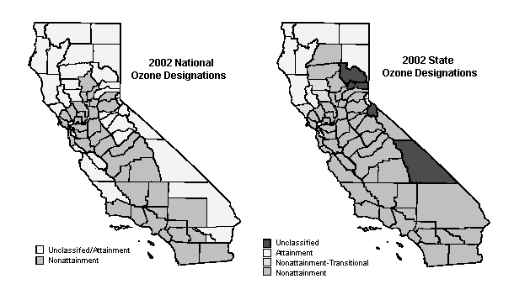

The greatest reductions are needed in the South Coast Air Basin. The SCAQMD revised its part of the ozone SIP in 1997, 1999, and in 2003. The 2003 SCAQMD ozone SIP revision calls for additional reductions beyond those incorporated in the 1997/1999 plan. These additional reductions are needed to offset increased emissions from mobile sources and meet all federal criteria pollutant standards within the time frames allowed under the Clean Air Act. The South Coast Air Basin is required to demonstrate attainment of the federal 1-hour ozone standard by 2010.

Significant reductions will also be needed in the San Joaquin Valley Air Basin which has been classified as severe nonattainment for ozone effective December 10, 2001. The San Joaquin Valley Air Basin is required to attain the ozone standards as expeditiously as possible, but no later than November 15, 2005. The San Joaquin Valley Air Basin cannot attain the one-standard by the required date but the District must reduce emissions by 3 percent per year on average and must continue to make progress toward attainment.

PM

Particulate pollution is a problem affecting much of California. The majority of California is designated as non-attainment for the state and federal fine particulate (PM₁₀) standards as shown in Figure IV-2. Only the Lake County Air Basin is designated as attainment in California and three counties in the northern half of the state remain unclassified. The nonattainment areas with serious problems will require substantial reductions of directly emitted PM₁₀ pollutants and PM₁₀ precursors. Also control of the emissions of ozone precursors should provide some small benefit due to the reduction in condensible PM₁₀ emissions from the organic ozone precursors. Control of NOx would also be effective in controlling ambient nitrate concentrations.

Figure IV-2: Federal and State Area Designations for PM₁₀.

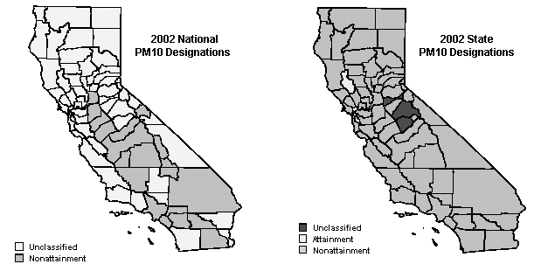

Governor's Action Plan for California's Environment

As part of Governor Schwarzenegger’s action plan for California environment, he has committed to protecting and restoring California’s air quality through an initiative to cut air pollution statewide by up to 50 percent. Through this initiative, the Governor has stated:

“Breathing clean and healthy air is a right of all Californians, especially our children, whose health suffers disproportionately when our air is polluted. The future health of California's environment and economy depend on our taking action now.”

One component of the Governor’s action plan for California’s environment includes expediting clean fuel transportation in the state. This includes the early introduction of cleaner, low-sulfur diesel fuels.

State Implementation Plan Commitments

State Implementation Plan - 2003 State and Federal Strategy and 2003 South Coast SIP

On October 23, 2003, ARB adopted the Proposed 2003 State and Federal Strategy for the California State Implementation Plan (Statewide Strategy) which reaffirms the ARB’s commitment to achieve health-based air quality standards through specific near-term actions and the development of additional longer-term strategies. The Statewide Strategy identifies the Board’s near-term regulatory agenda to reduce ozone and PM by establishing enforceable targets to develop and adopt new measures for each year from 2003 to 2006, including commitments for the Board to consider 19 specific measures. It also sets into motion a concurrent initiative to identify longer-term solutions to achieve the full scope of emission reductions needed to meet federal air quality standards in the South Coast, San Joaquin Valley, and the rest of California. In addition to meeting federal requirements, the Statewide Strategy ensures continued progress towards California’s own health-based standards.

ARB and local air districts are in the process of updating the California SIP to show how each region in the state will meet the federal air quality standards. The measures outlined in the adopted Statewide Strategy are being incorporated into these SIP revisions. The South Coast’s 2003 Air Quality Management Plan was adopted by the SCAQMD Governing Board on August 1, 2003. ARB approved the local SIP element on October 23, 2003, and on January 9, 2004, ARB submitted to U.S. EPA both the Statewide Strategy and the 2003 South Coast SIP as revisions to the California SIP. The new SIP updates all elements of the approved 1994 SIP. Upon approval by U.S. EPA, the 2003 SIP will replace the State’s commitments in the 1994 SIP. ARB is currently working with the SJVUPACD on a revision to the San Joaquin Valley’s ozone SIP. The revised San Joaquin Valley SIP is tentatively scheduled for consideration by the District’s Governing on Board October 8, 2004 and by ARB on October 28, 2004.

Together with significant reductions from cleaner engines, stationary industrial facilities, and other areawide sources, the use of cleaner fuels is an essential part of California’s effort to attain the air quality standards. In addition to providing direct emission benefits, cleaner fuels also enable more efficient use of exhaust treatment devices to further reduce emissions from existing engines.

Use of cleaner fuels for harborcraft is included in the Statewide Strategy and the 2003 South Coast SIP in Measure Marine-1: Pursue Approaches to Clean Up the Existing Harborcraft Fleet –Cleaner Engines and Fuels. One element of this SIP measure would require the use of cleaner diesel fuel in harborcraft operating in California.

To meet an emission reduction commitment for locomotives in the 1994 Ozone SIP for the South Coast, ARB and the two Class I freight railroads operating in California signed a memorandum of understanding (MOU) to ensure that the cleanest locomotive engines are brought to the South Coast Air Basin. Under the terms of the MOU, the use of cleaner fuels is one of the options for meeting the emission reduction targets. Any reductions achieved through use of cleaner fuels in the locomotives under the purview of the MOU could be credited toward the existing locomotive SIP commitment and may not be credited toward ARB’s new commitments under the 2003 SIP. However, emission reductions from the use of cleaner diesel fuels by passenger trains and Class III railroad intrastate locomotives is not covered by the MOU and could be creditable to the SIP. Thus, reductions from locomotives in other parts of California, such as the San Joaquin Valley, could also be credited in upcoming SIPs for those regions.

While no new defined controls for locomotives are included in the 2003 South Coast SIP, Board Resolution 03-22 directs staff to evaluate approaches to reduce emissions from in-use locomotives, passenger rail, and switcher and short haul locomotives not subject to the MOU.

In addition to the defined SIP measures, it is expected that further emission reductions will be needed from all source categories to meet the long-term emission reduction targets included in the South Coast SIP.

Toxic Air Contaminants

Components of Diesel Exhaust

Diesel exhaust is a complex mixture of inorganic and organic compounds that exist in gaseous, liquid, and solid phases. The composition of this mixture will vary depending on engine type, operating conditions, fuel, lubricating oil, and whether an emission control system is present.

Diesel engines operate with excess air (around 25-30 parts air to 1 part fuel). Consequently, the primary gas or vapor phase components of whole diesel exhaust are nitrogen (N₂), oxygen (O₂), carbon dioxide (CO₂), and water vapor (H₂O). Diesel exhaust also contains substances such as carbon monoxide (CO), NOx, SOx, hydrocarbons, PM, aldehydes, ketones, sulfates, cyanides, phenols, metals, and ammonia. These substances are unburned fuel and lubricant components, products of combustion, or are a result of engine wear or trace contaminants in the fuel and lubricating oil. Other gas phase components of diesel exhaust, are low-molecular mass polycyclic aromatic hydrocarbon (PAH) and nitro-PAH derivatives. Atmospheric reactions of these gas phase PAH and nitro-PAH derivatives may lead to the formation of several mutagenic nitro-PAH, and nitro-PAH compounds, including nitrodibenzopyranones, 2-nitroflouranthene and 2-nitropyrene.

Diesel exhaust contains over 40 substances that have been listed as TACs by the state of California and as hazardous air pollutants by the U.S. EPA. Fifteen of these substances are listed by the International Agency for Research on Cancer (IARC) as carcinogenic to humans, or as a probable or possible human carcinogen. The list includes the following substances: formaldehyde, acetaldehyde, 1,3-butadiene, antimony compounds, arsenic, benzene, beryllium compounds, bis(2-ethylhexyl)phthalate, dioxins and dibenzofurans, inorganic lead, mercury compounds, nickel, POM (including PAHs); and styrene.

Almost all of the diesel particle mass is in the fine particle (PM₁₀) fraction. However, approximately 95 percent of the mass of these fine particles is less than 2.5 microns in diameter. The particles have a very large surface area per unit mass which makes them excellent carriers for many of the organic compounds and metals found in diesel exhaust.

Potential Cancer Risk

In 1990, ARB staff reported the statewide population-weighted annual outdoor average diesel PM concentration as 3.0 μg/m³. Using this 1990 value for ambient concentrations, and assuming that the ratio of ambient concentration to statewide emissions remained constant, ARB staff calculated ambient diesel PM concentrations for 2000, 2010, and 2020. Estimates of statewide annual average ambient PM concentration are presented in Table IV-16 along with the corresponding percent reduction from the 1990 ambient concentration. Table IV-16 also shows estimates of the risks of contracting cancer from exposure to the indicated ambient diesel PM concentrations. The methodology for estimating these cancer risks is described in the ARB’s DRRP.

Diesel PM is a major contributor to potential ambient risk levels. In 2000, the average potential cancer risk associated with diesel PM emissions was estimated at over 500 potential cases per million. This diesel PM cancer risk accounted for approximately 70 percent of the ambient air toxics cancer risk (Figure IV-3).

In the SCAQMD's Multiple Air Toxics Exposure Study II (MATES II), it was estimated that the average potential cancer risk in the South Coast Air Basin from diesel PM was about 1000 excess cancers per million people, or 71 percent of the average cancer risk from all air toxics in the South Coast Air Basin. Localized or near-source exposures to diesel exhaust, such as might occur near busy roads and intersections, will present much higher potential risks.

Reducing the risk from diesel PM is essential to reducing overall public exposure to air toxics. The control measures proposed in the DRRP will result in an overall 85 percent reduction in the diesel PM inventory and the associated cancer risk by 2020.

Table IV-16: Statewide Population-Weighted Annual Outdoor Average Diesel PM Concentration for 1990, 2000, 2010, and 2020

 | 1990 | 2000 | 2010 | 2020
Outdoor Ambient  Concentration (μg/m³) | 3.0 | 1.8 | 1.5 | 1.2
Percent Reduction in Diesel PM from 1990 Concentration | N/A | 40% | 50% | 60%
Risk (cancers/million) | 900 | 540 | 450 | 360

Figure IV-3

State Average Potential Cancer Risk from
Outdoor Ambient Levels of Toxic Pollutants for the Year 2000

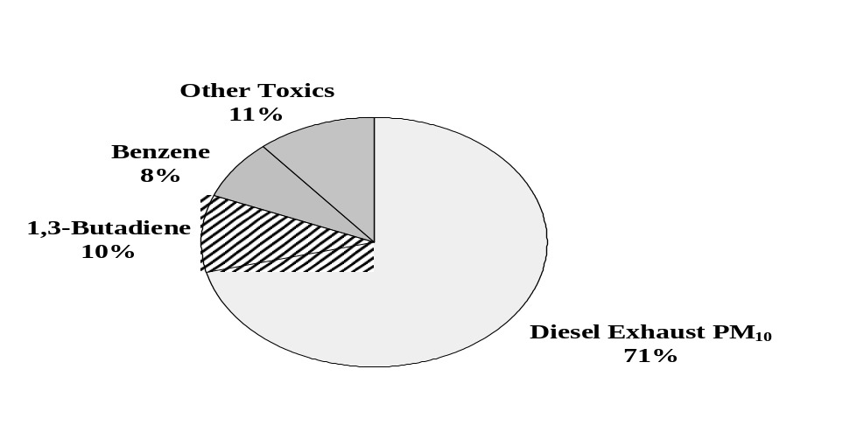

Health Benefits of Diesel Emissions Reductions

This chapter discusses the health effects of the pollutants emitted by diesel engines and the health benefits of the emissions reductions that would result from the use of CARB diesel fuel in intrastate locomotives and harborcraft. There would be health benefits through lower directly emitted diesel PM and ozone precursors. There would also be health benefits from the sulfate PM emissions reductions that result from the lowering of the sulfur limit to 15 ppmw. In addition, through the use of CARB low sulfur (15 ppmw) diesel fuel, there would be major health benefits from the reductions of emissions of NOx, diesel PM, and other toxic air contaminants from diesel engines equipped with exhaust aftertreatment systems.

Diesel Exhaust

Diesel exhaust is a complex mixture of inorganic and organic compounds that exist in gaseous, liquid, and solid phases. The composition of this mixture will vary depending on engine type, operating conditions, fuel, lubricating oil, and whether or not an emission control system is present. The primary gas or vapor phase components of diesel exhaust include typical combustion gases and vapors such as CO, CO₂, SO₂, NOx, reactive organic gases (ROG), water vapor, and excess air (nitrogen and oxygen). The emissions from diesel-fueled engines also contain potential cancer-causing substances such as arsenic, nickel, benzene, formaldehyde, and polycyclic aromatic hydrocarbons. Diesel exhaust includes over 40 substances that are listed by the U.S. EPA as hazardous air pollutants (HAPS) and by the ARB as toxic air contaminants (TACs). Fifteen of these substances are listed by the IARC as carcinogenic to humans, or as a probable or possible human carcinogen. The list includes the following substances: formaldehyde, acetaldehyde, 1,3-butadiene, antimony compounds, arsenic, benzene, beryllium compounds, bis(2-ethylhexyl)phthalate, dioxins and dibenzofurans, inorganic lead, mercury compounds, nickel, POM (including PAHs), and styrene.

Diesel PM

Diesel PM is either directly emitted from diesel-powered engines (primary PM) or is formed from the gaseous compounds emitted by a diesel engine (secondary PM). Diesel PM consists of both solid and liquid material and can be divided into three primary constituents: the elemental carbon fraction (ECF); the soluble organic fraction (SOF), and the sulfate fraction.

Many of the diesel particles exist in the atmosphere as a carbon core with a coating of organic carbon compounds, or as sulfuric acid and ash, sulfuric acid aerosols, or sulfate particles associated with organic carbon. The organic fraction of the diesel particle contains compounds such as aldehydes, alkanes and alkenes, and high-molecular weight PAH and PAH-derivatives. Many of these PAHs and PAH-derivatives, especially nitro-PAHs, have been found to be potent mutagens and carcinogens. Nitro-PAH compounds can also be formed during transport through the atmosphere by reactions of adsorbed PAH with nitric acid and by gas-phase radical-initiated reactions in the presence of oxides of nitrogen. Fine particles may also be formed secondarily from gaseous precursors such as SO₂, NOx, or organic compounds. Fine particles can remain in the atmosphere for days to weeks and travel through the atmosphere for hundreds to thousands of kilometers, while coarse particles deposit to the earth within minutes to hours and within tens of kilometers from the emission source.

Almost all of the diesel particle mass is in the fine particle range of 10 microns or less in diameter (PM₁₀). However, approximately 95 percent of the mass of these fine particles are less than 2.5 microns in diameter (PM_{2.5}). Because of their small size, the particles are readily respirable and can effectively reach the lowest airways of the lung along with the adsorbed compounds, many of which are known or suspected mutagens and carcinogens. They are easily distinguished from noncombustion sources of PM_{2.5} by the high content of elemental carbon with the adsorbed organic compounds and the high number of ultrafine particles (organic carbon and sulfate).

The SOF consists of unburned organic compounds in the small fraction of the fuel and atomized and evaporated lubricating oil that escape oxidation. These compounds condense into liquid droplets or are adsorbed onto the surfaces of the elemental carbon particles. Several components of the SOF have been identified as individual toxic air contaminants.

Health Impacts of Exposure to Diesel Exhaust

In addition to its contribution to ambient PM inventories, diesel exhaust is of specific concern because it poses a lung cancer hazard for humans as well as a hazard from noncancer respiratory effects such as pulmonary inflammation. More than 30 human epidemiological studies have investigated the potential carcinogenicity of diesel exhaust. On average, these studies found that long-term occupational exposures to diesel exhaust were associated with a 40 percent increase in the relative risk of lung cancer. However, there is limited specific information that addresses the variable susceptibilities to the carcinogenicity of diesel exhaust within the general human population and vulnerable subgroups, such as infants and children and people with pre-existing health conditions. The carcinogenic potential of diesel exhaust was also demonstrated in numerous genotoxic and mutagenic studies on some of the organic compounds typically detected in diesel exhaust.

Diesel exhaust was listed as a TAC by ARB after an extensive review and evaluation of the scientific literature by Office of Environmental Health Hazard Assessment (OEHHA) and subsequent review by the Scientific Research Panel (SRP). Using the cancer unit risk factor developed by OEHHA for the TAC program, it was estimated that for the year 2000, exposure to ambient concentrations of diesel (1.8 μg/m³) could be associated with a health risk of 540 excess cancer cases per million people exposed over a 70-year lifetime. This estimated risk is equivalent to about 270 excess cases of cancer per year for the entire State, which is several times higher than the risk from all other identified TACs combined. Another highly significant health effect of diesel exhaust exposure is its apparent ability to act as an adjuvant in allergic responses and possibly asthma. However, additional research is needed at diesel exhaust concentrations that more closely approximate current ambient levels before the role of diesel exhaust exposure in the increasing allergy and asthma rates is established.

Health Impacts of Exposure to Diesel PM

U.S. EPA discussed the epidemiological and toxicological evidence of the health effects of ambient PM and diesel PM in the regulatory impact analyses for on-road and nonroad diesel engine emission standards. The key health effects categories associated with ambient PM include premature mortality, aggravation of respiratory and cardiovascular disease (as indicated by increased hospital admissions and emergency room visits, school absences, work loss days, and restricted activity days), aggravated asthma, acute respiratory symptoms, including aggravated coughing and difficult or painful breathing, chronic bronchitis, and decreased lung function that can be experienced as shortness of breath.

Health impacts from exposure to the PM_{2.5} component of diesel exhaust have been calculated for California, using concentration-response equations from several epidemiologic studies. Both mortality and morbidity effects could be associated with exposure to either direct diesel PM_{2.5} or indirect diesel PM_{2.5}, the latter of which arises from the conversion of diesel NOx emissions to PM_{2.5} nitrates. It was estimated that 2,000 and 900 premature deaths resulted from long-term exposure to either 1.8 μg/m³ of direct PM_{2.5} or 0.81 μg/m³ of indirect PM_{2.5}, respectively, for the year 2000. The mortality estimates are likely to exclude cancer cases, but may include some premature deaths due to cancer, because the epidemiologic studies did not identify the cause of death. Exposure to fine PM, including diesel PM_{2.5} can also be linked to a number of heart and lung diseases. For example, it was estimated that 5,400 hospital admissions for chronic obstructive pulmonary disease, pneumonia, cardiovascular disease and asthma were due to exposure to direct diesel PM_{2.5}. An additional 2,400 admissions were linked to exposure to indirect diesel PM.

Health Impacts of Exposure to Ozone

Ozone is formed by the reaction of VOCs and NOx in the atmosphere in the presence of heat and sunlight. The highest levels of ozone are produced when both VOC and NOx emissions are present in significant quantities on clear summer days. This pollutant is a powerful oxidant that can damage the respiratory tract, causing inflammation and irritation, which can result in breathing difficulties. Currently there are no quantitative data available regarding the health impacts associated with ozone.

Studies have shown that there are impacts on public health and welfare from ozone at moderate levels that do not exceed the 1-hour ozone standard. Short-term exposure to high ambient ozone concentrations have been linked to increased hospital admissions and emergency visits for respiratory problems. Repeated exposure to ozone can make people more susceptible to respiratory infection and lung inflammation and can aggravate pre-existing respiratory diseases, such as asthma. Prolonged (6 to 8 hours), repeated exposure to ozone can cause inflammation of the lung, impairment of lung defense mechanisms, and possibly irreversible changes in lung structure, which over time could lead to premature aging of the lungs and/or chronic respiratory illnesses such as emphysema and chronic bronchitis.

The subgroups most susceptible to ozone health effects include individuals exercising outdoors, children and people with pre-existing lung disease such as asthma, and chronic pulmonary lung disease. Children are more at risk from ozone exposure because they typically are active outside, during the summer when ozone levels are highest. Also, children are more at risk than adults from ozone exposure because their respiratory systems are still developing. Adults who are outdoors and moderately active during the summer months, such as construction workers and other outdoor workers, also are among those most at risk. These individuals, as well as people with respiratory illnesses such as asthma, especially asthmatic children, can experience reduced lung function and increased respiratory symptoms, such as chest pain and cough, when exposed to relatively low ozone levels during prolonged periods of moderate exertion.

Health Benefits of Reductions of Diesel Exhaust Emissions

Reduced Ambient PM Levels

Studies have shown that there are public health and welfare effects from PM at concentrations that do not constitute a violation of the National Ambient Air Quality Standard (NAAQS) for PM. The emission reductions obtained with low sulfur (15 ppmw) diesel fuel and diesel engines equipped with aftertreatment systems will result in lower ambient PM levels and significant reductions of exposure to primary and secondary diesel PM. In contrast to ozone, which is a product of complex photochemical reactions and therefore difficult to directly relate to precursor emissions, ambient PM₁₀ concentrations are more directly influenced by emissions of PM and can therefore be correlated more meaningfully with emissions inventories. Lower ambient PM levels and reduced exposure mean reduction of the prevalence of the diseases attributed to diesel PM, reduced incidences of hospitalizations, and prevention of premature deaths.

Reduced Ambient Ozone Levels

Emissions of NOx are precursors to the formation of ozone in the lower atmosphere. Ozone can have adverse health impacts at concentrations that do not exceed the 1-hour NAAQS. Mobile sources contribute a substantial fraction of ozone precursors in any metropolitan area. Therefore, reduction of diesel mobile source emissions of NOx in urban areas, through the use of CARB low sulfur (15 ppmw) diesel fuel and exhaust aftertreatment systems, would make a considerable contribution to reducing exposures to ambient ozone. Controlling emissions of ozone precursors would reduce the prevalence of the types of adverse respiratory effects associated with ozone exposure and would reduce hospital admissions and emergency visits for respiratory effects.

Intrastate Locomotives: Operations, Fuel Consumption, and Emission Studies

This chapter provides an overview of California railroads that operate intrastate diesel-electric locomotives. This chapter also includes information about the ARB locomotive survey that was sent to operators of intrastate locomotives. Further, this chapter explains how the information collected in the ARB survey was used to estimate intrastate locomotive fuel consumption for each region of the state and for each type of railroad. Finally, this chapter examines existing test programs and studies on the emission benefits of using CARB diesel fuel as compared to U.S. EPA on-road diesel fuel and nonroad diesel fuel in locomotives.

Diesel-Electric Locomotives

The proposed regulatory amendments would apply to intrastate diesel-electric locomotives. In this section ARB staff provides definitions of diesel-electric locomotives, how their engines work, and why diesel-electric locomotive engines operate in a different manner from motor vehicle engines.

Definition of a Diesel-Electric Locomotive

A "locomotive" is defined in U.S. EPA's locomotive regulations (1998) as “a self-propelled piece of on-track equipment designed for moving or propelling cars that are designed to carry freight, passengers or other equipment, but which itself is not designed or intended to carry freight, passengers (other than those operating the locomotive) or other equipment.” Diesel-electric locomotives are defined by the railroad industry as those locomotives that use electric power provided by a diesel engine that drives a generator or alternator; the electrical power produced then drives the wheels using electric motors.

Use of Engine Power on a Diesel-Electric Locomotive

The fuel (usually diesel fuel in the United States) for an "engine-powered" locomotive is carried on the locomotive. The energy contained in the fuel is converted to power by burning the fuel in the locomotive engine. A small portion of the engine output power is normally used directly to drive an air compressor to provide brakes for the locomotive and train. However, the vast majority of the output power from the engine is converted to electrical energy in an alternator or generator which is directly connected to the engine. This electrical energy is transmitted to electric motors (traction motors) connected directly to the drive wheels of the locomotive for propulsion, as well as to motors which drive the cooling fans, pumps, etc., necessary for operation of the engine and the locomotive.

Differences Between Motor Vehicles and Diesel-Electric Locomotive Engines

One feature of locomotives that makes them different from motor vehicles is the way that power is transferred from the engine to the wheels. Most motor vehicles utilize mechanical means (i.e., a transmission) to transfer energy from the engine to the wheels or other point where the power is applied. Because there is a mechanical connection between the road vehicle engine and the wheels, the relationship between engine rotational speed and vehicle speed is mechanically dictated by the gear ratios in the transmission and final drive (e.g., the differential and rear axle). This results in engine operation which is very transient in nature, with respect to changes in both speed and load. In contrast, locomotive engines are typically connected to an electrical alternator or generator to convert the mechanical energy to electricity. As noted above, this electricity is then used to power traction motors which turn the wheels. The effect of this arrangement is that a locomotive engine can be operated at a desired power output and corresponding engine speed (steady-state) without being constrained by vehicle speed.

Use of Hotel Power on Passenger Trains

Hotel power is that electrical power generated on a locomotive to provide comfort for passengers aboard a train. Hotel power includes electrical demand for lighting, air conditioning, heating, kitchen power, and other uses that do not relate to actually moving the train. The electricity demand for hotel power to all of the passenger cars on a train can amount to as much as 800 KW (1,070 horsepower). Hotel power on a passenger locomotive is usually supplied either as a draw from the main propulsion engine, or from a head-end power engine or HEP. In some instances, a special generator car or engines mounted underneath one or more of the passenger cars on the train is used.

In older passenger train locomotives, hotel power is drawn from the main propulsion engine and this drain on the main engine can affect the fuel consumption and operations of the main propulsion engine. Since electrical demand can vary, the supply of hotel power will result in different speed and load points to generate similar propulsion power. These differences in speed and load points mean that locomotive engines will have different emissions characteristics when providing hotel power, as compared to a non-HEP equipped locomotive providing propulsion energy only.

In most newer passenger trains, however, electrical energy required for the operation of the passenger coaches is supplied by a separate auxiliary engine mounted on the locomotive, but operated separately from the main propulsion engine. Most of California's intrastate passenger trains are newer and have HEP engines that operate separately from the prime mover engine.

Types of Railroads that Operate in California

In the United States, railroads are classified through federal Surface Transportation Board (STB) regulations. STB classifies railroads into three categories based on annual operating revenues as prescribed in 49 CFR Chapter, X Part 1201, General Instruction 1-1(a). In 1992, the STB established national railroad classifications based on an average of three years of annual operating revenues and an annual inflation rate adjustment based on 1991 dollars:
- Class I railroad if annual revenue is $255.9 million or greater,
- Class II railroad if annual revenue is between $20.5 and 255.8 million,
- Class III railroad if annual revenue is less than $20.5 million.

Figure VI-4 shows the railroad lines operating in California. The heavy (thick) line denotes Class I railroads. The thin line denotes Class II and III railroads.

Figure VI-4
California Class I and Class III Railroads

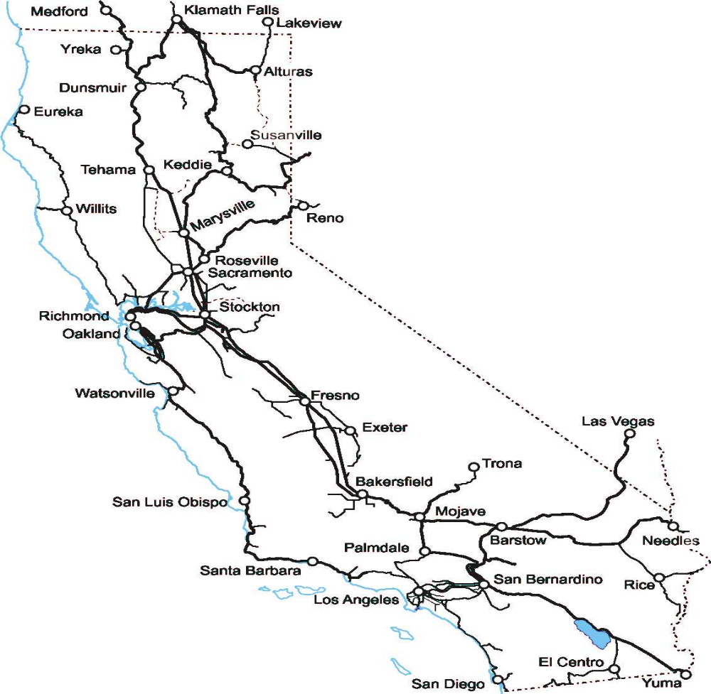

Copyright: Sonrisa Publications, P.O. Box 945, Auburn, WA 98071-0945. Used with permission granted by Mr. Dave Cooley, Sonrisa Publications.

Class I Freight Railroads

The Class I freight railroads are the nationwide, long distance, line-haul railroads which carry the bulk of the railroad commerce. Class I freight railroads account for nearly 90 percent of the ton-miles of freight hauled annually in the United States. The two Class I freight railroad companies that operate in California are Union Pacific Railroad (UP) and the Burlington Northern & Santa Fe Railroad (BNSF). While UP and BNSF provide freight services across the United States, they also have significant intrastate operations in California.

Passenger Railroads

California's sole Class I passenger railroad operator is Amtrak, which has both interstate and intrastate passenger train operations. Amtrak is the major interstate passenger train operator in California with a number of interstate lines that originate or terminate within the state. Amtrak does operate one intrastate passenger line (the Pacific Surfliner) from Oceanside to San Luis Obispo, and contractually operates both the San Joaquin and Capitol Corridor passenger trains for the California Department of Transportation (CalTrans).

There are also four regional and local government funded intrastate passenger-commuter and inter-city operations in California. These are:

- Metrolink in the Los Angeles area.
- Caltrain in the Bay Area.
- Coaster between San Diego and Oceanside.
- Altamont Commuter Express (ACE) between Stockton and San Jose.

A list of California's intrastate passenger trains is provided in Appendix B.

Class II Railroads

There is currently no Class II railroad operating in California that meets the proposed intrastate definition. A Class II railroad headquartered in Oregon does operate on a regular basis, but a small percentage of time, within California (i.e., Medford, Oregon to Weed, California). Class II railroads are being described here because a California Class III intrastate railroad could expand in the future, via mergers or consolidations, into a Class II railroad.

Class III Railroads

There are several Class III railroad companies operating within the state. These companies range from excursion operations to short distance line haul operations (i.e., small regional railroads) and terminal operations at major distribution centers like the ports of Los Angeles and Long Beach. A list of Class III railroads that operate solely within California are provided in Appendix B. Also, note there are two interstate Class III railroads headquartered in adjacent states that have partial operations in California (the Lake County Railroad (Lakeview, Oregon to Alturas) and the Arizona California Railroad (Parker, Arizona to Cadiz).

Industrial and Military Locomotives

California has a small number of intrastate locomotives that are owned by individual (non-railroad) companies or operated by the federal government on military bases within the state. This class of locomotive is referred to as "industrial" locomotives and are generally much smaller in size and horsepower than other classes of locomotives used by the larger railroads. Industrial locomotive operations are usually limited to small confined yards or industrial plants. ARB staff has identified about 120 of these locomotives with over half of them in the San Joaquin Valley (40) and South Coast (25) air districts.

CARB Intrastate Locomotive Survey on Operations and Fuel Consumption

In May 2004, ARB staff developed a survey (see Appendix C) to collect operational and fuel consumption information to better understand the existing operations of intrastate locomotives in California. This survey was developed with the input of California's Class I railroads, passenger train operators, and the California Shortline Railroad Association (CSLRA). The survey defined intrastate diesel-electric locomotives as those locomotives that operate and fuel primarily (at or greater than 90 percent of annual fuel consumption, mileage, and/or hours of operation) within the boundaries of the state of California.

The ARB intrastate locomotive survey was prepared to determine the following information:

Locomotive and Engine Information
- Locomotive identification number.
- Manufacturing make and model.
- Locomotive year built and year engine rebuilt (if applicable).
- Any plans for future locomotive engine rebuilds.
- Whether the locomotive was owned or leased.

Locomotive Operational Information
- Primary operational use (i.e., Switcher, Terminal, Local/Short Haul, Passenger).
- Home Railyard.
- Key cities and towns on primary rail routes.
- Annual hours of operations (years 2001, 2002, and 2003).
- Annual (rail) miles travelled (years 2001, 2002, 2003).

Locomotive Fuel Consumption
- Type of diesel fuel used (i.e., ULSD CARB, CARB diesel, U.S. EPA on-road diesel, or other fuel (e.g., biodiesel)).
- Fuel consumption for the years 2001, 2002, and 2003.

On May 18, 2004, ARB staff mailed the survey to California's intrastate locomotive owners and operators. The survey was mailed to both Class I railroad operators (UP and BNSF), and Amtrak and CalTrans, as well as the other commuter train operators in California (i.e., Metrolink, CalTrain, Coaster, and ACE). The survey was also mailed to 28 Class III railroad operators, of which only 20 operated locomotives that met the intrastate definition. ARB staff worked with the CSLRA to coordinate survey responses for their Class III railroad members. ARB staff requested all survey responses by June 28, 2004.

Survey responses were received from both of California's Class I railroads, all of the intrastate passenger railroad operators, and all but three of the twenty Class III railroads operators. For the three Class III railroad operators that did not respond to the survey, ARB staff obtained publicly available information on their locomotives and operations and developed estimates of fuel consumption, based on estimated annual miles traveled or annual hours of operation, to place in the survey database.

California's Intrastate Locomotive Population

As discussed in the previous section, there are four primary groups of intrastate locomotives that operate in California: 1) Class I freight railroads with short haul, switcher, and manifest operations, 2) passenger-commuter train operations that operate from city-to-city and usually within a particular area or region, 3) Class III short haul and switcher or terminal operations, and 4) individual company-owned industrial and military base locomotives that usually operate within a small confined yard or area

Class I Railroads

The UP and BNSF intrastate locomotives are generally segregated into three categories: switchers, short haul, and manifests. Switch locomotives generally operate within a railyard moving line haul locomotives and freight cars within the yard. Short hauls typically operate and move freight within a region or local area. Manifest operations are short hauls that operate in many yards (for intrastate purposes - usually within a region) by connecting mixed freight cars at different locations and eventually moving them to combine with larger or unit trains at central railyards.

Interstate line-haul locomotives are typically powered by engines of 4,000-6,000 horsepower. California's Class I railroads intrastate locomotives are usually older locomotives retired from line haul service. These locomotives are typically powered by engines with horsepower ranging from 1,500-4,000 horsepower. UP and BNSF combined operate about 383 intrastate locomotives in California. The average age of California's Class I intrastate locomotives is between 15 and 20 years. The Class I intrastate locomotives consume 23.3 million gallons annually within the state (about 60,000 gallons per locomotive per year). This information is summarized below in Table VI-17.

Table VI-17: Profile of Class I Railroad Intrastate Locomotives

Class I Intrastate  Locomotives | Range  (HP) | Avg.  (HP) | Age Range  (Years) | Average Age  (Years) | Total Annual  Fuel Consumption  (Gallons) | Avg. Annual Fuel Consumption Per  Locomotive  (Gallons)
383 | 1,500-4,000 | 2,400 | 1-19 | 15 | 23,300,000 | 60,000

Passenger (Commuter) Trains

California's intrastate passenger trains consist of intercity-commuter type operations that occur exclusively within the state of California (see Appendix B). California's intrastate passenger trains utilize a fleet of 113 locomotives to support their operations, with two of the locomotives serving only as switchers in one railyard. The 111 intrastate passenger train locomotives are typically fairly new, on average 10 years old, with a range from 1 to 19 years old. The two switchers used to support intrastate passenger train operations are on average 40 years old and both are rated at 1,500 horsepower. This information is summarized in Table VI-18.

Table VI-18: Profile of Passenger Train Intrastate Locomotives

Passenger  Train Intrastate  Locomotives | Range  (HP) | Avg.  (HP) | Age Range  (Years) | Average Age  (Years) | Total Annual  Fuel Consumption  (Gallons) | Avg. Annual Fuel Consumption Per  Locomotive  (Gallons)
111 | 3,000-3,600 | 3,100 | 1-19 | 10 | 20,400,000 | 184,000

California's intrastate passenger train locomotives are powered by engines that are on average 3,000 horsepower or more. Passenger train locomotives are usually equipped with an auxiliary engine to provide separate hotel power for the train, although some older passenger locomotives may also generate hotel power off the main engine.

California's 111 intrastate passenger trains transport commuters an estimated 8 million miles per year. Based on the ARB survey results, these locomotives consume an estimated 20.4 million gallons per year, which includes fuel consumption for the two switch locomotives that are operated only to support passenger train operations. Intrastate passenger trains typically are moving passengers 8 or more hours per day, but in some cases may leave hotel power and prime engines idling the remaining 16 hours each day. California's regional passenger trains generally operate 365 days per year (e.g., Pacific Surfliner, San Joaquin, and Capitol Corridor), which the intercity passenger trains (e.g., Metrolink, CalTrain, Coaster, and ACE) are focused more on the work week with some limited operations on the weekends.

Class III Railroads

Class III railroads typically operate either short haul or switcher-terminal locomotives. California has twenty Class III railroads that operate 120 intrastate locomotives. California's Class III railroad intrastate operations can generally be segregated into two major subset groups: switcher-terminal operations (such as Pacific Harbor Lines which operates in Los Angeles and Long Beach harbors and Modesto Empire and Traction which operates in the Modesto industrial railyard) and short haul operations (such as San Joaquin Valley Railroad and the California Northern Railroad). California has three interstate Class II/III railroads for which information was not collected as they did not meet the intrastate definition.

Class III railroad locomotives in California are operated with a wide range in engine size. Engine size ranges from 150 horsepower to 3,000 horsepower, averaging about 1,640 horsepower, which is about half the average engine size of the locomotives used for intrastate passenger train operations. California's Class III railroads consume on average about 27,800 gallons of diesel fuel annually per locomotive. In many cases, Class III shortline railroads will purchase older locomotives when they are retired by Class I railroads. As such, the locomotives operated by Class III railroads are typically older compared to those operated by Class I railroads. California's Class III railroads operate intrastate locomotives that are on average 40 years old, with an age-range of 24 to 62 years. Based on the ARB survey results, Class III railroads consume an estimated 3.3 million gallons annually statewide. This information is summarized in Table VI-19.

Table VI-19: Profile of Class III Railroad Intrastate Locomotives

Class III Intrastate  Locomotives | Range  (HP) | Avg.  (HP) | Age Range  (Years) | Average Age  (Years) | Total Annual  Fuel Consumption  (Gallons) | Avg. Annual Fuel Consumption Per  Locomotive  (Gallons)
120 | 150-3,000 | 1,640 | 24-62 | 40 | 3,336,000 | 27,800

Industrial and Military Locomotives

Industrial and military locomotives are used by individual companies (e.g., oil, chemical, agricultural) and the military for localized operations. These types of locomotives are typically less than 2,000 horsepower and average about 1,000 horsepower. Railroad enthusiasts refer to a large subset of these types of locomotives as "critters", those military and industrial locomotives ranging between 150 to 1,000 horsepower and limited to particular companies and specific yards.

Military and industrial locomotives are typically used intermittently throughout a calendar year, and usually limit their operations to a small confined yard or area. U.S. EPA's locomotive regulations specifically define that engines with rated horsepower of less than 750 kw (1,006 hp) are not locomotives (40 CFR Parts 86 and 89) for purposes of the federal locomotive regulations.

ARB staff did not survey industrial and military locomotive operators in California due to the difficulty in identifying all of the individual organizations with these types of locomotives. However, ARB staff did receive information from a railroad industry organization with a list of known industrial locomotives in the SCAQMD and SJVUAPCD. ARB staff also did internet searches to identify known locomotive rosters for military and other industrial locomotives located in other areas in California. Based on available information, it is estimated that individual companies and the military operate approximately 117 intrastate industrial and military locomotives in California.

Fuel Consumption for California's Intrastate Locomotives

Table VI-20 presents estimates of the fuel consumption for the Class I freight, passenger train, and Class III railroads intrastate locomotives, by region of the state. As can be seen, statewide intrastate locomotives consume over 47 million gallons of diesel fuel annually, which represents about 1.0 percent of California's total estimated annual diesel fuel production of about 4.6 billion gallons (both CARB and U.S. EPA on-road). Of the 47 million gallons consumed annually by intrastate locomotives, about 60 percent (28.4 million gallons) is CARB or CARB low sulfur diesel fuels (CARB diesel fuel already meeting a 15 ppmw sulfur cap). The remainder of the 47 million gallons consumed by intrastate locomotives is primarily EPA on-road diesel fuel (over 18 millions gallons), with a small amount of high sulfur federal nonroad diesel fuel (300,000 gallons annually).

Table VI-20: Intrastate Locomotive Diesel Fuel Consumption by Region
(Millions of Gallons)

Region | CARB  Low Sulfur | CARB | U.S. EPA On-road | U.S. EPA Nonroad | Total
South Coast | 5.0 | 3.9 | 10.1 | 0 | 19.0
Bay Area | 0 | 8.1 | 0.4 | 0 | 8.5
San Joaquin | 0 | 4.3 | 3.5 | 0.2 | 8.0
Mojave Desert | 0 | 0.6 | 3.3 | 0 | 3.9
Sacramento Area | 0 | 2.9 | 0 | 0 | 2.9
San Diego | 0.8 | 0.1 | 0 | 0 | 0.9
REST OF STATE | 0 | 2.7 | 1.0 | 0.1 | 3.8
Total * | 5.8 | 22.6 | 18.3 | 0.3 | 47.0
* may not add due to rounding.

As can be seen in Table VI-21 below, Class I freight intrastate locomotives accounted for 23.3 million gallons, or about half (50 percent) of the total intrastate locomotive fuel volume. Nearly 17 million gallons or 73 percent of Class I freight railroad intrastate locomotive diesel fuel consumption is non-CARB diesel fuel, but which meets U.S. EPA on-road diesel fuel specifications.

Table VI-21: Intrastate Locomotive Diesel Fuel Consumption By Type of Railroad
(Millions of Gallons)
Type of Railroad | CARB  Low Sulfur | CARB | U.S. EPA On-road | U.S. EPA Nonroad | Total
Class I Freight | 0 | 6.4 | 16.9 | 0 | 23.3
Passenger Trains | 5.8 | 14.1 | 0.5 | 0 | 20.4
Class III | 0 | 2.1 | 0.9 | 0.3 | 3.3
Total * | 5.8 | 22.6 | 18.3 | .3 | 47.0
* Numbers may not add due to rounding.

Passenger trains consume over 20 million gallons of diesel fuel annually, about 43 percent of the state's intrastate locomotive diesel fuel consumption, which is an amount slightly less than the Class I freight railroads. However, most of the passenger train diesel fuel consumption is CARB diesel, with less than 500,000 gallons annually of EPA on-road diesel fuel used, or about 2 percent of their total diesel fuel consumption. It is interesting to note that almost 30 percent of the passenger train diesel fuel consumption is low sulfur (15 ppmw) CARB diesel.

Class III railroads represent a small percentage (7 percent) of the intrastate locomotive diesel fuel consumption, with 3.3 million gallons of total annual diesel fuel consumption and nearly two-thirds (65 percent) of their diesel fuel consumption being CARB diesel fuel. The Class III railroads consume slightly over 1 million gallons annually of non-CARB diesel fuel.

Interstate Locomotive Activities in California

Both UP and BNSF have extensive national railroad freight operations. A component of those operations is the flexibility to move locomotives around the country to locations where they are needed. Because of this, unlike intrastate locomotives where the locomotives typically never leave the state, the in-state operations of interstate line-haul locomotives present in California are typically transitory in nature. An interstate locomotive present in California on one day may end up in another part of the country within a matter of days. This is in contrast to intrastate locomotives which typically never leave the state.

Interstate line-haul locomotives are typically powered by engines of 4,000-6,000 horsepower and a particular interstate locomotive may not remain in California for an extended period. As is discussed in the following sections, these locomotives consume significant quantities of diesel fuel, and are responsible for a significant quantity of emissions.

Interstate Locomotive Fuel Consumption

Table VI-6 shows the California diesel fuel consumption of both intrastate and interstate locomotives operated by UP and BNSF.

Table VI-22: Class I Freight Locomotive Fuel Consumption in California
(Millions of Gallons)

Type of Locomotive Activity | CARB Low Sulfur | CARB | U.S. EPA On-road | U.S. EPA  Nonroad | Total
Intrastate | 0 | 6.4 | 16.9 | 0 | 23.3
Interstate | 0 | 11.5 | 89.0 | 70.0 | 170.5
Total | 0 | 17.9 | 105.9 | 70.0 | 193.8

As can be seen from Table VI-22, intrastate locomotive fuel consumption represents only a small portion (about 12 percent) of the total fuel consumed by Class I freight locomotives in California. The remaining fuel consumption is in interstate locomotives. These locomotives consume about 11.6 million gallons of CARB diesel fuel and almost 90 million gallons of U.S. EPA on-road diesel fuel in California annually. Typically, the CARB and U.S. EPA on-road diesel fuel consumed in California by interstate locomotives is supplied from a railyard or other fueling facility in California.

However, unlike intrastate locomotives, where all of the fuel consumed by the locomotive is supplied within the state, interstate locomotives consume significant quantities of fuel supplied out-of-state and brought into the state in the locomotive’s on-board fuel tanks. This diesel fuel is typically U.S. EPA nonroad diesel fuel, with high fuel sulfur levels (averaging about 3,000 ppmw) and high aromatics levels. Because of this, unlike intrastate locomotives operated by the Class I freight railroads, not all of the diesel fuel consumed by interstate locomotives meets on-road (either CARB or U.S. EPA) diesel fuel standards.

Interstate Locomotive Emission Inventory

Commensurate with their substantially larger fuel consumption, emissions from interstate locomotives are more significant than those from intrastate locomotives. Table VI-23 shows the emission inventory for Class I freight locomotives in California.

Table VI-23: Interstate Locomotive Emission Inventory
(tons per day)

Region | NOx | PM | SOx
South Coast | 24.9 | 0.6 | 1.1
Bay Area | 6.2 | 0.2 | 0.3
San Joaquin | 22.0 | 0.5 | 1.0
Sacramento Valley | 21.0 | 0.5 | 1.0
South Central Coast | 6.7 | 0.2 | 0.3
San Diego | 0.2 | 0 | 0
Mojave Desert | 46.0 | 1.3 | 2.1
Rest of the State | 26.6 | 0.7 | 1.2
Total | 153.6 | 4.0 | 7.0

As can be seen in Table VI-7, Mojave Desert Air Basin accounts for 30 percent of the total interstate locomotive NOx and PM emissions in California. SCAQMD, San Joaquin Valley, and Sacramento Valley each account for 17 percent of the total NOx and PM interstate locomotive emissions. Combined these four regions of the state account for over 80 percent of the statewide NOx and particulate emissions from interstate locomotives.

Summary of the Benefits of Clean Fuels in Diesel-Electric Locomotives

In this section, staff has provided a summary of the benefits of cleaner fuels in diesel-electric locomotives.

NOx

In 2000, the Southwest Research Institute (SWRI) conducted a test program to quantify emissions of two types of locomotive engines using selected diesel fuels. Emission testing was performed between August 1998 and May 1999 at the SWRI Locomotive Exhaust Emissions Test Center in San Antonio, Texas. Locomotive exhaust emission and fuel consumption measurements were performed on six late-model locomotives:

- Three (3) - 4,000 horsepower EMD SD70MAC
- Three (3) - 4,400 horsepower GE DASH944CW

This test program made regulated and selected unregulated exhaust emission measurements on six locomotives, each operating on commercially available CARB diesel fuel, federal on-highway diesel, and a high-sulfur (4,760 ppmw) nonroad diesel fuel. Due to the fact that the sulfur level of the "high sulfur" fuel was higher than the nonroad diesel fuel typically purchased by the railroads, a fourth fuel was also used in the three GE locomotives, which was a nonroad fuel with a sulfur level of 3,190 ppmw. This fourth fuel is considered to be more representative of high sulfur nonroad diesel fuels used by the railroads. Table VI-24 shows some of the key properties of these four test fuels.

Table VI-24: SWRI Locomotive Test Program: Key Diesel Fuel Properties

Property | ASTM  Test  Method | CARB |  | U.S. EPA On-road |  | U.S. EPA Nonroad
Property | ASTM  Test  Method | Test Fuel | In-Use Levels | Test Fuel | In-Use Levels | Test Fuel | Test Fuel
Sulfur (ppmw) | D2622-94 | 50 | 140 | 330 | 360 | 4,760 | 3,190
Cetane Index | D976 | 52.0 | 50 | 47.8 | 45 | 48.6 | 46.5
Aromatics  (% Volume) | D5186-96 | 22.4 | 19 | 32.2 | 35 | 34.4 | 39.8

A summary of the relative emissions difference for the line haul weighted NOx results from the test program are shown below in Table VI-25. The test program indicated that the CARB test fuel emitted 3.4 percent lower NOx than the EPA low sulfur test fuel and about 6.7 percent less NOx than both of the high sulfur test fuels. However, ARB staff believes that the NOx emission benefits of transitioning from U.S. EPA on-highway diesel fuel to CARB diesel fuel are underreported. This is because U.S. EPA on-highway diesel fuel has aromatics levels in-use at about 35 percent by volume, 3 percent by volume higher than the test fuel used. In addition, the aromatics content of average CARB diesel is about 19 percent, about 3 percent less than the CARB diesel used in the comparison test. Also, the cetane index number was higher on the U.S. EPA on-highway test fuel than in-use levels. These differences would tend to suppress the NOx emissions benefits. As such, ARB staff believes that the actual NOx emission benefits are closer to those shown from going from nonroad diesel fuel to CARB diesel fuel. As a result, CARB staff expects about a 6 percent reduction in NOx emissions from the use of CARB diesel fuel versus EPA on-road and nonroad diesel fuels. This estimate is more in line with a much larger body of test results of diesel engines that use lower aromatic and higher cetane diesel fuels.

Table VI-25: NOx Emissions Comparison - ARB Test Fuel vs. Others

Engine | Cycle | U.S. EPA  On-road | U.S. EPA Nonroad
Engine | Cycle | U.S. EPA  On-road | Hi Sulfur (0.5%) | Hi Sulfur (0.3%)
BNSF 9693 | 2-stroke | -3.0% | -6.3% | NA
BNSF 9754 | 2-stroke | -3.8% | -4.1% | NA
BNSF 9696 | 2-stroke | -4.7% | -7.1% | NA
UP9715 | 4-stroke | -2.6% | -7.9% | -6.0%
UP9724 | 4-stroke | -4.3% | -8.2% | -5.6%
UP 9733 | 4-stroke | -2.5% | -6.2% | -5.1%
Average Difference |  |  | -3.4% | -6.7% | -5.6%

SOx

Intrastate locomotives and harborcraft will realize over a 95 percent reduction in SOx emissions by using CARB low sulfur (15 ppmw) or U.S. EPA on-road diesel fuels as compared to U.S. EPA nonroad diesel fuel in 2007. In 2007, U.S. EPA nonroad diesel fuel will have a sulfur maximum limit of 500 ppmw. Current in-use levels for U.S. EPA on-road diesel fuel nationwide is about 350 ppmw. Staff assumes that when the U.S. EPA nonroad diesel fuel requirements begin in 2007, that refiners will produce this diesel fuel in-use with sulfur levels about 350 ppmw. When diesel fuel is consumed the fuel sulfur is converted to SOx and emitted to the atmosphere. As such, a 95 percent reduction in fuel sulfur levels will result in a 95 percent reduction in SOx emissions.

PM

Directly Emitted PM

The SWRI study also examined the PM benefits of CARB diesel fuel relative to U.S. EPA fuels. The findings of the SWRI study indicated that the PM emissions were significantly lower on the CARB diesel fuel and the U.S. EPA on-road diesel fuel as compared to the high sulfur test diesel fuels. PM emissions decreased 26 percent with the CARB test diesel fuel as compared to the high sulfur diesel fuels. The difference between the CARB test diesel fuel and the EPA on-road test diesel fuel was small. Only on one engine were the PM results significantly lower with the CARB diesel fuel as compared to U.S. EPA on-road diesel fuel. Part of the reason the differences were small is that at low diesel fuel sulfur levels, the relatively high engine oil consumption (and its contribution to PM emissions) masks the differences in fuel properties.

However, ARB staff believes that the PM emission benefits of transitioning from U.S. EPA on-road diesel fuel to CARB diesel fuel were under represented, as was the case with the NOx benefits. Again, this is due to differences in the test fuel properties relative to actual in-use levels as was discussed in the previous section. As such, ARB staff believes that the actual PM emission benefits are similar to those observed transitioning from nonroad diesel fuel to CARB diesel fuel. As a result, ARB staff expects about a 14 percent reduction in PM emissions from the use of CARB diesel fuel as compared to U.S. EPA on-road and nonroad diesel fuels.

Indirectly Emitted PM:

SOx emissions from diesel-powered engines are proportional to fuel sulfur levels. As was discussed in Chapter V, SOx emissions result in the formation of secondary particulate in the atmosphere. The U.S. EPA estimates that SO₂ reacts in the atmosphere to form either ammonium sulfate or ammonium bisulfate.

The U.S. EPA estimates that about 12 percent of SO₂ emitted in urban areas is converted in the atmosphere to sulfate PM. Using U.S. EPA's methodology, which assumes 12 percent of the SO₂ forms sulfate PM, and correcting for the differences in the molecular weight between ammonium sulfate and ammonium bisulfate and SO₂, staff estimated the indirect PM reductions from the use of CARB diesel fuel.

Like SOx, NOx emissions serve as a precursor to the formation of secondary particulate matter emissions. This formation is through the oxidation of NOx into nitric acid, which then reacts with gaseous ammonia to form ammonium nitrate. Staff estimates that the NOx emission reductions achieved through the proposed amendments would provide about a 0.03 percent reduction in ambient particulate levels. This corresponds to less than a 0.02 tpd reduction in secondary particulate matter emissions from intrastate locomotives and harborcraft.

Harborcraft - California Operations and Emissions

This chapter provides an overview of the different types of diesel powered harborcraft operating in California. In this chapter, staff also provides estimates of the quantities and types of diesel fuel these harbor craft consume.

Much of the information in this chapter is based on the results of a 2002 survey of commercial harborcraft conducted by the ARB staff. The survey collected information about the various commercial harborcraft operating in California to help update the statewide emissions inventory for commercial marine vessels operating in the State. The survey did not collect information on recreational diesel powered vessels, so other sources of information were used for these vessels. As noted below, recreational diesel engines account for a relatively small percentage of the total harborcraft emissions inventory.

Types of Harborcraft Operating in California

Harborcraft are marine vessels that operate primarily along California’s coastline, and in inland waterways. They include a wide variety of vessels such as tug/tow boats, commercial fishing vessels, commercial passenger fishing vessels (“party boats”), pilot boats, work boats, crew/supply boats, ferries/excursion vessels, military vessels, and diesel powered recreational vessels. Brief descriptions of each type of vessel follows:

Tug/Tow Boats: These vessels are designed to move large oceangoing ships into and out of berths, or to tow barges (unpowered vessels) between ports.

Commercial Fishing Vessels: Vessels dedicated to the search and collection of fish or other sea life for the purpose of sale at market.

Commercial Passenger Fishing Vessels: Vessels for hire by the general public dedicated to fishing for sport or personal consumption.

Work Boats: Vessels used to perform duties such as fire/rescue, law enforcement, hydrographic surveys, spill/response, research, training, and construction.

Crew/Supply Boats: Vessels used for carrying personnel and supplies to and from off-shore and in-harbor locations, such as offshore work platforms, construction sites, and other vessels.

Ferries/Excursion: Vessels operated for public use in the transportation of persons or property. Ferries are generally used primarily as a means of transportation, while excursion vessels are often used for pleasure and tourism (harbor tours, weddings, etc.).

Military: Vessels used by the Coast Guard or other branches of the military. For example, Coast Guard utility boats, patrol boats, and buoy tenders.

Recreational Vessels: Diesel powered vessels used for pleasure, including cabin cruisers, inboard runabouts, and yachts.
Table VII-26 below shows a breakdown by the number of vessels for each sector of commercial harborcraft, based on the ARB’s 2002 survey. As shown, commercial fishing vessels account for the largest number of vessels by far. ARB’s 2002 survey did not cover recreational vessels. However, a recent EPA staff report noted that the diesel engines used on recreational craft tend to be inboard cabin cruisers, with a limited number of sterndrive vessels and very few outboard designs (“Final Regulatory Support Document: Control of Emissions from Unregulated Nonroad Engines;” U.S. EPA, September, 2002).

Table VII-26: Commercial Harborcraft Use

Type of Vessel | Number of Vessels | Total
Commercial Fishing Boats | 2,520 | 64%
Charter Fishing Boats | 512 | 13%
Ferry/Excursion Boats | 412 | 11%
Tug Boats | 128 | 3%
Other | 136 | 3%
Work Boats | 87 | 2%
Crew Boats | 70 | 2%
Tow Boats | 35 | 1%
Pilot Boats | 24 | 1%
Total * | 3,924 | 100%
* Based on December 2002 ARB Commercial Harborcraft Survey, USCG, CDFG and other sources.

Harborcraft Operational Range

As mentioned above, harborcraft are marine vessels that operate primarily along California’s coastline, and in inland waterways. As shown in Figure VII-5, most commercial harborcraft spend the majority of their time operating within 25 miles of shoreline, with very little operation greater than 100 miles offshore. This is significant because it means that the majority of their emissions are likely to impact California’s air quality. More specifically, their emissions are primarily within “California Coastal Waters (CCW),” the boundary within which emissions are likely to be transported ashore and affect air quality in California’s coastal air basins. CCW ranges from 27 to 102 miles offshore as shown in Figure VII-6. Development of the definition of CCW was based on over 500 thousand island, shipboard, and coastal meteorological observations. These data were taken from official records of a number of agencies including the U.S. Weather Bureau, Coast Guard, Navy, Air Force, Marine Corps., Civil Aeronautics Administration and Army Air Force. (“Report to the California Legislature on Air Pollutant Emissions from Marine Vessels;” ARB, 1984).

Figure VII-5
Percent of Vessel Hours Operated at Varying Distances from Shore
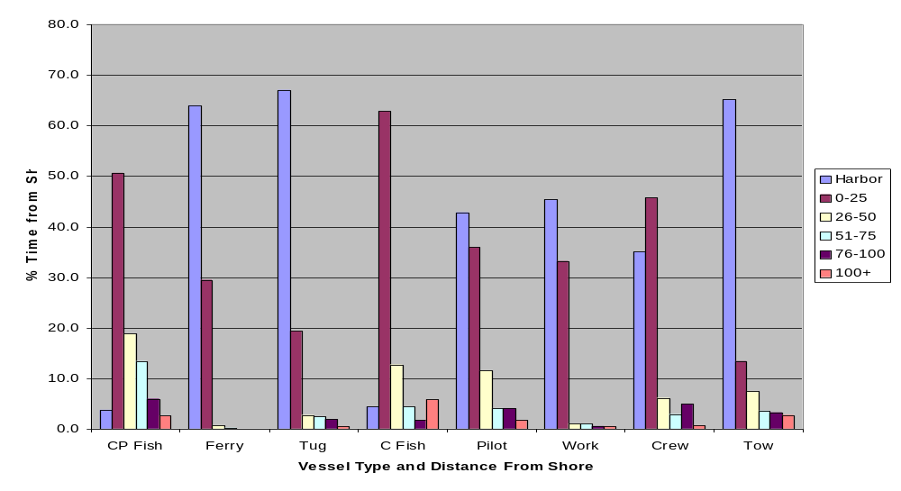
Figure VII-6: California Coastal Waters
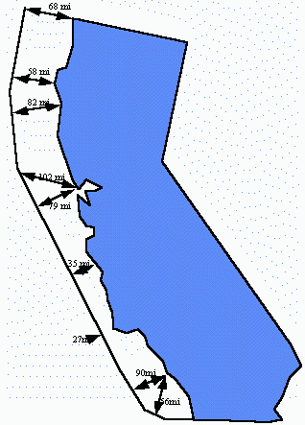

Harborcraft Distinction from Oceangoing Ships

Harborcraft include all marine vessels except oceangoing ships. Oceangoing ships are not distinct from harborcraft because they travel internationally, generally burn heavy fuel oil in their main engines, and often do not take on fuel when they visit California ports. Oceangoing ships are generally defined as vessels that meet any one of the following criteria:

- a foreign trade vessel with a “registry” endorsement on their United States Coast Guard certificate of documentation, or registration under the flag of another country.
- a vessel greater than or equal to 400 feet in length overall (LOA) as defined in 50 CFR § 679.2.
- a vessel of 10,000 gross tons (GT ITC) or greater per the convention measurement (international system) as defined in 46 CFR 69 Subpart B.
- a vessel propelled by a marine diesel engine with a per-cylinder displacement of 30 liters or more (United States Environmental Protection Agency “category 3” engine).

Since most oceangoing ships visiting California’s ports are foreign-flagged vessels, the first criteria will cover the vast majority of oceangoing ships in California. The remaining three categories cover oceangoing ships involved in the domestic trade, such as tankers traveling between California and Alaska, and cargo vessels traveling between California and Hawaii.

Types of Engines Used in Commercial Harborcraft

Harborcraft have one or more propulsion engines, and often auxiliary engines as well. Based on the ARB’s 2002 survey, 63 percent of commercial harborcraft have one propulsion engine, 33 percent have two, and the remaining have more than two. Data on the manufacturers of propulsion engines is provided in Figure VII-7. As shown, Detroit Diesel engines are most common, followed by Caterpillar, Cummins, and a number of other manufacturers. Table VII-27 shows the range and average horsepower for different types of harborcraft. As shown, these engines range in horsepower from less than 50 to nearly 4,000. In general, tugs have the highest horsepower engines, averaging about 1300 horsepower. Commercial fishing and work boats, at the other end of the spectrum, averaged a little over 200 horsepower.

Figure VII-7: Commercial Harborcraft Propulsion Engine Manufacturers

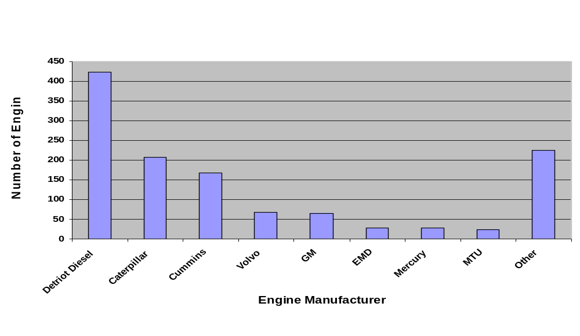

Table VII-27: Propulsion Engine Horsepower

Type of Vessel | Horsepower
Type of Vessel | Range | Average
Commercial Fishing Boats | 8 – 1,485 | 230
Commercial Passenger Fishing Boats | 80 – 1,400 | 381
Ferry Boats | 35 – 3,110 | 733
Tug Boats | 24 – 3,600 | 1,274
Work Boats | 15 – 1,300 | 239
Other | 28 – 764 | 281
Crew Boats | 225 – 750 | 439
Tow Boats | 24 – 1,500 | 500
Pilot Boats | 230 – 550 | 408

Auxiliary engines are used to power on-board equipment such as electrical lights, refrigeration units, and radios. Based on the ARB’s 2002 survey, about 40 percent of harborcraft have auxiliary engines. Of those vessels with auxiliary engines, 56 percent reported having one engine, 38 percent reported having two, and 5 percent reported have three to five. Figure VII-8 provides information on the manufacturers of these engines. Detroit Diesel engines are the most prevalent, as with propulsion engines. Table VII-28 shows the power range for auxiliary engines used on different types of harborcraft. As shown, these engines ranged from 4-400 horsepower.

Figure VII-8: Harborcraft Auxiliary Engine Manufacturers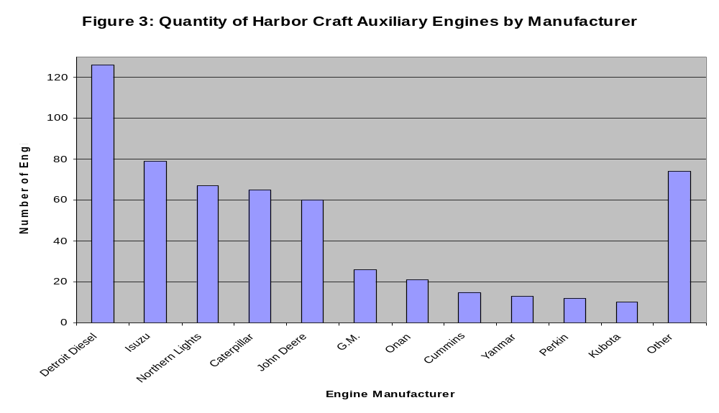

Table VII-28: Quantity of Auxiliary Engines and Average Horsepower

Type of Vessel | Horsepower
Type of Vessel | Range | Average
Commercial Fishing Boats | 6 - 300 | 71
Tug Boats | 7 - 300 | 111
Ferry Boats | 10 – 400 | 94
Commercial Passenger Fishing Boats | 4 – 185 | 50
Other | 10 – 240 | 56
Work Boats | 9 – 221 | 101
Crew Boats | 16 – 110 | 79
Tow Boats | 18 – 175 | 79
Pilot Boats | N/A | 30

Fuel Consumption in Commercial and Recreational Harborcraft

Harborcraft are estimated to consume nearly 90 million gallons of diesel fuel annually, as shown in Table VII-4. This estimate relies on data from ARB’s 2002 Commercial Harborcraft Survey. Specifically, total annual fuel consumption from commercial harborcraft is estimated using the average annual fuel consumption per vessel from the survey respondents, and scaling this up for the total estimated number of commercial harborcraft in California. For recreational craft, diesel fuel consumption is estimated based on the ARB emissions inventory, as shown in Appendix D.

The estimated breakdown of CARB and U.S. EPA on-road diesel fuels was estimated based on the following:
- a state law requiring that ferries use CARB on-road diesel fuel. Specifically, CARB diesel is required for ferries with a capacity to hold 75 or more passengers (California Harbors and Navigation Code Section 654.3);
- information provided by the major suppliers of marine fuels in California. These suppliers have noted that U.S. EPA on-road diesel is the predominate diesel fuel used, except for coastal areas north of the Bay Area, where CARB diesel fuel is supplied to marine vessels as well as on-road heavy duty trucks, since the small volumes do not justify a dual distribution system. Suppliers indicated that very little federal nonroad diesel fuel is used by harborcraft in California; and
- the ARB’s 2002 Commercial Harborcraft Survey, which provides data by vessel type (e.g. ferries) and by region (e.g. north coast).

Table VII-29: Harborcraft Fuel Consumption by Region
(Millions of gallons)

Type of Vessel | Total | CARB | U.S. EPA On-Road
Commercial Harborcraft (CHC)*
S.F. Bay Area Air Basin | 27.0 | 10.2 | 16.8
South Coast Air Basin | 23.8 | 10.8 | 13.0
North Coast Air Basin | 6.0 | 6.0 | 0
All Other Areas | 25.5 | 10.0 | 15.5
Total CHC | 82.3 | 37.0 | 45.3
Recreational Craft**
S.F. Bay Area Air Basin | 0.4 | 0 | 0.4
South Coast Air Basin | 1.8 | 0 | 1.8
North Coast Air Basin | 0.1 | 0.1 | 0
All Other Areas | 2.7 | 0 | 2.7
Total Recreational Craft | 4.9 | 0.1 | 4.9
Harborcraft Total | 87 | 37 | 50
* Commercial fuel consumption estimates based on 2002 ARB Commercial Harborcraft Survey. All ferries
** Recreational fuel consumption estimates based on 2003 ARB Emissions Inventory (See Appendix E)

Table VII-30 shows the fuel consumption by type of harborcraft. As shown, ferries consume the largest amount of fuel, followed by commercial fishing vessels, and tugboats.

Table VII-30: Harborcraft Fuel Consumption by Type of Vessel
(Millions of gallons)

Type of Vessel | Total | CARB | U.S. EPA On-Road
Commercial Harborcraft (CHC)*
Ferry/Excursion | 31.5 | 31.5 | 0
Commercial Fishing | 17.4 | 4.5 | 12.9
Tugs | 12.6 | 0.2 | 12.4
Charter Fishing | 9.8 | 0.5 | 9.3
Tow Boats | 4.7 | 0 | 4.7
Crew and Supply | 3.7 | 0.3 | 3.4
Work Boats | 1.5 | 0.1 | 1.4
Pilot | 0.7 | 0 | 0.7
Other | 0.4 | 0 | 0.4
Total CHC | 82.3 | 37.0 | 45.3
Recreational Craft** | 4.9 | 0.1 | 4.9
Harborcraft Total | 87 | 37 | 50
* Commercial fuel consumption estimates based on 2002 ARB Commercial Harborcraft Survey.
** Recreational fuel consumption estimates based on 2003 ARB Emissions Inventory (See Appendix XX)

Benefits of Clean Fuels in Harborcraft

The benefits of cleaner fuels, such as CARB diesel fuel, in harborcraft are the same as those discussed for locomotives in Chapter VI. In summary, staff estimates that harborcraft would realize emission reductions of 6 percent NOx, 14 percent PM, and over 95 percent SOx from the use of CARB diesel fuel. In addition, the SOx emission reductions would also provide a significant reduction in sulfates which would form PM indirectly.

Proposed Amendments for Intrastate Locomotives

In this chapter, staff’s proposed amendments extending the California motor vehicle diesel fuel standards to diesel fuel used in intrastate locomotives are discussed. The full text of the proposed regulatory language is contained in Appendix A. A discussion of the alternative regulatory concepts considered is provided in Chapter X.

Diesel Fuel Sold to Intrastate Locomotive Operators Statewide Beginning January 1, 2007

ARB staff is proposing that, beginning January 1, 2007, diesel fuel sold, supplied, or offered for use in California intrastate diesel-electric locomotives statewide be required to meet the specifications for vehicular diesel fuel, as specified in Title 13, CCR, sections 2281, 2282, and 2284.

The proposed effective date will ensure implementation of the proposed amendments prior to U.S. EPA's nonroad diesel fuel program implementation date of June 1, 2007. In addition, ARB staff believes implementing the proposed amendments on January 1, 2007, will provide adequate time for diesel fuel suppliers to complete the transition to U.S. EPA and CARB low sulfur (15 ppmw) diesel fuel for on-road, off-road, and stationary sources in California on June 1, 2006. Further, the proposed effective date would be in the winter, when diesel fuel demand is historically low, and diesel fuel inventories are typically at higher levels. Therefore, implementation during the winter months should reduce potential impacts on diesel fuel production and supply.

Under the proposal, California would receive the benefits of five years use of low sulfur (15 ppmw) diesel fuel over the federal nonroad diesel fuel program. In addition, neither the U.S. EPA on-road or nonroad diesel programs achieve the NOx and PM emission reductions provided by the aromatic component of the CARB diesel fuel program.

Alternative Emission Control Plan

To provide flexibility to affected locomotive operators, staff is also proposing that operators of intrastate locomotives be provided the opportunity to participate in an alternative emission control plan (AECP). The AECP concept is intended to provide a less costly mechanism to comply with the proposed amendments. The AECP would allow the owner or operator of an intrastate diesel-electric locomotive to submit, for approval by the Executive Officer, a substitute fuel and/or emission control strategy. The substitute fuel and/or emission control strategy must achieve equivalent or greater reductions than those achieved solely through compliance with CARB diesel fuel requirements or which would otherwise be expected to be a best practices measure used to reduce emissions and exposure to PM around rail facilities. In addition, adequate enforcement provisions would be required. Further, a proposed AECP would need to be as protective as the use of CARB diesel in terms of reducing exposure to diesel PM for individuals living in areas that have existing local air pollution or localized air toxic impacts.

The AECP provisions are intended to provide the flexibility to intrastate locomotive operators to consider any combination of fuels, equipment, or operational changes at one or more of their rail facilities in the State. Some examples of these changes might include:

- The increased use of CARB diesel fuel in interstate locomotives.
- The use of alternative diesel fuels, such as biodiesel and emulsified fuels.
- Exhaust aftertreatment devices, such as diesel particulate filters or diesel oxidation catalysts.
- Engine modifications, such as cylinder liners for reduced lubrication oil consumption or engine timing adjustments.
- Replacement of a portion of the existing fleet with less polluting equipment, such as low horsepower, electric or hybrid switchers.

However, whatever approach is proposed, the AECP may not sacrifice emission reductions in one area or region at the expense of another, and could not take credit for other measures such as smoke reduction programs or efforts that would reduce unnecessary idling that should be implemented as best management practices around major rail facilities or are required by other regulations or agreements.

Definitions for Intrastate Locomotives

In this section, staff examines the proposed amendments and definitions recommended for diesel-electric locomotive and intrastate locomotive.

Definition of a Diesel-Electric Locomotive

A "locomotive" was defined in the U.S. EPA locomotive regulations (1998) as a self-propelled piece of on-track equipment designed for moving or propelling cars that are designed to carry freight, passengers or other equipment, but which itself is not designed or intended to carry freight, passengers (other than those operating the locomotive) or other equipment. Diesel-electric locomotives are defined by the railroad industry as those locomotives that use electric power provided by a diesel engine that drives a generator or alternator; the electrical power produced then drives the wheels using electric motors.

Definition of an Intrastate Locomotive

Staff is proposing that an intrastate locomotive be defined to include a diesel-electric locomotive that operates principally within California, where at least 90 percent of a locomotive's fuel consumption, hours of operation, or annual rail miles traveled occur within the boundaries of the state of California. This definition includes, but is not limited to, diesel-electric locomotives used in the following operations: passenger intercity and commuter, short haul, short line, switch, industrial, port, and terminal operations. This definition is intended to allow for some out-of-state operation of intrastate locomotives for such activities as repair or maintenance at facilities outside of the state, or infrequent operation in neighboring states, for up to 36 days per year.

Staff is proposing to not include in the definition of California intrastate locomotives those line-haul freight locomotives meeting the U.S. EPA’s “Tier II” locomotive emission standards (for both NOx and PM) which primarily move freight into and out of the SCAQMD. This is in recognition that by 2010, both UP and BNSF will, under the federally enforceable railroad MOU in the SCAQMD, be required to meet a “Tier II” fleet average for NOx for their locomotive operations in the SCAQMD. This will achieve over a 60 percent reduction in NOx emissions from the operations of UP and BNSF within the SCAQMD. For UP and BNSF, meeting this fleet average will likely necessitate the deployment of dedicated Tier II locomotives for service into and out of the SCAQMD, beginning in 2005, creating a “new” captive intrastate locomotive fleet not currently present in the State. To the extent that these locomotives do use CARB diesel fuel, under the railroad MOU, the emission reductions achieved through the use of cleaner fuels are creditable towards the railroads Tier II fleet average and not to the use of CARB diesel. In addition, staff is investigating means to encourage the early introduction of Tier II locomotives in the rest of the state and may propose additional recommendations to the Board at the hearing.

However, under staff’s proposed definition, switcher and short haul locomotives operated by UP and BNSF in the SCAQMD would continue to be subject to the proposed amendments, even if they meet the U.S. EPA Tier II emission standards. This is designed to preserve both the NOx and PM emission benefits achieved with the proposed amendments in and around railyards in the SCAQMD.

D. Structure of the regulations

The staff is proposing that the Board adopt two almost identical sections of the California Code of Regulations (CCR). Section 2299, title 13, CCR, would be in a new Chapter 5.1. Standards for Fuels For Nonvehicular Sources, and would regulate diesel fuel used in intrastate locomotives and harborcraft pursuant to ARB’s Health and Safety Code section 43013 authority to adopt standards and regulations for locomotives and marine vessels. A second regulation – section 93116, title 17, CCR – would regulate diesel fuel used in intrastate locomotives and harborcraft as an Air Toxic Control Measure (ATCM) for nonvehicular sources. Both regulations would provide that all diesel fuel sold, offered for sale or supplied for use in harborcraft and intrastate diesel-electric locomotives on or after the implementation dates will be subject to all of ARB’s requirements for California motor vehicle fuel on sulfur content, aromatic hydrocarbon content, and lubricity. Technical amendments would be made to the motor vehicle diesel fuel regulations to alert the reader of the applicability of the two new sections on diesel fuel for use in intrastate diesel-electric locomotives and harborcraft.

Proposed Amendments for Commercial and Recreational Harborcraft

In this chapter, staff’s proposed amendments extending the California motor vehicle diesel fuel standards to diesel fuel used in commercial and recreational harborcraft are discussed. The full text of the proposed regulatory language is contained in Appendix A. A discussion of the alternative regulatory concepts considered is provided in Chapter X.

Diesel Fuel Sold to Harborcraft Operators in the SCAQMD Beginning January 1, 2006.

ARB staff is proposing that, beginning January 1, 2006, diesel fuel sold, supplied, or offered for use in commercial or recreational harborcraft within the SCAQMD be required to meet the specifications for motor vehicular diesel fuel, as specified in title 13, CCR, sections 2281, 2282, and 2284.

The early implementation date for the SCAQMD is proposed in order to satisfy emission reduction commitments for harborcraft, as contained in the 2003 Statewide Strategy of the California SIP. Specifically, the use of cleaner fuels (including CARB diesel fuel) for harborcraft is included in Measure Marine-1: Pursue Approaches to Clean Up the Existing Harborcraft Fleet – Cleaner Engines and Fuels.

The 2003 Statewide Strategy requires a total of 0.09 tons per day of NOx emission reductions by 2006 and 2.7 tons per day of NOx emission reductions from harborcraft by 2008. The proposed amendments will provide about 0.4 tons per day of direct NOx emission reductions for existing harborcraft in the SCAQMD beginning in 2006, and enable advanced control technologies to provide additional emission reductions in the future.

The 2003 Statewide Strategy also requires a total of 0.02 tons per day of PM emission reductions by 2006 and 0.05 tons per day of PM emission reductions by 2008. The proposed amendments will provide the SCAQMD with 0.02 tons per day or more of PM emission reductions from existing harborcraft in the SCAQMD beginning in 2006, and enable advanced control technologies to provide additional emission reductions in the future.

Diesel Fuel Sold to Harborcraft Operators Statewide Beginning January 1, 2007

ARB staff is proposing that, beginning January 1, 2007, diesel fuel sold, supplied, or offered for use in commercial or recreational harborcraft statewide be required to meet the specifications for vehicular diesel fuel, as specified in Title 13, CCR, sections 2281, 2282, and 2284.

The proposed effective date will ensure implementation of the proposed amendments prior to the U.S. EPA's nonroad diesel fuel program implementation date of June 1, 2007. In addition, CARB staff believes implementing the proposed amendments on January 1, 2007, will provide adequate time for diesel fuel suppliers to complete the transition to U.S. EPA and CARB low sulfur (15 ppmw) diesel fuel for on-road, off-road, and stationary sources in California on June 1, 2006. Further, the proposed effective date would be in the winter, when diesel fuel demand is historically low, and diesel fuel inventories are typically at higher levels. Therefore, implementation during the winter months should reduce potential impacts on diesel fuel production and supply.

Under the proposal, California would receive the benefits of five years use of low sulfur (15 ppmw) diesel fuel over the federal nonroad diesel fuel program. In addition, neither the U.S. EPA on-road or nonroad diesel programs achieve the NOx and PM emission reductions provided by the aromatic component of the CARB diesel fuel program.

Definition of Commercial and Recreational Harborcraft

The following is a discussion of the proposed definition for commercial and recreational harborcraft used in the proposed amendments.

Staff is proposing that the definition of harborcraft include a subset of all marine vessels. "Marine vessels" would be defined as any ship, boat, watercraft, or other artificial contrivance used as a means of transportation on water. This includes recreational as well as commercial vessels. To exclude ocean-going ships, the definition of harborcraft would exclude the following marine vessels:

- Foreign trade vessels with a “registry” endorsement on their United States Coast Guard certificate of documentation, or registration under the flag of another country.
- Vessels greater than or equal to 400 feet in length overall (LOA) as defined in 50 CFR § 679.2.
- Vessels of 10,000 gross tons (GT ITC) or greater per the convention measurement (international system) as defined in 46 CFR 69 Subpart B.
- Vessels propelled by a marine diesel engine with a per-cylinder displacement of 30 liters or more (U.S. EPA “category 3” engine).

D. Structure of the regulations

The staff is proposing that the Board adopt two almost identical sections of the California Code of Regulations (CCR). Section 2299, title 13, CCR, would be in a new Chapter 5.1. Standards for Fuels For Nonvehicular Sources, and would regulate diesel fuel used in intrastate locomotives and harborcraft pursuant to ARB’s Health and Safety Code section 43013 authority to adopt standards and regulations for locomotives and marine vessels. A second regulation – section 93116, title 17, CCR – would regulate diesel fuel used in intrastate locomotives and harborcraft as an ATCM for nonvehicular sources. Both regulations would provide that all diesel fuel sold, offered for sale or supplied for use in harborcraft and intrastate diesel-electric locomotives on or after the implementation dates will be subject to all of ARB’s requirements for California motor vehicle fuel on sulfur content, aromatic hydrocarbon content, and lubricity. Technical amendments would be made to the motor vehicle diesel fuel regulations to alert the reader of the applicability of the two new sections on diesel fuel for use in intrastate diesel-electric locomotives and harborcraft.

Alternatives Considered

This chapter presents a summary of the alternatives to the proposed amendments that were considered for intrastate locomotives and commercial and recreational harborcraft.

Alternatives Considered for Intrastate Locomotive Diesel Fuel

Staff evaluated five alternatives to the proposed amendments for intrastate locomotives that included:

- Not extending CARB diesel fuel requirements to diesel fuel for use by intrastate locomotives (in which case the fuel would still be subject to U.S. EPA nonroad diesel fuel standards).
- Not requiring any diesel fuel for use by Class III railroads locomotives to have to comply with the CARB diesel fuel requirements.
- Not requiring diesel fuel for use by certain rural Class III railroads locomotives, not operating in ozone non-attainment areas, to have to comply with the CARB diesel fuel requirements until June 1, 2012.
- Requiring diesel fuel for use by all intrastate locomotives in the SCAQMD to meet the CARB diesel fuel standards by January 1, 2006, with diesel fuel for use by intrastate locomotives and harborcraft in the rest of the state to be subject to the CARB diesel fuel standards by January 1, 2007.
- Making diesel fuel for use by all harborcraft and all interstate and intrastate locomotives subject to the CARB diesel fuel requirements.

In considering the alternatives identified above, staff concluded that the first three would not provide the emission reductions needed, for both the SIP and overall improvements in air quality, above those that would be realized through implementation of only the U.S. EPA nonroad diesel fuel program.

Staff believes that the additional CARB diesel fuel demand created by the fourth alternative could put excessive strain on the diesel fuel supply in the SCAQMD in 2006, during the transition to 15 ppmw CARB and U.S. EPA on-road diesel fuel. The fifth alternative would not assure emission reductions as interstate locomotives have the potential to change existing fuel patters. This might increase the purchase of U.S. EPA nonroad diesel fuel prior to entering California, reducing the potential benefits of this option.

A discussion of the cost and emission impacts of these alternatives is provided in Chapter XIII.

Alternatives Considered for Harborcraft Diesel Fuel

In considering alternatives for diesel fuel for harborcraft, staff considered the alternative of allowing for the implementation of only the U.S. EPA nonroad diesel fuel program. However, staff concluded that this alternative would not provide the emission benefits achieved through the proposed amendments above those that would be realized through implementation of only the U.S. EPA nonroad diesel fuel program. Further, this alternative would not provide the NOx and PM emission reductions required under Measure Marine-1: Pursue Approaches to Clean Up the Existing Harborcraft Fleet – Cleaner Engines and Fuels in the 2003 SCAQMD SIP. A discussion of the cost and emission impacts of these alternatives is provided in Chapter XIII.

Environmental Effects of the Proposed Amendments to the Diesel Fuel Regulations

This chapter discusses the environmental impacts of the proposed amendments to extend the applicability of the CARB diesel fuel regulations to diesel fuel used in intrastate locomotives and harborcraft.

Legal Requirements Applicable to Analysis

The California Environmental Quality Act (CEQA) and ARB policy require an analysis to determine the potential adverse environmental impacts of the proposed standards. Because the ARB’s program involving the adoption of regulations has been approved by the Secretary of Resources (see Public Resources Code, section 21080.5), the CEQA environmental analysis requirements are to be included in the ARB’s Staff Report in lieu of preparing an environmental impact report or negative declaration. In addition, the ARB will respond in writing to all significant environmental issues raise by the public during the public review period or the public Board hearing. These responses are to be contained in the Final Statement of Reasons for the proposed amendments.

Public Resources Code section 21159 requires that the environmental impact analysis conducted by the ARB include the following:
- An analysis of the reasonably foreseeable environmental impacts of the methods of compliance;
- An analysis of reasonably foreseeable mitigation measures; and
- An analysis of reasonably foreseeable alternative means of compliance with the standard.

Compliance with the proposed amendments is expected to directly affect air quality and have minimal indirect affects on other environmental media as a consequence of the air quality impacts. Staff's analysis of the reasonable foreseeable environmental impacts of the methods of compliance is presented in the sections below. Regarding mitigation measures, CEQA requires the lead agency to identify and adopt any feasible mitigation measures that would minimize any significant adverse environmental impacts described in the environmental analysis.

The proposed amendments to extend the applicability of the CARB diesel fuel regulations to intrastate locomotives and harborcraft are needed to:
- Ensure compliance with California's State Implementation Plan (SIP).
- Provide necessary emission reductions towards achieving state and federal ambient air quality standards.
- Enable the retrofit of existing intrastate locomotives and commercial and recreational harborcraft with aftertreatment control technologies.
- Reduce the risk from diesel PM emissions as required by the 2000 California Diesel Risk Reduction Plan (DRRP).

Alternatives to the proposed amendments have been discussed in the previous chapter of this report. ARB staff has concluded that at this time, there is no alternative means.

Effects on Air Quality

Intrastate locomotives and harborcraft (with the exception of ferries) are not currently required to use fuel that meets CARB diesel formulation requirements. However, a significant portion of these source categories are already using complying fuel because of California’s fuel distribution network which limits access to non-CARB diesel fuel at many locations in the state. The proposed amendments will increase the use of CARB diesel fuel which will result in lower NOx, PM, and SOx emissions from intrastate locomotive and harborcraft diesel fueled engines. Requiring the use of CARB diesel in intrastate locomotives and harborcraft will have a positive air quality impact by reducing ambient levels of ozone and both primary and secondary emitted PM.

Reduced Ambient Ozone Levels

Emissions of NOx and ROG are precursors to the formation of ozone in the lower atmosphere. Exhaust from diesel engines contributes a substantial fraction of ozone precursors in any metropolitan area. Therefore, reductions in NOx from diesel engines would make a considerable contribution to reducing exposures to ambient ozone. Controlling emissions of ozone precursors would reduce the prevalence of the types of respiratory problems associated with ozone exposure and would reduce hospital admissions and emergency visits for respiratory problems.

Reduced Ambient PM Levels

Emissions of diesel PM directly affect PM levels in both urban and rural areas and impact contributions to local air toxics impacts. Sulfur in diesel fuel contributes to ambient levels of secondary fine PM through the formation of sulfates, both in the exhaust stream of the diesel engine and later in the atmosphere leading to higher ambient PM levels. Higher aromatic hydrocarbon levels in diesel fuel contribute to ambient levels of NOx and PM. Additional air quality benefits will be achieved from reductions of emissions of toxic air contaminants (diesel PM) through the use of CARB diesel fuel in intrastate locomotive and harborcraft diesel engines.

Reduced Ambient Sulfur Dioxide Levels

The proposed amendments would ensure that intrastate locomotive and harbor craft operators would reduce the impacts of SO₂ emissions in both urban and rural areas. As discussed above, lowering sulfur levels in diesel fuel will result in approximately a 12 percent reduction in sulfate and diesel PM emissions. Further, there will be at least a 95 percent reduction in SO₂ emissions. The proposed amendments will ensure that intrastate locomotives and harborcraft are using low sulfur (15 ppmw) diesel fuel and eliminates the possibility of the use of much higher sulfur levels (500 ppmw) from nonroad diesel fuel, prior to implementation of the U.S. EPA low sulfur (15 ppmw) requirements in 2012.

Enabling Advanced Control Technologies

The use of CARB diesel will also help provide added emissions benefits by enabling the implementation of the DRRP to reduce diesel PM emissions from existing intrastate locomotives and commercial and recreational harborcraft diesel-fueled engines. The proposed amendments will enable the retrofitting of existing intrastate locomotives and harborcraft diesel engines with sulfur sensitive catalytic after-treatment control technologies to control diesel PM and oxides of nitrogen emissions.

Current Emission Inventory

This section discussed the current emission inventory for both intrastate locomotives and harborcraft.

Intrastate Locomotives

Below are ARB's emission inventory estimates for intrastate locomotives by type of railroad (Table XI-31) and by the region of the state (Table XI-32).

Table XI-31: Emission Inventory from Intrastate Locomotives by Type of Railroad
(tons per day)

Type of Railroad | NOx | SOx | Particulate  Matter
Class I | 22 | 0.2 | 0.5
Passenger Train | 10 | 0.0 | 0.3
Class III | 6 | 0.1 | 0.1
Total * | 38 | 0.3 | 1.0
* Numbers may not add due to rounding.

As can be seen in Table XI-31, Class I freight railroads account for about 60 percent of the NOx and PM emissions, and about 70 percent of the SOx emissions associated with intrastate locomotives. Passenger trains, due to their current high use of CARB and low sulfur (15 ppmw) CARB diesel fuel, have a smaller impact on emissions (especially for SOx) despite their significant fuel consumption (20.4 million gallons annually). However, passenger trains still account for over 25 percent of the intrastate locomotive NOx emissions. The emissions from the Class III railroads represent the smallest contributors to the emission inventory due to their lower fuel consumption.

As can be seen in Table XI-32, the regions of the state most impacted by intrastate locomotive NOx emissions are the South Coast (34 percent), and the Bay Area (21 percent) and San Joaquin Valley (20 percent). These three regions combined account for 75 percent of the NOx emissions associated with intrastate locomotives.

Table XI-32: Emission Inventory from Intrastate Locomotives by Region of the State
(tons per day)

Region | NOx | SOx | PM
South Coast | 12.9 | 0.1 | 0.3
Bay Area | 8.2 | 0.1 | 0.2
San Joaquin | 7.5 | 0.1 | 0.3
Sacramento Valley | 4.2 | 0 | 0.1
South Central Coast | 2.4 | 0 | 0
San Diego | 1.2 | 0 | 0
Rest of the State | 2.0 | 0 | 0
Total * | 38.0 | 0.3 | 1.0
* Number may not add due to rounding.

Commercial and Recreational Harborcraft

Commercial Harborcraft

Based on the ARB’s 2003 emission inventory and the ARB commercial harborcraft survey, commercial and recreational harborcraft emissions statewide are estimated to be about 27 tons per day of NOx and about 1.5 tons per day of PM. Table XI-33 presents the emissions data by air district.

Table XI-33: Emission Inventory for Harborcraft by Region
(tons per day)

Region | NOx | SOx | PM
Commercial Harborcraft
S.F. Bay Area Air Basin | 5.8 | 1.0 | 0.3
South Coast Air Basin | 10.6 | 0.2 | 0.2
North Coast Air Basin | 2.6 | 0.4 | 0.3
All Other Areas | 5.0 | 0.3 | 0.5
Total | 24.0 | 1.9 | 1.4
Recreational Vessels *
S.F. Bay Area Air Basin | 0.2 | 0 | 0
South Coast Air Basin | 1.0 | 0 | 0
North Coast Air Basin | 0 | 0 | 0
All Other Areas | 1.5 | 0 | 0
Total | 2.8 | 0.1 | 0.1
Total ** | 27.0 | 2.0 | 1.5
* ARB 2003 Emissions Inventory (See Appendix E for details).
** Numbers may not add due to rounding.

In evaluating this data, it is important to note that the current inventory is being updated, and ARB staff hope to have a revised inventory completed by the end of the year. Preliminary results for this effort indicate that harborcraft emissions may be much higher than currently estimated.

Recreational Vessels

California has nearly 20,000 recreational diesel-powered watercraft engines according to current ARB modeling estimates. However, their emissions are much lower than commercial harborcraft. For recreational vessels, the ARB emissions inventory estimates about 2.8 tons per day of NOx and about 0.1 tons per day of PM statewide.

Anticipated Emission Reductions

In this section, staff provides estimates of the anticipated emission reductions from the proposed amendments.

Emission Reductions from Intrastate Locomotives

The intrastate locomotive emission reductions were calculated based on the level of current non-CARB diesel fuel use and segregated by each of the railroad types. As can be seen in Table XI-34, about 90 percent of the anticipated NOx, and about 80 percent of the directly and indirectly emitted PM emission reductions from the proposed amendments are from Class I intrastate freight locomotives. Passenger trains consume nearly as much diesel fuel as the Class I intrastate locomotives, but nearly all of their diesel fuel consumption is currently low sulfur (15 ppmw) CARB or CARB diesel. About 10 percent of the anticipated intrastate locomotive emission reductions are from Class III railroads.

Table XI-34: Emission Reductions from Intrastate Locomotives by Railroad Type
(tons per day)

Type of Railroad | NOx | SOx | PM
Type of Railroad | NOx | SOx | Direct | Indirect
Class I | 0.9 | 0.3 | 0 | 0
Passenger Train | 0 | 0 | 0 | 0
Class III | 0.1 | 0 | 0 | 0
Total * | 1.0 | 0.3 | 0.05 | 0.06
* Numbers may not add due to rounding.

As can be seen in Table XI-35, over 30 percent of the NOx and PM emission reductions associated with the proposed amendments would be realized in the SCAQMD. Significant reductions of NOx and PM would also be realized in the SJVUAPCD and the Bay Area. Also, the use of CARB diesel in intrastate locomotives and harborcraft is expected to reduce SOx emissions by over 95 percent.

Table XI-35: Emission Reductions from Intrastate Locomotives by Region of State
(tons per day)

Region | NOx | SOx | PM
Region | NOx | SOx | Direct | Indirect
South Coast | 0.3 | 0.1 | 0.02 | 0.02
Bay Area | 0.2 | 0.1 | 0.01 | 0.01
San Joaquin | 0.2 | 0.1 | 0.01 | 0.01
Sacramento Region | 0.1 | 0 | 0.01 | 0.01
South Central Coast | 0.1 | 0 | 0 | 0.01
San Diego | 0 | 0 | 0 | 0
Rest of the State | 0.1 | 0 | 0 | 0.01
Total * | 1.0 | 0.3 | 0.05 | 0.06
* Numbers may not add due to rounding.

Emission Reductions from Harborcraft

As shown in Table XI-36, the total estimated NOx and PM and emissions and emission reductions for harborcraft from implementing the proposed amendments are provided. The potential emission reductions are about 1 ton per day of NOx and about 0.5 tons per day of directly and indirectly emitted PM. In addition, SOx emissions would be reduced by nearly 1.5 tons per day. These emissions reductions are significant when considering that the majority of harborcraft emissions are concentrated in and around California’s coastal nonattainment districts, and large commercial ports in particular. The methodology used to calculate harborcraft emission reductions is described in Appendix F.

Table XI-36: Emission Reductions for Harborcraft by Region of the State
(tons per day)

Region | NOx | SOx | PM
Region | NOx | SOx | Direct | Indirect
Commercial Harborcraft *
S.F. Bay Area Air Basin | 0.2 | 1.0 | 0 | 0.2
South Coast Air Basin | 0.4 | 0.2 | 0 | 0
North Coast Air Basin | 0 | 0.01 | 0 | 0
All Other Areas | 0.2 | 0.3 | 0.1 | 0.1
Total | 0.8 | 1.5 | 0.1 | 0.3
Recreational Craft **
S.F. Bay Area Air Basin | 0 | 0 | 0 | 0
South Coast Air Basin | 0.1 | 0 | 0 | 0
North Coast Air Basin | 0 | 0 | 0 | 0
All Other Areas | 0.1 | 0 | 0.1 | 0
Total | 0.2 | 0 | 0.1 | 0
Total | 1.0 | 1.5 | 0.1 | 0.3
* Commercial fuel consumption estimates based on 2002 ARB Commercial Harborcraft Survey.
** Recreational fuel consumption estimates based on 2003 ARB Emissions Inventory (See Appendix D).

Total Emission Reductions for Intrastate Locomotives and Harborcraft

The total emission reductions anticipated from intrastate locomotives and commercial and recreational harborcraft are shown in Table XI-37. As can be seen, it is estimated that the use of CARB diesel in both intrastate locomotives and harborcraft would provide an estimated 2 tons per day of NOx emission reductions, nearly 2 tons per day of SOx emission reductions, and about 0.6 tons per day of directly and indirectly emitted PM emission reductions.

Table XI-37: Emission Reductions from Intrastate Locomotives and Harborcraft by Regions
(tons per day)

Region | NOx | SOx | PM
Region | NOx | SOx | Direct | Indirect
South Coast | 0.7 | 0.3 | 0.05 | 0.1
Bay Area | 0.5 | 1.0 | 0.05 | 0.2
Rest of the State | 0.8 | 0.5 | 0.10 | 0.1
Total * | 2.0 | 1.8 | 0.2 | 0.4
* Numbers may not add due to rounding.

Table XI-38 shows the anticipated emission reductions by source type. As can be seen, Class I intrastate locomotives and harborcraft combined account for about 85 percent of both the total NOx and PM emission reductions.

Table XI-38: Emission Reductions from Intrastate Locomotives and Harborcraft
(tons per day)

Source Type | NOx | SOx | PM
Source Type | NOx | SOx | Direct | Indirect
Class I | 0.9 | 0.3 | 0.1 | 0.1
Passenger Train | 0 | 0 | 0 | 0
Class III | 0.1 | 0 | 0 | 0
Subtotal | 1.0 | 0.3 | 0.1 | 0.1
Commercial Harborcraft | 0.8 | 1.5 | 0.1 | 0.3
Recreational Harborcraft | 0.2 | 0 | 0 | 0
Subtotal | 1.0 | 1.5 | 0.1 | 0.3
Total * | 2.0 | 1.8 | 0.2 | 0.4
* Numbers may not add due to rounding.

Effects on Greenhouse Gas Emissions

Greenhouse gases (GHG) are predominantly comprised of carbon dioxide (CO₂), methane (CH₄) and nitrous oxide (N₂O). The gases differ in their atmospheric warming potential and as a result, the contribution of each gas is determined as equivalent CO₂ emissions using conversion factors approved by the Intergovernmental Panel on Climate Change; for example, methane has 21 times the warming potential of carbon dioxide.

Transportation is a large source of greenhouse gas emissions around the world. Table XI-39 reports greenhouse gas emissions as million metric tons of carbon dioxide equivalent (MMTCO₂ Eq.) for diesel and gasoline consumption in the transportation sector in California. The CO₂ emissions estimates for diesel consumption include non-highway vehicles, ships, and trains which together are a small proportion of the total emissions. The estimates of CH₄ and N₂O emissions are only for highway vehicles.

Table XI-39: Greenhouse Gas Emissions from Diesel and Gasoline Consumption in the Transportation Sector in 1999

Greenhouse Gas | Global Warming Potential | GHG Emissions  (MMTCO₂ Eq.)
Greenhouse Gas | Global Warming Potential | Diesel | Gasoline
CO₂ | 1 | 27.0 | 126.8
CH₄ | 21 | + | 0.4
N₂O | 310 | 0.2 | 5.6
+ Does not exceed 0.05.
Source: California Energy Commission: Inventory of California Greenhouse Gas Emissions and Sinks: 1990-1999. California Energy Commission Publication #600-02-001F-ES, November 2002.

Implementation of the proposed amendments could have a small net effect on global warming. The production of low sulfur diesel is expected to increase emissions of greenhouse gases, but the greenhouse effect from diesel production is expected to be substantially offset by the effect of a reduction in CO₂ emissions from the use of the lower sulfur diesel fuel in diesel engines.

Emissions of CO₂ from refineries will increase due to the increased demand for energy for additional hydrogen production and additional processing to produce low sulfur diesel fuel. Methane emissions are expected to increase due to natural gas production and distribution losses but these methane losses will be small compared to the additional carbon dioxide emissions. A smaller amount of methane and nitrous oxide will be emitted in the natural gas combustion process. Some of the extra hydrogen and the energy it represents will be in the fuel, increasing the hydrogen to carbon ratio and reducing CO₂ exhaust emissions.

Impacts on the SIP in the South Coast and San Joaquin Valley

In this section, staff examines the impacts of the proposed amendments on the SIP for both the SCAQMD and SJVUAPCD.

On October 23, 2003, ARB adopted the Proposed 2003 State and Federal Strategy for the California State Implementation Plan (Statewide Strategy) which reaffirms the ARB’s commitment to achieve the health-based air quality standards through specific near-term actions and the development of additional longer-term strategies. It also sets into motion a concurrent initiative to identify longer-term solutions to achieve the full scope of emission reductions needed to meet federal air quality standards in the SCAQMD, SJVUAPCD, and rest of California. Upon approval by U.S. EPA, the 2003 SIP will replace the State’s commitments in the 1994 SIP.

In addition to the defined SIP measures, it is expected that further emission reductions will be needed from all source categories to meet the long-term emission reduction targets included in the South Coast SIP.

Harborcraft

ARB staff estimates that the proposed amendments would reduce NOx emissions by about 0.4 tons per day from harborcraft in the SCAQMD in 2010. The harborcraft NOx emission reductions would provide the first increment of progress toward fulfilling ARB’s commitment for Measure Marine-1: Pursue Approaches to Clean Up the Existing Harborcraft Fleet – Cleaner Engines and Fuels in the 2003 SCAQMD SIP.

Under measure Marine-1, ARB anticipates reducing 2010 South Coast harborcraft NOx emissions by a total of 2.7 tons per day . In addition to providing immediate NOx emission reductions, the low sulfur (15 ppmw) CARB diesel fuel will enable the use of exhaust treatment devices on harborcraft engines, another element of measure Marine-1. The proposed amendments would have a minimal emissions benefit in the SJVUAPCD as harborcraft emissions are a relatively small part of the emission inventory in that region.

Intrastate Locomotives

ARB staff estimates that the proposed amendments would reduce NOx emissions by about 0.3 tons per day from intrastate locomotives in the SCAQMD in 2010. However, these new NOx emission reductions are not directly creditable towards ARB’s commitments in the 2003 SCAQMD SIP.

To meet an emission reduction commitment for locomotives in the 1994 Ozone SIP for the South Coast, ARB and the two freight railroads operating in California signed a memorandum of understanding (MOU) to ensure that the cleanest locomotive engines are brought to the SCAQMD. Under the terms of the MOU, use of cleaner diesel fuels is one of the options for meeting the emission reduction targets. Any emission reductions achieved through use of cleaner diesel fuels in the locomotives, under the purview of the MOU, could be credited toward the existing locomotive SIP commitment, not towards ARB’s new 2003 SIP commitments. However, emission reductions from passenger train and Class III railroads with intrastate locomotives could be credited to the SIP.

NOx emission reductions from intrastate locomotives not covered in the MOU, such as those in the San Joaquin Valley, would be creditable in the SIPs for those regions. ARB staff estimates that this measure would reduce intrastate locomotive NOx emissions in the San Joaquin Valley by 0.2 tons per day in 2010.

Health Benefits of Reductions of Diesel PM Emissions

The emission reductions obtained from this regulation will result in lower ambient PM levels and significant reductions of exposure to primary and secondary diesel PM. Lower ambient PM levels and reduced exposure, in turn, would result in a reduction of the prevalence of the diseases attributed to PM and diesel PM, including hospitalizations for cardio-respiratory disease, and premature deaths. ARB staff estimates approximately 71 premature deaths would be avoided by 2010 and cumulatively 233 premature deaths by 2020 as a result of the emission reductions of primary and secondary PM obtained through the proposed regulations.

Primary Diesel PM

Lloyd and Cackette estimated that, based on the Krewski et al. study, a statewide population-weighted average diesel PM_{2.5} exposure of 1.8 μg/m³ resulted in a mean estimate of 1,985 premature deaths per year in California. (Lloyd/Cackette, 2001). The diesel PM emissions corresponding to the direct diesel ambient population-weighted PM concentration of 1.8 μg/m³ is 28,000 tons per year. (ARB, 2000) Based on this information, we estimate that reducing 14.11 tons per year of diesel PM emissions would result in one fewer premature death (28,000 tons/1,985 deaths). Comparing the PM_{2.5} emission before and after this regulation, the proposed regulation is expected to reduce emissions by 3,054 tons at the end of year 2020, and therefore prevent an estimated 217 premature deaths (106-326, 95 percent confidence interval (95 CI)) by year 2020. Prior to 2020, cumulatively, it is estimated that 66 premature deaths (33-100, 95 CI) would be avoided by 2010 and 141 (70-213, 95 CI) by 2015. The health benefit calculations are based on the assumption that the emission reductions would occur in populated areas, and therefore, the results may over-estimate the actual health benefits of implementing the proposed regulation.

The estimated annual costs of the proposed regulation from 2006 to 2020 range from $444,000 to $3,038,465 (in 2004 $). Since 93% of the estimated deaths prevented by this regulation would be attributed to PM emission reduction, we allocate 93% of these costs to PM emission reductions and 7% to NOx reductions. To adjust for the time value of money, we discounted future costs to present value (at 5% real discount rate). The average present value of costs per ton of PM would be $5,412 based on low cost estimate and $7,964 based on high cost estimate. The average present value of costs per ton of NOx would be $122 (low cost estimate) and $179 (high cost estimate). To estimate the costs of control per premature death prevented, we multiply the estimated tons of diesel PM that would result in one fewer premature deaths (14.11 tons per year) by the cost of $5,412 or $7,964 per ton. The resulting estimated cost of control per premature death prevented is about $76,360 to $112,375. The U. S. EPA has established $6.3 million (in 2000 $) for a 1990 income level as the mean value of avoiding one death (U.S. EPA, 2003). As real income increases, the value of a life may rise. The U.S. EPA further adjusted the $6.3 million value to $8 million (in 2000 $) for a 2020 income level. Assuming that real income grew at a constant rate from 1990 and will continue at the same rate until 2020, we adjusted the value of avoiding one death for the income growth. Since the control costs are expressed in 2004 $ discounted values, accordingly, we updated value of life to 2004 dollar and discounted values of avoiding a premature death in the future back to the year 2004. In the U.S. EPA’s guidance of social discounting, it recommends using both three and seven percent discount rates. (U.S. EPA, 2000a) Using these rates, and the annual avoided deaths as weights, the weighted average value of reducing a future premature death discounted back to the year 2004 is $4.3 million at seven percent discount rate, and $6.1 million at three percent. The cost range per death avoided because of this proposed regulation is 38 to 80 times lower than the U.S. EPA’s benchmark for value of avoided death. This rule is, therefore, a cost-effective mechanism to reduce premature deaths that would otherwise be caused by diesel PM emissions without this proposed regulation.

Secondary Diesel PM

Lloyd and Cackette also estimated that indirect diesel PM_{2.5} exposures at a level of 0.81 μg/m³ resulted in a mean estimate of 895 additional premature deaths per year in California, above those caused by directly emitted formed diesel PM. The NOx emission levels corresponding to the indirect diesel ambient PM concentration of 0.81 μg/m³ is 1,641 tpd (598,965 tpy). Following the same approach as above, we estimate that reducing 669 tons of NOx emissions would result in one fewer premature death (598,965 tons/895 deaths). Therefore, with the 10,403 ton reduction of NOx that is expected by the end of 2020, an estimated 16 deaths (8-24, 95 percent CI) would be avoided. Similar to the calculation of premature deaths avoided through reducing primary diesel PM, it was assumed that the emission reductions would occur in populated areas, and therefore, the results may over-estimate the actual health benefits of implementing the proposed regulation.

If we multiply 669 tons of NOx emissions by the NOx cost of $122 or $179 per ton, the estimated costs of control per premature death prevented are about $81,640 to $119,880. The costs are again lower than the U.S. EPA's present value of an avoided death by 36 to 75 times.

Additional Benefits

There are additional benefits associated with reducing diesel PM emissions. These include:
- Improved visibility with reduction of both primary and secondary particles;
- Less soiling and material damage as a result of decreased deposition of airborne diesel PM; and
- Decreased noncancer health effects associated with diesel PM.

The proposed amendments to extend the applicability of CARB diesel fuel regulations to diesel fuel used in intrastate locomotives and commercial and recreational harborcraft are critical to the attainment of the emission and risk reduction targets in the Diesel Risk Reduction Plan (DRRP).

Potential Exposures and Risk from Diesel PM Emissions from Diesel-Fueled Locomotives and Harborcraft

This section examines the potential exposures and cancer health risks associated with exposure to PM emissions from intrastate locomotives and harborcraft. A brief qualitative discussion is provided on the potential exposures of Californians to the diesel PM emissions from these sources. In addition, a summary is presented of the health risk assessment conducted to determine the 70-year potential cancer risk associated with potential exposures to diesel PM emissions from locomotives and diesel-fueled harborcraft. Additional details on the methodology used to estimate the health risks are presented in Appendix G this report.

Potential Exposures

As discussed previously, diesel-fueled locomotive and harborcraft engines are found in many areas of the State and contribute to ambient levels of diesel PM emissions. Because analytical tools to distinguish between ambient diesel PM emissions from diesel-fueled locomotive and harborcraft engines from other sources of diesel PM do not exist, we cannot measure the actual exposures to persons from the emissions of these emission sources. However, modeling tools can be used to estimate potential exposures to the emissions from diesel-fueled locomotive and harborcraft engines.

Based on the most recent emissions inventory, there are over 700 intrastate locomotive engines and 3,900 harborcraft engines operating in California. These engines are distributed throughout California. As mentioned previously, the locomotives typically operate as short haul, switcher, terminal, or manifest locomotives. By virtue of their operation, many of these locomotives are found in urban areas near where people live such as railyards, short haul lines and passenger lines that travel through urban areas. Harborcraft can also operate in areas where people may be nearby such as ferry and excursion shuttles that typically operate out of highly populated centers such as San Francisco. Based on this information, we believe that there are exposures to diesel PM emissions from the operation of diesel-fueled intrastate locomotives and harborcraft in California. As presented below these exposures can result in potential cancer health risks.

Health Risk Assessment

Risk assessment is a complex process that requires the analysis of many variables to simulate real-world situations. There are three key types of variables that can impact the results of a health risk assessment for stationary diesel-fueled engines – the magnitude of diesel PM emissions, local meteorological conditions, and the length of time someone is exposed to the emissions. Diesel PM emissions are a function of the age and horsepower of the engine, the emissions rate of the engine and the annual hours of operation. Older engines tend to have higher pollutant emissions rates than newer engines, and the longer an engine operates, the greater the total pollutant emissions. Meteorological conditions can have a large impact on the resultant ambient concentration of diesel PM, with higher concentrations found along the predominant wind direction and under calm wind conditions. How close a person is to the emissions plume and how long he or she breathes the emissions (exposure duration) are key factors in determining potential risk with longer exposures times typically resulting in higher risk.

Because risk estimates for diesel-fueled locomotives and harborcraft engines are dependent on numerous factors and because these factors vary from location to location, ARB staff developed a generic risk assessment to represent possible operating scenarios for intrastate locomotives and harborcraft. We evaluated two scenarios: excursion or ferry vessel activity within a port and a short-haul intrastate locomotive. Two sets of meteorological data were used to represent the range of meteorological conditions in California. West Los Angeles (1981) (West LA) was selected to provide meteorological conditions with lower wind speeds and more persistent wind directions, which will result in less pollutant dispersion and higher estimated risk. Long Beach (1981) and Richmond (1998) were selected to represent other areas. The U.S. EPA’s ISCST3 air dispersion model was used to estimate the annual average diesel PM concentration at varying distances from the locomotive or harborcraft activity.

The estimated annual average diesel PM concentrations were then adjusted following the current risk assessment methodology recommended by the OEHHA and used by ARB in evaluating potential cancer risk from diesel PM emission sources. (OEHHA, 2002a) (OEHHA, 2002b) (OEHHA, 2000) Following the OEHHA guidelines, we assumed that the most impacted individual would be exposed to modeled diesel PM concentrations for 70 years. This exposure duration represents an “upper-bound” of the possible exposure duration. The potential cancer risk was estimated by multiplying the modeled current annual average concentrations of diesel PM, adjusted for the duration of exposure, by the unit risk factor for diesel PM (300 excess cancers per million people/microgram/cubic meter of diesel PM).

Based on our analysis under the conditions outlined above, the estimated cancer risk for persons exposed to the emissions from a hypothetical excursion vessel or ferry in port and that live about 200 meters away, ranged from 50 to 280 potential cancer cases in a million. The low end represents a the 65th percentile breathing rate results using the Richmond meteorological data and the high end, the 95th percentile breathing rate and West Los Angeles meteorological data. For the locomotives, operation of a short-haul line through an urban neighborhood resulted in potential risks ranging from 4 to12 at a distance of 200 meters away from the locomotive activity. The low end in this case represents the 65th percentile breathing rate results using the Long Beach meteorological data and the high end, the 95th ^{p}ercentile breathing rate and West Los Angeles meteorological data.

The estimated risk levels presented here are based on a number of assumptions. The potential cancer risk for actual situations may be less than or greater than those presented here. For example, an increase in the emissions rate of an engine or the annual hours of operation in a given area would increase the potential risk levels. A decrease in the exposure duration or an increase in the distance from the engine would decrease potential risk levels. The estimated risk levels would also decrease over time as newer, lower-emitting locomotive or harborcraft diesel-fueled engines replace older engines. Therefore, the results presented are not directly applicable to any particular operation. Rather, this information provides an indication as to the potential relative levels of risk that may be attributed to diesel-fueled locomotives and harborcraft and to act as an example when performing a site-specific risk assessment for locomotives or harborcraft.

Effects on Water Quality

The proposed amendments should have no significant adverse impacts on water quality. One direct benefit of lowering the sulfur content limit is a reduction of emitted sulfur oxides, and particulate sulfate and consequently a reduction of atmospheric deposition of sulfuric acid and sulfates in water bodies. The low sulfur diesel fuel will enable the use of aftertreatment devices to reduce NOx and diesel PM emissions from retrofitted engines. As a result, there should be a decrease in atmospheric deposition of nitrogen and airborne diesel particles as well as the associated heavy metals, PAHs, dioxins, and other toxic compounds typically found in diesel exhaust.

The release of diesel fuel to surface water and groundwater can occur during production, storage, distribution or use. The potential sources of such releases, which include underground storage tanks, above-ground storage tanks, refineries, pipelines, and service stations, will be the same as with the current diesel fuel. Also, the mechanisms by which the diesel fuel enters surface water or migrates in the subsurface at a site will be unchanged. The factors that control the behavior of diesel in soil and water are not expected to be significantly different with the low sulfur fuel.

The refining process to reduce the sulfur content of diesel fuel to 15 ppmw is not expected to result in a significant change in the chemical composition of the fuel. Also, the expected increase in additives to meet ARB's lubricity standard should not significantly change the chemical composition of the diesel fuel. Therefore, there should be no significant change in the physical or chemical properties that affect the activity of the fuel in soil and water, and any release of low sulfur diesel fuel to the environment should have no additional impact on water quality compared to the current diesel fuel.

Retrofitting of Intrastate Locomotives and Harborcraft

The proposed amendments will remove one obstacle that might otherwise prevent the retrofitting of existing diesel engines with control devices that reduce PM emissions. ARB staff estimates that the retrofit of existing intrastate locomotives and commercial and recreational harborcraft could result in a significant reduction in the diesel PM emission inventory and the associated potential cancer risk for 2020, when compared to today’s diesel PM emission inventory and risk. ARB staff is currently determining the availability and feasibility of DPFs and other control technologies. This reduction in potential cancer risk from diesel PM is necessary to achieve the Board's goals as defined in the DRRP.

Potential Impacts of the Proposed Amendments on the Availability of California Diesel Fuel

This chapter presents a summary of the potential impacts of the proposed amendments on diesel fuel production by California refineries and diesel fuel supply in California.

Diesel Production in California Refineries

The proposal to extend CARB diesel fuel requirements to intrastate locomotives and harborcraft are not expected to have any significant impact on the ability of California to produce and supply adequate volumes of California diesel fuel. In California, on-road diesel fuel (either CARB or U.S. EPA) is produced at 12 large refineries and two small refineries. Based on information from the CEC, in 2001, these refineries produced 190 Mbpd of California diesel fuel, and nearly 110 Mbpd of U.S. EPA on-road diesel fuel (about 3 percent, or 9 Mbpd, of this production includes diesel fuel used by locomotives and marine vessels). This is an increase in California diesel fuel production of more than 14 percent, and an increase of more than 12 percent for U.S. EPA on-road diesel fuel over 1998 levels. Figure XII-9 shows the annual diesel fuel production from California refineries from 1998 through 2002.

Figure XII-9
California Refinery Diesel Production (1998 – 2002)

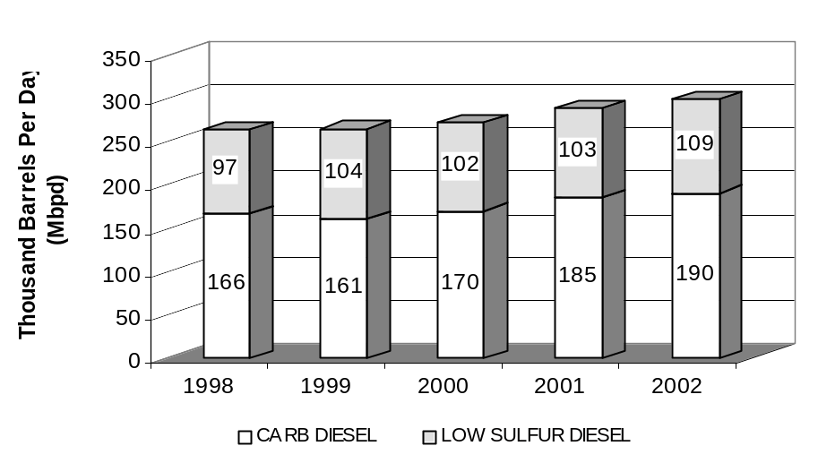

Based on recent statewide diesel fuel consumption trends showing increases of nearly four percent per year, staff estimates that in 2007, nearly 231 Mbpd of California low sulfur diesel fuel will need to be produced to meet anticipated California demand. Also, over 130 Mbpd of U.S. EPA on-road diesel fuel will be needed to meet diesel demands in neighboring states. These diesel fuel production demand estimates are shown in Figure XII-10.

Figure XII-10
Anticipated 2007 On-Road Diesel Production Compared
to 2002 Actual Diesel Production

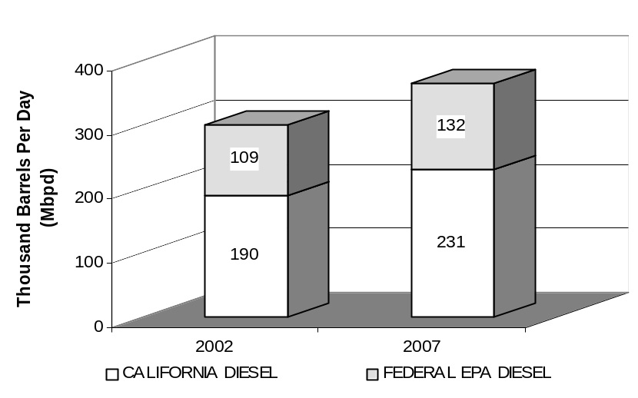

Based on information from California refiners, CARB diesel fuel capacity is expected to be approximately 275,000 barrels per day in 2007. As can be seen, there is still a wide margin between projected estimates for diesel fuel production in 2007 and the estimated diesel capacity, as reported by the refineries.

Diesel Capacity of California Refineries

Currently, California refineries have the capacity to produce about 190 Mbpd of California diesel fuel, and about 110 Mbpd of capacity to produce U.S. EPA on-road diesel fuel. Based on information provided by refiners, the requirements to supply CARB diesel fuel to intrastate locomotives and harborcraft will not have any significant impact on the ability of California refiners to produce adequate volumes of CARB diesel fuel. Because several refiners indicated that they will expand their ability to produce volumes of California diesel fuel, it is expected that California refining capacity to produce California diesel fuel will increase to 275 Mbpd by 2007. In addition, the capacity of California refiners to produce U.S. EPA on-road diesel fuel will increase to about 120 Mbpd by 2007. This is shown in Figure XII-11.

Figure XII-11
California Refiners’ Diesel Fuel Production Capacity
(2002 Versus 2007)

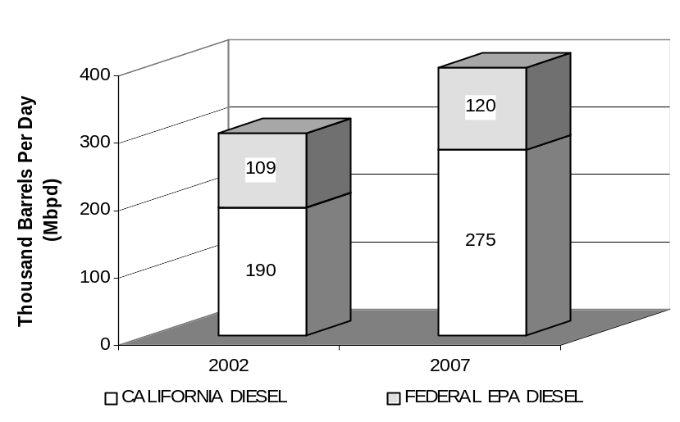

In comparing Table XII-2 to Table XII-3, it can be seen that there should be more than adequate refining capacity by California refineries to increase their production of CARB diesel fuel to meet projected incremental demand estimates. However, it appears the situation may be more constrained for the production of U.S. EPA diesel fuel. Staff does not believe that this should be significant for two reasons. First, the ability of refiners to import U.S. EPA diesel from other parts of the country fuel to supply to neighboring states will be available. Also, since there appears to be excess CARB diesel fuel production capacity available to California refiners, they have the ability to supply CARB diesel fuel to neighboring states as demand and market conditions allow.

Cost Analysis

This chapter presents a summary of the analysis of the costs to produce CARB diesel fuel for use in intrastate locomotives and harborcraft. Analysis of diesel fuel spot prices, the cost effectiveness of the proposed amendments, and the costs of the alternatives described in Chapter X are also provided.

Costs to produce CARB diesel fuel

Today, only two types of diesel fuel are generally produced, supplied, or transported in California – U.S. EPA on-road diesel fuel and CARB diesel fuel, both meeting a 500 ppmw sulfur limit (limited quantities of CARB diesel fuel meeting a 15 ppmw sulfur limit are available). There currently exists little, if any, supply of diesel fuel not meeting either of these specifications (this is evident in the fuel usage data reported by intrastate locomotive and harborcraft operators in Chapters VI and VII). Based on conversations with California refiners and the CEC, staff believes that when the proposed amendments are fully implemented in 2007, the diesel fuel supply market in California will be similar to today’s. The only change would be that diesel fuel in general commerce in the state will meet a 15 ppmw sulfur limit.

In evaluating the potential costs of the proposed amendments, staff has considered the likely diesel fuels expected to be generally available in California in 2007. Based on the fact that intrastate locomotive and harborcraft operators will likely use, at a minimum, U.S. EPA on-road diesel fuel meeting a 15 ppmw sulfur limit, staff has determined the costs of the proposed amendments based on the incremental cost in 2007 to produce CARB diesel fuel relative to U.S. EPA on-road diesel fuel.

Staff estimates that the incremental cost to produce CARB diesel fuel relative to U.S. EPA on-road diesel fuel will be about 3 cents per gallon. This is the incremental cost to reduce the aromatic hydrocarbon content of U.S. EPA on-road diesel fuel from a limit of 35 volume percent to a limit of 10 volume percent (or an equivalent formulation limit).

Effects of Staff’s Proposal on Fuel Prices

With respect to the impacts on diesel prices as a result of staff’s proposed amendments, it is very difficult to predict what will occur in the marketplace. Supply/demand, crude oil prices, competitive market considerations, etc. predominately influence diesel fuel prices. However, it is reasonable to assume that over time, refiners will recover the increased costs of production in the marketplace. With this assumption, and the staff’s estimate that the incremental cost to produce CARB diesel fuel relative to U.S. EPA on-road diesel fuel will be about 3 cents per gallon, it is reasonable to assume that this increase in production cost will, on average, be reflected in diesel fuel prices. This assumption does not attempt to predict changes in fuel taxes and refinery product markup. Refiners will recover costs through increased diesel fuel markup if competitive conditions allow it. However, predictions of 2006 and beyond petroleum product markup and pricing are beyond the scope of this document.

It is very difficult to predict how the proposed rule, which will result in a slight increase in the demand for CARB diesel fuel, will affect diesel pricing and volatility. However, the proposed amendments should not impact the ability of California refiners to supply sufficient quantities of diesel fuel to the California market. Conversations between ARB staff and California refiners, as well as with the staff of the CEC suggest that sufficient diesel refinery capacity already exists. In addition, the implementation of the federal on-road and nonroad low sulfur diesel regulations, adoption of the California diesel fuel regulations by the state of Texas, and the ability of out-of-state refiners to produce diesel fuel meeting California standards should provide even greater diesel fuel availability to the State. As a result, the overall diesel fuel production system consisting of California refineries and imports should be no more subject to supply disruptions than today. In fact 2006 market conditions may be better able to readily adjust to any California diesel production requirements that occur in the future.

Evaluation of spot fuel prices for various grades of diesel fuel

In evaluating the impacts of production costs, staff believes it is most useful to examine how production costs have historically translated into fuel costs on the open market. For diesel fuel supplied to locomotive and marine operators, this can be fairly represented by the diesel fuel spot market in California. In the diesel fuel spot market, sizable batches of diesel fuel (generally supplied directly from a refinery or fuel importer) are traded for a negotiated price. By using spot market prices, it is possible to remove such outside influences on fuel costs such as transportation, tax impacts, local diesel fuel market conditions, and other costs to yield a fairly representative gauge of fuel production costs.

In Figure XIII-12, staff has graphed the incremental spot price differential between CARB diesel fuel and both U.S. EPA on-road diesel fuel, for the years 1996 through 2003.

Figure XIII-12:
Incremental Spot Price Differential between CARB
and U.S. EPA On-road Diesel Fuel
(1996-2003)

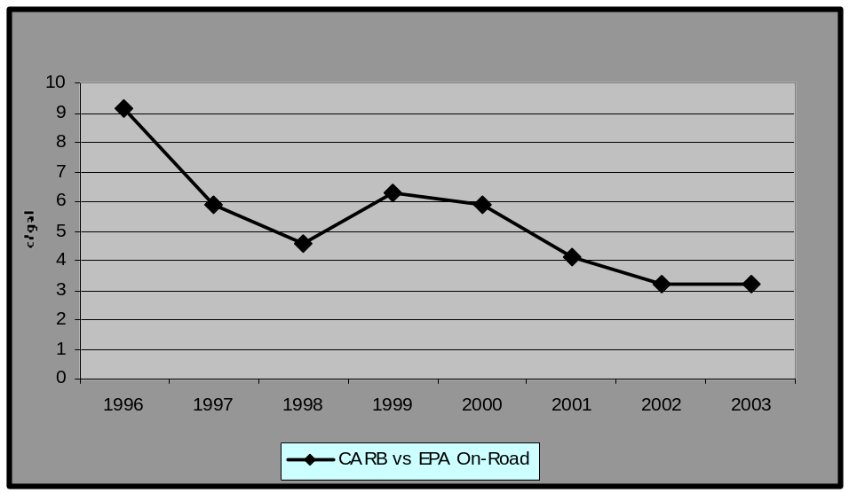

As can be seen from Figure XIII-12, the incremental spot price of CARB diesel fuel relative to U.S. EPA on-road diesel fuel has been steadily decreasing over the last 8 years. In 1996, the incremental spot price differential between CARB diesel fuel and U.S. EPA on-road diesel fuel was about 9 cents per gallon. By 2003, that differential had been reduced to about 3 cents per gallon. This price differential is consistent with the estimated incremental diesel fuel production cost of 3 cents per gallon.

These data indicate that the relative price differences between CARB and non-CARB diesel fuel in California has been steadily decreasing over the last 8 years. Staff believes this is due to a number of factors, including:

- Increased demand of U.S. EPA on-road diesel fuel in PADD V (Alaska, Arizona, Hawaii, Nevada, Oregon and Washington) outside of California.
- A resulting shift in production at California and Washington refineries from nonroad diesel fuels to on-road diesel fuel.
- Changes in the fuel distribution system whereby higher sulfur fuels (such as U.S. EPA nonroad diesel fuel) are not fungible, thereby limiting the production demand for these fuels
- Tight overall supply of all transportation fuels in PADD V.

Other benefits from the use of low sulfur diesel fuel

Staff has identified several benefits to diesel fuel end users from the proposed amendments that have not been quantified in the above production cost estimates. These benefits will be felt both initially, and over the course of the life of the program.

Initially, diesel fuel users are expected to see a decrease in engine wear as a result of low sulfur diesel fuel. This is because fuel sulfur tends to produce acidic compounds that increases the corrosion wear of engine components.

In addition, lower sulfur fuels should increase the life of diesel engine lubrication oil, as fuel sulfur tends to increase the acidification of engine lubricating oils resulting in loss of pH control. By reducing the diesel fuel sulfur content, it is expected that the interval between oil changes can be extended, leading to a cost saving to diesel engine operators. The U.S. EPA estimates the reduced oil change intervals provide the single largest savings from using 15 ppm sulfur diesel fuel. Currently, engine manufacturers specify different oil change intervals as a function of diesel fuel sulfur levels.

The U.S. EPA has estimated fuel operating cost savings attributed to the oil change interval. The U.S. EPA estimates an oil change interval extension of 31 percent through the use of 500 ppmw sulfur fuel, resulting in a fuel operating cost savings of 2.9 cents per gallon. They further estimate additional cost savings of 0.3 cents per gallon for the oil change interval extension that would be enabled by the use of 15 ppmw sulfur diesel fuel. These savings will occur without additional new cost to the equipment owner beyond the incremental cost of the low-sulfur diesel fuel. These savings are dependent on changes to current maintenance schedules. Such changes seem likely given the magnitude of the savings. There are many mechanisms by which end-users could become aware of the opportunity to extend oil drain intervals. First, it is typical practice for engine and equipment manufacturers to issue service bulletins regarding lubrication and fueling guidance for end-users. In addition, the equipment and end-user industries have a number of annual conferences that are used to share information, including information regarding appropriate engine and equipment maintenance practices. The end-user conferences are also designed to help specific industries and business reduce operating costs and maximize profits, which would include information on equipment maintenance practices. There are trade journals and publications that provide information and advice to their users regarding proper equipment maintenance. Finally, some nonroad users perform routine oil sample analysis to determine appropriate oil drain intervals, and in some cases to monitor overall engine wear rates to determine engine rebuild needs.

Anticipated costs to intrastate locomotive and harborcraft diesel fuel end users

This section discusses the anticipated costs of the proposed amendments to intrastate locomotive and harborcraft diesel fuel end users. The first section discusses staff’s estimate of the anticipated costs. The second section discusses the anticipated costs based on conversations with affected industry.

Staff’s estimate of anticipated costs

Based on staff’s belief that, over time, increased diesel fuel production costs will be passed on from producers to end users, staff has used the incremental fuel production cost estimate of 3 cents per gallon to estimate the potential statewide costs of the proposed amendments. These costs are based on both the volumes of non-CARB diesel fuel currently being consumed and the incremental diesel fuel production costs cited.

In developing these costs, staff’s methodology uses a range of costs. The lower range of the costs is the anticipated incremental cost to shift all current non-CARB diesel fuel purchases to CARB diesel fuel. This methodology assumes that those nonroad diesel fuel users who are currently using CARB diesel fuel will not experience any fuel price increases as a result of the proposed amendments since they will continue to purchase the same fuel that they buy today. Staff believes this is a likely scenario, because in many portions of the state, CARB diesel fuel is the only fuel available, and the production costs of CARB diesel fuel are already being incurred and presumably reflected in current diesel fuel prices. Because of this, the increased demand for CARB diesel fuel should not place upward price pressures on the market in these areas. In addition, in a number of instances, CARB diesel fuel is currently being specified by the diesel fuel end user (i.e., for ferry operators and certain commuter train operators).

However, recognizing that the proposed amendments remove the flexibility of nonroad diesel fuel end users to use non-CARB diesel fuel, staff has also developed a conservative upper estimate which assumes that 50 percent of the existing CARB diesel fuel use, in addition to the non-CARB diesel fuel use, will command a higher price, equal to the production cost increases cited above.

Using the fuel use data provided in Chapters VI and VII, and the incremental production cost described above, staff has calculated the potential total statewide costs to intrastate locomotive and harborcraft operators associated with the proposed amendments. In developing this data, staff has looked at 2 different periods: 2006, and 2007 and beyond. This is necessary due to different implementation dates within the proposed amendments. The potential total annual statewide costs are shown in Table XIII-40.

Table XIII-40: Potential Total Annual Statewide Costs by Year

Cost Range |  | Potential Costs by Year
 |  | 2006 | 2007+
Upper | $600,000 |  | $3,040,000
Lower | $440,000 |  | $2,060,000

As can be seen in Table XIII-40, the potential first year costs (which would only be experienced in the SCAQMD) are expected to range from about $440,000 to $600,000. When the proposed amendments become fully effective in 2007, the potential statewide costs are expected to range from $2.1 to $3 million.

Estimate of anticipated costs based on comments from affected industry

During the development of the proposed amendments, affected industry has indicated that the actual cost impact will be greater than that estimated by staff. This is because affected industry believes that even though they do not specify for the delivery of CARB diesel fuel, they often receive CARB quality diesel fuel, at below CARB diesel fuel market prices. As a result, they believe that any requirements for the supply of CARB diesel fuel will necessitate the specification of CARB diesel fuel for future fuel purchases, resulting in higher fuel costs. This will require that they incur the incremental additional fuel costs of 3 cents per gallon for both their current non-CARB diesel fuel being supplied, as well as for that volume of CARB diesel fuel already being supplied.

Based on this information, staff has estimated these affected industry stated costs. These costs are presented below in Table XIII-41. While this methodology yields potential annual fuel cost increases that are about 30 percent higher than those estimated by staff, this has little impact on the overall cost-effectiveness of the proposed amendments.

Table XIII-41: Estimate of Potential Annual Costs Using Industry Methodology

Year
2006 | 2007+
$770,000 | $4,010,000

As previously discussed, staff does not believe that this methodology yields a realistic estimate of the anticipated costs of the proposed amendments. Because the incremental fuel production costs of CARB diesel relative to other grade of diesel fuel are generally fixed, the methodology advocated by affected industry would result in fuel producers selling diesel fuel below their production costs. While some diesel fuel end-users may receive diesel fuel price concessions from fuel vendors and suppliers, these are likely based on volume, other market conditions, or corporate relations between the end user and the fuel supplier, and can be highly variable from company to company, and even seasonal in nature. Because of this, a meaningful comparison between the price paid for diesel fuel by some end users in relation to market prices is not feasible. In addition, no data supporting affected industry’s methodology has been provided to staff. As such, staff does not believe that the price concessions received by affected industry are a function of the ability of the end-user to use a “dirtier” (i.e., U.S. EPA nonroad) diesel fuel than is supplied, and that staff’s upper range estimate above (which accounts for a lack of flexibility to use non-CARB diesel fuel) adequately accounts for potential increased fuel costs to affected industry.

Cost-Effectiveness

As was discussed in Chapter XI, staff has estimated that the proposed amendments, when fully implemented in 2007, will provide about 2 tpd of NOx, and about or 0.6 tpd of diesel particulate (both directly emitted and secondary formation) emission benefits. Using these emission benefits and the cost information provided above, staff has calculated the cost-effectiveness of the proposed amendments. The cost-effectiveness, for the cost ranges and years shown in Table XIII-40, is shown below in Table XIII-42.

Table XIII-42: Anticipated Cost-Effectiveness of the Proposed Amendments

Cost Range |  | Cost-Effectiveness  (Dollars per Pound)
 |  | 2006 | 2007+
Upper | $1.10 |  |  | $1.60
Lower | $0.80 |  |  | $1.10
* The emission benefits in 2006 are only from marine vessels in the SCAQMD and are estimated to be 0.5 tpd of NOx.

As can be seen from Table XIII-42, the cost-effectiveness of the proposed amendments in 2006 in the SCAQMD ranges between $0.80 and $1.10 per pound of NOx plus PM reduced. In 2007, when the proposed amendments are fully implemented statewide, the cost-effectiveness ranges between $1.10 and $1.60 per pound of NOx plus PM reduced. This is in the range of other recent criteria pollutant control measures approved by the Board.

In addition, calculating the cost-effectiveness using the costs derived with the industry cost methodology described above, the cost-effectiveness is about $2.10 per pound of NOx plus PM reduced, which is also within the range of other recent criteria pollutant control measures approved by the Board.

Sensitivity of cost-effectiveness to CARB diesel fuel production cost increases

Based on concerns by current locomotive and harborcraft operators that the actual potential diesel fuel price increases will be higher than those predicted by staff, staff has performed a sensitivity analysis on the cost-effectiveness of the proposed amendments. In performing this sensitivity analysis, staff has evaluated the impact on cost-effectiveness based on changes to the CARB diesel fuel production cost estimates presented earlier. In doing this analysis, staff has looked at the impacts of the actual CARB diesel fuel production costs being greater than staff’s estimate (as suggested by diesel fuel end users). The results of this analysis are shown below in Figure XIII-13.

Figure XIII-13
Sensitivity of Cost-Effectiveness from Differences in Incremental
CARB Diesel Fuel Production Cost Estimates

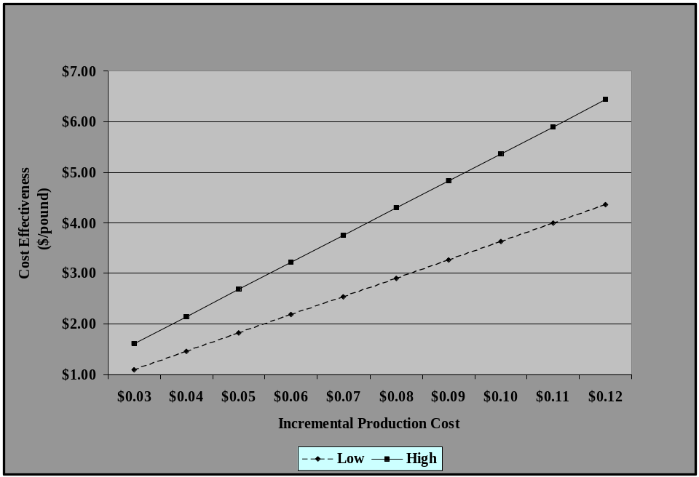

As can be seen from Figure XIII-13, for incremental CARB diesel fuel production cost differences that are higher than staff’s estimate, even up to four times greater (12 cents per gallon versus 3 cents per gallon), the cost-effectiveness ranges from about $4.40 to $6.40 per pound of NOx plus PM reduced. Even with these higher costs and reduced cost effectiveness, the proposed amendments are still within the range of other control measures approved by the Board.

Costs of Alternative Proposals Considered

As was discussed in Chapters and VIII and IX, staff considered five alternatives to the proposed regulations. These alternatives are listed again below:

- Not extending CARB diesel fuel requirements to diesel fuel for use by intrastate locomotives (in which case the fuel would still be subject to U.S. EPA nonroad diesel fuel standards).
- Not requiring any diesel fuel for use by Class III railroads locomotives to have to comply with the CARB diesel fuel requirements.
- Not requiring diesel fuel for use by certain rural Class III railroads locomotives, not operating in ozone non-attainment areas, to have to comply with the CARB diesel fuel requirements until June 1, 2012.
- Requiring diesel fuel for use by all intrastate locomotives in the SCAQMD to meet the CARB diesel fuel standards by January 1, 2006, with diesel fuel for use by intrastate locomotives and harborcraft in the rest of the state to be subject to the CARB diesel fuel standards by January 1, 2007.
- Making diesel fuel for use by all harborcraft and all interstate and intrastate locomotives subject to the CARB diesel fuel requirements.

In considering the feasibility of the alternatives considered in relation to the proposal, staff has identified a number of factors that lead to the proposal as being the most appropriate approach.

For the first alternative, which would allow for the implementation of only the less stringent U.S. EPA nonroad diesel fuel standards in 2007, necessary emission reductions associated with the use of California diesel fuel would not be achieved. This would result in the State not meeting commitments identified in the federally enforceable SIP, and could also result in the State failing to meet federal National Ambient Air Quality Standards for both ozone and PM. This could result in the potential loss of federal highway funding.

The second alternative would retain the same harborcraft provisions as are contained in the proposed regulations, but would only include the Class I and passenger/commuter railroads (Class III railroads would be excluded). While this alternative would provide an annual cost savings of $35,000 to $68,000 to the Class III railroads in California, this alternative would sacrifice NOx emission benefits of about 0.1 tpd (about 10 percent of the NOx emission benefits anticipated from intrastate locomotives) on about 1 million gallons of diesel fuel consumed in the state annually. In addition, diesel particulate emission reductions would also be sacrificed. The loss of these diesel particulate emission benefits would be realized in certain environmentally sensitive (environmental justice) communities around the state, resulting in continued elevated exposure to toxic air contaminants (including diesel particulate). The emission reductions achieved through the proposed amendments will reduce exposure to diesel particulate in these sensitive areas.

The third alternative also would retain the same harborcraft provisions as are contained in the proposed regulations, but would exclude certain rural railroads not in ozone non-attainment areas until June 1, 2012. This alternative does sacrifice a small amount of emission reductions over the proposal and would provide a very slight cost savings of $4,000 to $5,000 for a few Class III railroad operators. However, the emission reductions sacrificed include diesel PM, and could potentially have an adverse impact on individuals living in close proximity to railroad operations in these rural areas. In addition, the proposed amendments would require these rural Class III railroads would meet the same CARB diesel fuel requirements as other on- and off-road mobile sources, as well as stationary sources, operating in these areas.

The fourth alternative would include both intrastate locomotives and harborcraft operating in the SCAQMD in the proposed regulations beginning January 1, 2006, and include the remaining railroads and harborcraft operating in the rest of the State beginning January 1, 2007. This alternative would achieve temporary additional emission reductions in 2006 of about 0.3 tpd of NOx benefits, at an additional cost of between $300,000 to $440,000 in 2006. However, the period during which these benefits would be realized (2006) will see the implementation of the California and federal on-road 15 ppmw sulfur diesel fuel standards, as well as the SCAQMD’s Rule 431.2, which requires all diesel fuel supplied to mobile sources (except locomotive and marine applications) in the SCAQMD to meet a 15 ppmw sulfur cap. The addition of over 10 million gallons of additional CARB diesel fuel demand from intrastate locomotives in the SCAQMD in 2006 could create supply issues during the simultaneous implementation of the three other diesel regulations in the SCAQMD. This could result in an environmental disbenefit if adequate volumes of CARB diesel fuel are unavailable.

The final alternative considered would have extended the proposed amendments to include both intrastate and interstate locomotives, as well as harborcraft. This alternative has the potential to achieve additional emission reductions up to about 5 tpd of NOx, and 1.3 tpd of PM (both directly emitted and secondary) at an additional cost of about $2.8 million per year. However, it is likely that the actual emissions reductions would be much less than this amount because interstate locomotive operators would have an economic incentive to significantly increase the amount diesel fuel bought out-of-state. This is because, by nature, interstate locomotives have the ability to travel long distances without refueling and could likely obtain lower priced fuel that meets U.S. EPA nonroad standards from out-of-state. As such, a requirement that interstate locomotive operators use CARB diesel fuel could result in changes to existing California locomotive fueling patterns, and an increase in the use of out-of-state U.S. EPA nonroad diesel fuel. Further, a requirement on interstate operators could also result in a corresponding decrease in the use of cleaner CARB or U.S. EPA diesel fuels that otherwise would have been used. Because of this potential loss in benefits, staff concluded that this alternative was not advisable.

Economic Impacts of the Proposed Amendments

This section describes the economic impacts of the proposed amendments. The section focuses on the economic impacts to the statewide economy and specific industry sectors. The industry sectors examined are transportation, railroad, and marine. In evaluating the economic impacts, staff used, where possible, both estimates of the direct costs to typical businesses, as well as the combined costs on the general economic sector in California.

Potential Impacts on the California Economy

The proposed amendments are not expected to require any new capital requirements at California refineries. However, the proposed amendments are expected to increase diesel fuel production costs for to California refiners by 3 cents per gallon from for that volume of fuel currently supplied to intrastate locomotive and harborcraft operators that does not presently meet the CARB diesel fuel requirements. This impact could increase diesel fuel costs to intrastate locomotive and harborcraft operators by $2 to $3 million per year. This impact is not expected to have a significant impact on the overall California economy.

Potential Impacts on the California Petroleum Sector

The proposed amendments are not expected to require any new capital requirements at California refineries. However, the proposed amendments are expected to increase diesel fuel production costs to California refiners by 3 cents per gallon beginning in 2007 for that volume of fuel currently supplied to intrastate locomotive and harborcraft operators that does not presently meet the CARB diesel fuel requirements. Staff expects that these costs will likely be passed on to intrastate locomotive and harborcraft operators.

Potential Impacts on Intrastate Locomotive Operators

This section describes the potential impacts of the proposed amendments on the Class I freight railroads, passenger railroad operations, and Class III railroads.

Class I Railroads

Both UP and BNSF are publicly traded corporations. Based on the most recently available annual financial data, staff has estimated the potential economic impacts of the proposed amendments on UP and BNSF. Table XIV-43 lists the pre-tax profits of both Class I railroads operating in California.

Table XIV-43: National Operating Income of Class I Freight Railroads Operating in California

California Class I Freight Railroad | Operating Income
California Class I Freight Railroad | 2001 | 2002 | 2003 | 2001-2003 Average Operating Income
UP | $2,018,000,000 | $2,253,000,000 | $2,133,000,000 | $2,135,000,000
BNSF | $1,750,000,000 | $1,656,000,000 | $1,665,000,000 | $1,690,000,000
Total | $3,768,000,000 | $3,909,000,000 | $3,798,000,000 | $3,825,000,000
Source: 2003 Annual Reports from UP and BNSF.

As discussed in previous chapters, staff estimates that intrastate locomotives operated by UP and BNSF combined consume over 23 million gallons of diesel fuel annually. Of this diesel fuel, about 17 million gallons is U.S. EPA on-road diesel fuel and the rest is CARB diesel fuel. Using the same cost methodology described in Chapter XIII, applied to the Class I freight railroads combined, staff estimates that the costs of the proposed amendments, in terms of increased fuel costs, will range from about $500,000 to $600,000. This increase represents an impact of less than 0.02 percent on the combined operating income of the two railroads, and represents an average cost of $1,300 to $1,600 per Class I freight intrastate locomotive operated in California.

Based on this information, staff does not believe the proposed amendments will have a significant economic impact on the Class I freight railroads operating in California.

Passenger and Commuter Railroads

Currently, there are four local government transit agencies that operate diesel-electric locomotives in commuter service. Three of these, Metrolink (operated by the South Coast Regional Rail Authority) the Coaster (operated by the North Coast Transit District), and Caltrain (operated by the Peninsula Corridor Joint Powers Board), already specify CARB diesel fuel for their fuel purchases. The Altamont Commuter Express, operated by the Altamont Commuter Express Joint Powers Authority, currently receives CARB diesel fuel, but does not specify it during its fuel procurement process. Staff does not believe the proposed amendments will result in increased diesel fuel costs because the fuel suppliers do not have ready access to any fuel other than CARB diesel. Staff believes that the current prices paid already reflect CARB diesel fuel production costs. Staff believes the proposed regulations should have no fiscal or economic impact on these agencies.

Under the direction and funding of the state Department of Transportation (Caltrans), Amtrak operates two commuter rail services (the Capital Corridor between Emeryville and Auburn and the San Joaquin between Oakland or Sacramento and Bakersfield) in the State. Currently, these commuter rail lines receive CARB diesel fuel, although they do not specify this type of fuel during the fuel procurement process. Staff does not believe the proposed amendments will result in increased diesel fuel costs because the fuel suppliers do not have ready access to any fuel other than CARB diesel. Staff believes that the current prices paid by Caltrans already reflect CARB diesel fuel production costs. Staff believes the proposed regulations should have no fiscal or economic impact.

Class III Railroads

In general, Class III railroads in California are privately held companies. Financial data on these operations is not readily available. As such, the magnitude of any potential increases in fuel costs and the corresponding reduction in profits is difficult to estimate reliably for any particular Class III California railroad. However, the California Public Utilities Commission (PUC) collects and publishes information on the gross revenues of the Class III railroads operating in California. Staff used this information to estimate the economic impact of the proposed amendments on the Class III railroad operations subject to the proposed amendments.

Class III railroads operating in California (and subject to staff’s proposed amendments) have gross revenues that range from $25,000 to $11.5 million per year. Using the cost methodology described in Chapter X, applied each Class III railroad operating in California, staff estimates that the costs of the proposed amendments, in terms of increased fuel costs, will vary for each company from no cost to about $20,000, averaging between $1,800 to $3,400 per company, or about $290-$560 per Class III locomotive in California operation. Staff estimates that this potential increase in diesel fuel costs could represent up to 1 percent of the gross revenues of the Class III railroads. Based on this information, staff does not believe the proposed amendments will have a significant economic impact on the Class III railroads operating in California.

While the ability of the Class III railroad operators to absorb higher fuel costs is more difficult than the Class I freight railroad operators, fuel price volatility is commonplace in today’s business environment. Staff does not believe that the proposed amendments will increase CARB diesel fuel prices above the current volatility range of diesel fuel prices. In fact, the spot diesel fuel price information provided in Chapter XIII suggests that the variation in diesel fuel prices for various grades of diesel fuel is shrinking. This should help mitigate diesel fuel price increases to Class III railroad operators resulting from the proposed amendments.

Potential Impacts on Harborcraft Operators

To analyze the impacts of the proposed amendments, typical commercial fishing businesses and tugboat operators were chosen for analysis. Commercial fishing operators represent the largest number of vessels and businesses compared to other types of harborcraft operations. As discussed in Chapter VII, commercial fishing vessels account for about half of all harborcraft operated in California. In addition, commercial fishing operations are largely single boat operations representative of smaller harborcraft businesses. Tugboat companies were analyzed because they have the highest average fuel consumption, and the most vessels per company. Staff believes that these two types of harborcraft operations are an adequate representation of the range of harborcraft companies.

The impacts on California harborcraft operators are to the extent that implementation of the proposed regulation reduces their profitability. Table XIV-44 summarizes the costs for typical commercial fishing and tug operators for various years, and provides the percent change in the return on owner’s equity (ROE). Based on staff’s analysis, staff believe that the average ROE may decline by less than one percent for commercial fishing operations and by about four to seven percent for tugboat operations as a result of the proposed amendments. The larger impact on tugboat operators is a reflection of their higher consumption of diesel fuel.

Based on this analysis, the proposed amendments are not expected to have a significant impact on the profitability of affected harborcraft operations. In addition, ferries are already required to use CARB diesel, so there would be no expected impact on their profitability. As a result, staff does not expect any noticeable economic impacts on California harborcraft operators.

Table XIV-44: Added Annual Costs and Change in Return on Owner’s Equity for California Commercial Harborcraft Operators

Location | Years | Commercial Fishing |  | Tugboat Operators
Location | Years | Added Annual Cost | ∆ ROE (%) | Added Annual Cost | ∆ ROE (%)
South Coast
 | 2006 | $372 | -0.184 | $18,615 | -4.40
 | 2007-2011 | $307 | -0.152 | $15,330 | -3.62
Rest of State
 | 2007 | $591 | -0.293 | $29,565 | -6.98
 | 2008-2011 | $526 | -0.261 | $26,280 | -6.21

Economic Effects on Small Businesses

Government Code sections 11342 et. Seq. requires the ARB to consider any adverse effects on small businesses that would have to comply with a proposed regulation. Also, this definition includes only businesses that are independently owned and, if in retail trade, gross less than $2,000,000 per year. Thus, staff’s analysis of the economic effects on small business is limited to the costs to Class III railroad transportation companies and commercial harborcraft.

Based on the potential economic impacts discussed above for Class III railroad and commercial harborcraft operators, staff does not believe the proposed amendments will have a significant economic impact on small businesses in California.

A Class I railroad is defined by the Surface Transportation Board as a railroad with annual operating revenues of $250 million or more.
2 A Class III railroad is defined by the Surface Transportation Board as a railroad with annual operating revenues of $20 million or less.
3 http://www.joinarnold.com/en/agenda/#D1
Technical Support Document for Proposed Adoption of Regulations Limiting the Sulfur Content and the Aromatic Hydrocarbon Content of Motor Vehicle Diesel Fuel, October 1988, ARB.

